



**Forecasting Future Skill Demands with Predictive Modelling Approach**

**By**

**JOSHUA LIM JOON YEW**

**TP061853**

**APU3F2402CSDA**

A report submitted in partial fulfillment of the requirements for the degree of

B.Sc. (Hons) Computer Science Specialism in Data Analytics

at Asia Pacific University of Technology and Innovation.

**Supervised by Dr. Murugananthan Velayutham**

**2nd Marker: Dr. Preethi Subramanian**

**2024**

**DECLARATION OF THESIS CONFIDENTIALITY**

Author’s full name: Joshua Lim Joon Yew

IC No./Passport No.: 021212-08-1125

Thesis/Project title: **Forecasting Future Skill Demands with Predictive Modelling Approach**

I declare that this thesis is classified as:

CONFIDENTIAL

RESTRICTED

OPEN ACCESS

I acknowledged that Asia Pacific University of Technology & Innovation (APU) reserves the right as follows:

1. The thesis is the property of Asia Pacific University of Technology & Innovation (APU).
2. The Library of Asia Pacific University of Technology & Innovation (APU) has the right to make copies for the purpose of research only.
3. The Library has the right to make copies of the thesis for academic exchange.

|  |  |
| --- | --- |
| Author’s Signature: | A screenshot of a clock  Description automatically generated with low confidence…………………………… |
| Date: | 2 October 2024 |
|  |  |
| Supervisor’s Name: | Dr. Murugananthan Velayuhtham |
| Date: | 2 October 2024 |
| Signature: | ……… ***V. Murugananthan*** ……… |

**Library Cataloguing Details**

|  |
| --- |
| First Name: Joshua |
| Middle Name (only if applicable): Joon Yew |
| Last Name: Lim |
| Title of the Final Year Project / Dissertation / Thesis:  Forecasting Future Skill Demands with Predictive Modelling Approach |
| Abstract:  In this Final Year Project, an investigation into trends and dynamics within the job market is undertaken, aiming to tackle pressing challenges related to employment trends and future demand forecasting. By leveraging data science techniques, the study utilizes a comprehensive dataset from Kaggle, carefully curated to facilitate research in job market analysis. This research directly contributes to Sustainable Development Goal 8 (SDG 8), which promotes Decent Work and Economic Growth. The dataset encompasses a wide array of industries and job types, providing a rich foundation for detailed analyses and predictive modeling.  The primary objective of this project is to uncover insights into job market trends, with a particular focus on the technology sector, through rigorous data analysis and modeling. Key challenges include identifying in-demand skills, analyzing job posting trends over time, and refining datasets to extract meaningful features for predictive modeling. Through iterative exploration and refinement, the study aims to provide actionable insights that enhance the understanding of employment dynamics and inform decision-making processes for job seekers, recruiters, and policymakers alike.  By thoroughly exploring these aspects, this research seeks to foster a deeper understanding of employment landscapes and facilitate informed decision-making among stakeholders in the job market. |
| A few keywords associated with the work: Job Market Analysis, Forecasting Future In Demand Skills, Predictive Modeling, Skill Mismatch, Technical Skill Gap, Unemployment, Data Science |
| General Subject: Computer Science in Data Analytics |
| Date of Submission: 2nd October 2024 |

# ACKNOWLEDGEMENT

I want to express my thanks to all those who have helped me complete this final year project. Their assistance, guidance and motivation have been invaluable throughout this process. Firstly, I want to show my appreciation to Dr. Murugananthan Velayutham, my supervisor for his support, insightful advice and continuous encouragement. His expertise and constructive feedback have played a role in shaping this project and I am truly grateful for his mentorship. Also, a big thanks to Dr. Preethi Subramanian, my second marker, but still helped me and guided me along.

I also want to thank Mr. Dhason Padmakumar and Dr. Dewi Octaviani, the Project Managers of my Final Year Project for their guidance and ongoing support. His dedication to promoting an understanding of the subject matter and commitment to student success are greatly valued. Furthermore, I would like to recognize the backing and motivation from my family and friends. Their understanding, patience and belief in me have been a source of strength and inspiration throughout this journey.

A special acknowledgment goes out to my peers and colleagues for their camaraderie, collaboration creating an environment for discussion and knowledge sharing. This project would not have come together without the support and encouragement, from all these individuals. Thank you all for being a part of this experience.

.

# ABSTRACT

In this Final Year Project, an investigation into trends and dynamics within the job market is undertaken, aiming to tackle pressing challenges related to employment trends and future demand forecasting. By leveraging data science techniques, the study utilizes a comprehensive dataset from Kaggle, carefully curated to facilitate research in job market analysis. This research directly contributes to Sustainable Development Goal 8 (SDG 8), which promotes Decent Work and Economic Growth. The dataset encompasses a wide array of industries and job types, providing a rich foundation for detailed analyses and predictive modeling.

The primary objective of this project is to uncover insights into job market trends, with a particular focus on the technology sector, through rigorous data analysis and modeling. Key challenges include identifying in-demand skills, analyzing job posting trends over time, and refining datasets to extract meaningful features for predictive modeling. Through iterative exploration and refinement, the study aims to provide actionable insights that enhance the understanding of employment dynamics and inform decision-making processes for job seekers, recruiters, and policymakers alike.

By thoroughly exploring these aspects, this research seeks to foster a deeper understanding of employment landscapes and facilitate informed decision-making among stakeholders in the job market.

*Keywords: job market analysis, forecasting future in demand skills, predictive modeling, skill mismatch, technical skill gap, unemployment, data science*

**SDG Goal 3: Decent Work and Economic Growth**

**TABLE OF CONTENTS**

ACKNOWLEDGEMENT 6

ABSTRACT 7

CHAPTER 1: INTRODUCTION TO THE STUDY 14

1.1 Introduction 14

1.2 Problem Background 14

1.3 Project Aim 16

1.4 Objectives 16

1.5 Scope 17

1.5.1 Deliverables 17

1.5.2 Nature of Challenges/Risk 18

1.6 Potential Benefit 19

1.6.1 Tangible Benefit 19

1.6.2 Intangible Benefit 20

1.7 Overview of the IR 20

1.8 Project Plan 22

CHAPTER 2: LITERATURE REVIEW 24

2.1 Introduction 24

2.2 Domain Research 25

2.2.1 Labor Market and Unemployability 25

2.2.2 Technical and Soft Skills Demand 27

2.2.3 Predictive Modelling and Forecasting 28

2.2.4 Machine Learning Algorithms 29

2.2.5 Natural Language Processing 30

2.3 Similar Systems 32

2.3.1 GBT-Based Models 32

2.3.2 Logpop + Two-step Classifier 34

2.3.3 Deep Learning CNN (LSTM) 36

2.3.4 Ensembled Regression + Classification Models 37

2.3.5 ARIMA Model 38

2.4 Technical Research 39

2.4.1 Hardware 39

2.4.2 Software 43

CHAPTER 3: METHODOLOGY 47

3.1 Introduction 47

3.2 Methodology 47

3.2.1 Comparison of Methodologies 47

3.1.2 Justifications 49

3.1.3 Chosen Methodology 52

3.3 Summary 56

CHAPTER 4: DESIGN AND IMPLEMENTATION 57

4.1 Introduction 57

4.2 Data Collection 57

4.3 Data Pre-processing 59

4.3.1 Import Libraries and Data Loading 59

4.3.2 Initial Data Exploration 59

4.3.3 Filtering ‘Job Title’ into Tech Related Industry 61

4.3.4 Preprocess ‘Job Posting Date’ 61

4.3.5 Preprocess ‘skills’ Column 62

4.3.6 Data Normalization and Standardization 70

4.3.7 Categorical Features Encoding 75

4.3.8 Feature Selection 77

4.3.9 Class Imbalance Resampling Technique 78

4.3.10 Data Splitting 82

4.4 Data Understanding 84

4.4.1 Distribution of ‘Qualifications’, ‘Work Types’ and ‘Preference” 84

4.4.2 Skill Distribution Across Job Titles 86

4.4.3 Skill Combinations Analysis 88

4.4.4 Feature Importance 90

4.5 Model Building 92

4.5.1 Random Forest Classifier 92

4.5.2 Logistic Regression 95

4.5.3 XGBoost 97

4.5.4 LightGBM 99

4.5.5 Save Models 101

4.6 Summary 102

CHAPTER 5: RESULT AND DISCUSSION 103

5.1 Introduction 103

5.2 Model Evaluations and Discussions 103

5.2.1 Evaluation of Random Forest Models 103

5.2.2 Evaluation of Logistic Regression Models 106

5.2.3 Evaluation of XGBoost Models 108

5.2.4 Evaluation of LightGBM 110

5.2.5 Comparison and Discussions 113

5.2.6 Analysis 118

5.3 Model Deployment 119

5.3.1 Streamlit 120

5.3.2 Deployment interface 124

5.3.3 Predictions 125

5.4 Summary 126

CHAPTER 6: CONCLUSION 128

6.1 Critical Evaluation 128

6.1.1 Achievements 128

6.1.2 Contributions of the Project 129

6.1.3 Strength of the Project 129

6.2 Limitation 130

6.3 Recommendation 131

REFERENCES 133

APPENDICES 141

Appendix A: PPF 141

Appendix B: Ethics Forms 149

Appendix C: Log Sheets 153

Appendix D: Poster 160

Appendix E: Gantt Chart 161

Appendix F: Sample Code Implementation 163

**LIST OF FIGURES**

Figure 1: Project Plan Semester 1 24

Figure 2: Project Plan Semester 2 25

Figure 3 Deep Learning Ensemble DistilBERT (Weichselbraun, et al., 2024) 35

Figure 4 LLM on GPT API (Weichselbraun, et al., 2024) 36

Figure 5 Formula for Popularity Types (Yazdanian, et al., 2022) 37

Figure 6 Scheme of Pipeline (Garcia, et al., 2022) 38

Figure 7 Device Specification Screenshot 42

Figure 8 Operating System Specifications Screenshot 42

Figure 9 GPU Screenshot 43

Figure 10 Manufacturer of Device 43

Figure 11: Visual Studio Code Logo 45

Figure 12: Python Logo 46

Figure 13 SCRUM Methodology Processes (Korkut, 2023) 51

Figure 14 Kanban Practices (Udodov, 2023) 52

Figure 15 Lean Principles (Lavender, 2022) 52

Figure 16 Extreme Programming XP Feedback Loops (Editor, 2021) 53

Figure 17 Adaptive Project Framework (APF) Cycle (Imran, 2023) 53

Figure 18 CRISP-DM Process Flow (Hotz, 2024) 54

Figure 19 CRISP-DM Flowchart with Description of Each Phases 55

Figure 20: Data Analytics Project Flowchart 57

Figure 21 Data Preprocessing – Imports 61

Figure 22 Read CSV 61

Figure 23: Shape of dataset 61

Figure 24 EDA, Data Info, Unique Data, Missing Data 62

Figure 25 Filter Job Titles 63

Figure 26: Preprocessing ‘Job Posting Date’ and create other temporal features – coding 63

Figure 27: Output of ‘Job Posting Date’ preprocessing 64

Figure 28: Preprocessing ‘skills’ column step 1 65

Figure 29: Preprocessing ‘skills’ column step 2 66

Figure 30: Unique skills before mapping 67

Figure 31: Skill Mapping 1 67

Figure 32: Skill mapping 1 – Code and Output 68

Figure 33: Skill mapping 2 : Further reduce classes 69

Figure 34: Skill mapping 2: Code and Output 70

Figure 35: One-hot encoding ‘skills’ list 71

Figure 36: One-hot encoded skills columns output 71

Figure 37: Preprocessing ‘salary’ code 72

Figure 38: Preprocessing ‘experience’ code 72

Figure 39: Apply StandardScaler 72

Figure 40: Output and Description after scaler 73

Figure 41: Check outliers for ‘Avg Salary’ and ‘Avg Experience’ code 74

Figure 42: Output of outliers 75

Figure 43: Company Size Plot 75

Figure 44: Min Max Scaling ‘Company Size’ 76

Figure 45: ‘Company Size’ after Min Max Scaling 76

Figure 46: Unique ‘Qualifications’ before preprocessing 77

Figure 47: ‘Qualifications’ grouping 77

Figure 48: Categorical feature One-Hot Encoding 78

Figure 49: One-Hot Encoding results 78

Figure 50: Dropping columns 79

Figure 51: Identify Potential Class Imbalances 80

Figure 52: Skills Grouped by their Total Frequency 81

Figure 53: Resampling Technique Code 82

Figure 54: Data after Resampling 83

Figure 55:Data Splitting Part 1 84

Figure 56: Data Splitting Part 2 85

Figure 57: Save preprocessed data frame to csv 85

Figure 58: Distribution of ‘Qualifications’, ‘Work Types’ and ‘Preference” Code 86

Figure 59 Distribution of ‘Qualifications’, ‘Work Types’ and ‘Preference” Graphs 87

Figure 60: Skill Distribution Across Job Titles Code 88

Figure 61: Skill Distribution Across Job Titles Graph 89

Figure 62: Skill Combinations Analysis Code 90

Figure 63: Skill Combinations Analysis Graph 91

Figure 64: Feature Importance Code Using Random Forest Classifier 92

Figure 65: Feature Importance Using Random Forest Classifier Chart 93

Figure 66: Random Forest Base Model Code 94

Figure 67: Random Forest Hyperparameter Tuning Code 96

Figure 68: Logistic Regression Base Model Code 97

Figure 69: Logistic Regression Hyperparameter Tuning Code 98

Figure 70: XGBoost Base Model Code 99

Figure 71: XGBoost Hyperparameter Tuning Code 100

Figure 72: LightGBM Base Model Code 101

Figure 73:LightGBM Hyperparameter Tuning Code 102

Figure 74: Save All Models 103

Figure 75: Random Forest Result Code 105

Figure 76: Metrics of Random Forest Base Model 106

Figure 77: Metrics of Random Forest Tuned Model 107

Figure 78: Metrics of Logistic Regression Base Model 108

Figure 79: Metrics of Logistic Regression Tuned Model 109

Figure 80: Metrics of XGBoost Base Model 110

Figure 81: Metrics of XGBoost Tuned Model 111

Figure 82: Metrics of LightGBM Base Model 112

Figure 83: Metrics of LightGBM Tuned Model 113

Figure 84: Comparison of Metrics- All Models - Code 115

Figure 85: Comparison of Metrics- All Models – Result 116

Figure 86: Average Metrics Comparison Code 118

Figure 87: Average Metrics Comparison Code Result 119

Figure 88: StreamLit Code imports 122

Figure 89: StreamLit code for web interface 123

Figure 90: StreamLit Code – Preprocess User Input Function 124

Figure 91: StreamLit Code – Predict Function 125

Figure 92: Deployment Interface 126

Figure 93: Sample Predictions 1 127

Figure 94: Sample Predictions 2 128

Figure 95: FYP Poster 162

Figure 96: Gantt Chart Semester 1 163

Figure 97: Gantt Chart Semester 2 164

**LIST OF TABLES**

Table 1 Hardware Specification Comparison 44

Table 2 Python Libraries 48

Table 3 System Development Methodology Comparison Table 51

# CHAPTER 1: INTRODUCTION TO THE STUDY

## Introduction

As technology rapidly evolves, the tech industry, particularly in fields like information technology, computer science, and software engineering, is crucial for driving innovation and economic progress. However, this fast-paced environment often leads to a mismatch between the skills job seekers possess and what employers need, especially in the data science sector. This research aims to tackle these challenges by forecasting in-demand skills using predictive analytics (Mukozho & Lisa F. Seymour, 2021). With the rise of AI, millions of jobs could be affected by automation by 2030, especially in white-collar roles like customer service and accounting (Acemoglu, Autor, Hazell, & Restrepo, 2022). Job seekers face the challenge of staying relevant, while employers struggle to find talent equipped with the right skills. This misalignment often results in underemployment and limits career growth (Pellizzari & Fichen, 2017). By analyzing job postings and industry trends, this study provides data-driven insights to help job seekers adapt and assist employers in building agile teams that meet future demands. The ultimate goal is to create a more aligned and thriving workforce in the tech industry.

## Problem Background

The job market in fields like information technology, computer science, and software engineering is present with huge complexities that create significant challenges between the skills job seekers possess and the expectations of employers. This disconnect often results in underemployment and a mismatch of skills (Cappelli, 2015). Despite a wealth of talent and opportunities available, both new graduates and seasoned professionals frequently face challenges related to these discrepancies in skills. The swift pace of technological advancements and the changing demands of the industry only intensify this mismatch, making it increasingly difficult for job seekers to align their capabilities with what employers are looking for (Hornstein, Krusell, & Violante, 2005).

A clear manifestation of this issue is the technical skills gap, like many job seekers find themselves lacking the specific expertise needed to keep pace with the demands of emerging technologies such as artificial intelligence, cybersecurity, cloud computing, data analytics and so on. This gap is compounded by the absence of reliable information regarding future skill requirements and job market trends, which makes many job seekers feeling uncertain about their career paths and the skills they should focus on acquiring. Consequently, employers encounter difficulties in pin-pointing candidates who possess the right skills to foster innovation and bolster organizational effectiveness.

Other than that, the significance of soft skills in today's workplace cannot be ignored. Employers are increasingly prioritizing qualities such as problem-solving abilities, teamwork, and effective communication, often valuing these competencies even more than technical skills (Lyu & Liu, 2021) .Unfortunately, many job seekers struggle to showcase their proficiency in these areas, which hinders their ability to collaborate effectively with colleagues, stakeholders, and clients.

Underemployment slowly becomes a pressing concern when such a substantial gap exists between the skills possessed by job seekers and the requirements set by employers. Many individuals find themselves in roles that do not fully leverage their abilities or offer meaningful opportunities for career development and advancement (Maynard, Joseph, & Maynard, 2006). This misalignment often leads to frustration and dissatisfaction among employees who feel their skills are not being utilized to their fullest potential, and causes more after effects from it like anxiety, depressions.

This raises an important question: what drives the underutilization of skills among individuals? Is it a matter of being unable to effectively showcase their abilities, a shortage of opportunities, or simply a mismatch between their skills and the job requirements? When skills do not align with expectations or become outdated, their usefulness diminishes (Radlińska, 2023). This disconnect further restricts career mobility of job seekers, preventing them from pursuing rewarding careers that align with their talents and ambitions, often leaving them stuck in entry-level or less fulfilling roles (Desjardins, 2011).

Moreover, inefficiencies in the talent acquisition process exacerbate these challenges, leading to a waste of time, resources, and opportunities for both employers and job seekers alike. Companies struggle to identify and connect with qualified candidates, or the skill sets required, while job seekers often find it challenging to discover roles that fit their qualifications and aspirations.

The broader economic implications of these issues are considerable, particularly when it comes to reduced productivity in the tech sector. The underutilization of skills not only affects individual career paths but also weakens organizational competitiveness and overall productivity. Additionally, the mismatch of skills contributes to economic inequality by limiting access to high-skilled and high-paying job opportunities for certain segments of the workforce. This exacerbates socioeconomic disparities and complicates efforts to achieve upward mobility, creating a cycle that is hard to break.

In conclusion, the complex relationship between underemployment, skills mismatch, and their economic ramifications paints a complex picture that calls for thoughtful examination and strategic action. Therefore, it is worthwhile for this project to try addressing these challenges to better enhance individual career development and improve overall economic efficiency in these eras.

## Project Aim

The research aims to develop an optimal predictive analytics model that forecasts future in-demand skills and provide meaningful insights within the tech sector such as, information technology, computer science, and software engineering and data science sector to address skills mismatch and underemployment among fresh graduates and industry-related personnel.

## Objectives

1. To analyze historical job posting data to predict future in demand skills within the tech sector.
2. To establish methods to improve the reliability and performance of different machine learning algorithms in predicting future skill demands.
3. To offer data driven insights for job seekers to make informed decision about their career path and upskilling options.
4. To provide actionable insights and recommendations for educational institutions and policymakers to bridge skill mismatches and technical gaps based on the predictive model outcomes.

## Scope

### 1.5.1 Deliverables

1. Data Collection:

A dataset of job postings will be obtained through Kaggle.com as the main dataset of this research after searching through and filtering dozens of datasets available publicly online.

1. Data Preprocessing:

Dataset will undergo preprocessing steps like data cleaning, data transformation, feature selections, and tokenization of skills ensuring the accuracy of analysis later on.

1. Data Modelling:

The development of machine learning models to forecast future in demand skills, including all the codes, algorithms, and documentations. The models will be chosen are Random Forest Classifier, Logistic Regression, XGBoost and LightGBM.

1. Technical Documentation:

All the technical aspects involve in the entire process of this Final Year Project will be documented clearly, such as the hardware and software used, choice of IDE, programming languages, machine learning model and data visualization tool.

1. Final Research Documentation:

A comprehensive research documentation that clearly explains the background, problem statements, scope, aims and objectives of this Final Year Project. As well as extensive domain research and similar system research. The process of the technical aspect will be documentation from the beginning to the very end, explaining all the useful findings, limitations, and future directions.

1. Insights and Recommendation:

Findings of the research will be dissected and discussed thoroughly in the research paper with data visualization method, providing valuable insights into the future in-demand skills within the employment sector. These insights will be used to develop actionable recommendations for various stakeholders.

### 1.5.2 Nature of Challenges/Risk

1. Data-Related Challenges:

The data-related challenges are revolving around the fundamental challenges of handling enormous amounts of job postings data, which are sometimes rife with inconsistencies and missing values. Preprocessing textual data from job postings has its own set of challenges, it requires careful extraction of relevant information while maintaining data integrity. As for the main feature which are the skills required in the job posting data is even required more attention for preprocessing.

1. Data Modelling and Analytical Challenges:

Challenges occur when trying to derive practical insights from textual data in the modelling and analytical field. For the model to function effectively and to turn out accurate, suitable features must be discovered in the unstructured text, extracted and properly preprocessed. Furthermore, another difficulty is ensuring that predictive models are not just accurate but also generalizable across different contexts and time periods. Models need to be able to adjust over time to new trends and patterns since skill demands are dynamic, making time management crucial.

1. Implementation and Practical Challenges:

On the implementation and practical part, challenges present in translating model predictions into actionable insights. To encourage acceptance and trust, it is crucial to make sure that stakeholders can read and comprehend the model results. Moreover, there are logistical and technological difficulties in smoothly incorporating predictive models into current workflows and systems. It is imperative to include stakeholders and secure their support across the implementation phase to ensure the effective acceptance and use of the predictive models.

1. Ethical and social Challenges:

Finally, because skills forecasts may have an impact on employment patterns and individual livelihoods, ethical and social issues become very important. Prediction fairness and bias must be addressed in order to minimise any unforeseen implications. For the safety of the private information included in job posting data, confidentiality and safety of data standards must be enforced. Furthermore, the wider societal impact and consequences of such predictions must be carefully considered when addressing the ethical concerns of forecasting future skill demands. The project's success and ethical conduct will be greatly dependent on how well these complex issues are navigated.

## Potential Benefit

### Tangible Benefit

1. Increase Job Matching and Employment Rate for Fresh Graduates and Job Seekers

By predicting emerging skills and aligning them with market demand, unemployment rates can be reduced as individuals are provided with actionable insights. A well-prepared workforce contributes to economic growth by fulfilling the needs of industries and reducing underemployment.

1. Improve Workforce Development Program for Companies

Companies can use the findings of the predictive models to anticipate future skill requirements, and this allows them to plan their workforce more effectively. This includes targeted recruitment, training programs, and strategic hiring, which ultimately reduces technical and soft skill gaps and increases organizational efficiency.

1. Data Driven Decision Making for Educator and Policymakers

Policymakers and educational institutions can leverage the findings to design specific curricula and training programs that are aligned with the predicted emerging demands of the job market within the tech industry. This ensures that educational offerings remain relevant and beneficial to create a skilled workforce that is more resilient and meets future industry needs.

### Intangible Benefit

1. Empowerment and Confidence for Individuals

This project can empower individuals’ confidence level with the knowledge of which skills will be in demand, so that they could take a proactive approach to personal and professional development. This empowerment can lead to increased and motivation among job seekers and employees for them to continue learning and upskilling themselves.

1. Societal Well-Being

Access to information about future skill demands can help reduce inequalities by providing all individuals of all backgrounds with the opportunities to develop in-demand skills. This cultural shift towards continuous learning and innovation can benefits individuals and organizations, which leads to an environment where both parties can thrive along with changing industry landscapes. Individuals from diverse backgrounds can also achieve upward social mobility by acquiring skills that are in high demand, hence, changing their own lives.

1. Enhance Collaboration and Engagement with Stakeholders

The insights generated by this project can facilitate a better communication and collaboration among various stakeholders, such as educational institutions, world industry leaders, and government bodies. This collaboration can lead to more cohesive strategies for addressing skill gaps, because they understood the importance of in demand skills. Hence, they could ensure that the workforce development initiatives are well-coordinated and impactful.

## Overview of the IR

**CHAPTER 1: INTRODUCTION**

The first chapter of the investigation report introduces the overall project, providing readers with a comprehensive overview of the main topic. It establishes the significance and context of the project by discussing its background and the rationale behind the solution to the problems it aims to address. This chapter outlines the project’s aims, objectives, and expected outcomes, giving a clear picture of what the project intends to achieve. It also identifies the target users and potential challenges in implementation. The chapter concludes with a detailed project plan, including the timeline and milestones to be achieved.

**CHAPTER 2: LITERATURE REVIEW**

Chapter 2 delves into existing research and studies relevant to the project. Drawing from academic journals, books, and reputable online sources, this chapter reviews the domain from general to specific, including related theories, technologies, and algorithms that contribute to solving the identified problems. Furthermore, each sub-topic within the domain is reviewed through extensive research, with an analysis of similar systems or works with different characteristics, strengths, and weaknesses. The chapter ends with a conclusion that synthesizes the findings from the literature.

**CHAPTER 3: METHODOLOGY**

This chapter outlines the overall approach and methodology chosen for the research and system development. It starts with an introduction to the selected system development methodology, justifying the choice and detailing the activities and processes involved in each phase. The chapter also covers the data gathering design, describing the techniques used for data collection. The analysis section hence covers the data preprocessing, exploratory data analysis and feature engineering applied to the dataset.

**CHAPTER 4: DESIGN & IMPLEMENTATION**

Chapter 4 is about the design and implementation of my data analysis project. Every detail regarding the technical aspect of the project will be documented here. For examples, the data source, data preprocessing steps, data understanding, and model building. There will be four types of machine learning models built in this project.

**Chapter 5: RESULT & DISCUSSION**

This chapter discuss about the findings of the machine learning models. Comprehensive evaluation of all models will be performed and documentation by the researcher. The feature importance will also be discussed in this section. Model deployment code and sample output will be documented as well.

**Chapter 6: CONCLUSION**

Chapter 6 gives a ending to the FYP, discussing various aspect of the project such as the contribution of the project to the job seekers, employers or related personnel. Other than that, the limitations of the project will also be critically analyses and documented for future improvements, from there, recommendations are also given to inspire future works.



## 1.8 Project Plan

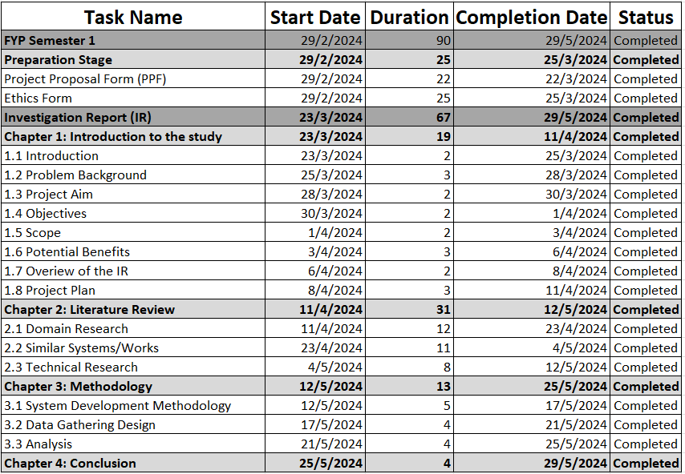

Figure 1: Project Plan Semester 1

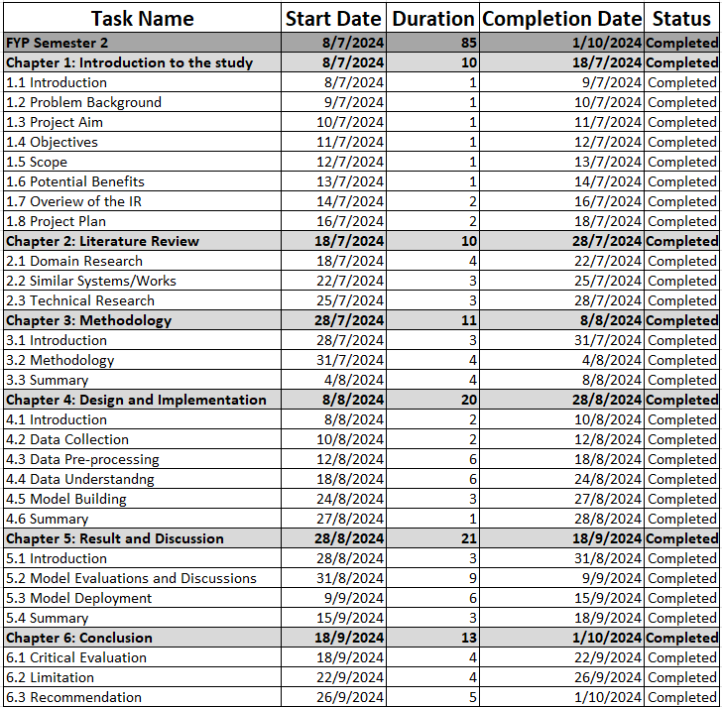

Figure 2: Project Plan Semester 2

# CHAPTER 2: LITERATURE REVIEW

## 2.1 Introduction

Before diving into the actual implementation of the project, it is crucial to conduct comprehensive research and analysis thoroughly. This chapter serves as a compass that guides through the maze of understanding and allow the researcher to explore into various perspectives and angles. It is essential to grasp the problem the system aims to solve, along with its scope, and the impact it has on external stakeholders. Understanding the challenges faced by fresh graduates and industry professionals in the tech sector, including underemployment struggles and the reasons behind them is vital.

Moreover, this literature review dives into the factors contributing to skill mismatches between job seekers and available positions from employer. Other than that, exploring the gaps between the technical skills demanded by the industry and those possessed by job seekers is equally important. By understanding these dynamics, the solutions can be tailored accordingly to address real-world challenges effectively.

In tandem with examining predictive modeling approaches for forecasting future in-demand skills, it's imperative to study existing systems. This ensures that the model used not only addresses shortcomings in current systems but also represents a significant enhancement. Analyzing similar systems enables this research to glean the best practices and innovative ideas, enriching the final analysis and ensuring value addition.

Conducting a comparative analysis of this system's features and capabilities against existing ones is essential. This process ensures that the solution is well-informed, meticulously designed, and ultimately impactful. Leveraging academic papers, conference proceedings, journals, books, and official websites will provide a comprehensive understanding of the landscape. These resources are invaluable, offering insights and expertise critical for the success of the project.

## 2.2 Domain Research

### 2.2.1 Labor Market and Unemployability

The literature on the impact of technological change on employment presents a diverse array of perspectives, with debates often centered around the potential for widespread technological unemployment. Contrary to prevailing narratives of a looming "Robocalypse" or jobless future, this researcher challenges the notion of technological unemployment as a phantom rather than a reality. Drawing on theoretical insights, empirical evidence, and historical analysis, it offers a nuanced understanding of the relationship between technology and employment dynamics (Kapeliushnikov, 2019).

One key theme in the literature is the complexity of this relationship. Economic theory suggests that while technological advancements may initially raise concerns about job displacement, various market mechanisms can mitigate these effects. Classical economists have identified compensation mechanisms such as increased consumer demand, investment-driven job creation, wage adjustments, and the labor-intensive nature of product innovations (Piva & Vivarelli, 2017). These mechanisms counteract the notion of a one-to-one correspondence between technological progress and job loss, highlighting the intricate interplay between technology and labor markets.

Empirical studies provide further insights into the historical patterns of employment dynamics in the face of technological change. Analysis of data from different countries reveals that periods of accelerated labor productivity growth often coincide with increased rather than decreased demand for labor (Mokyr, Vickers, & Ziebarth, 2015). For instance, observations from the Russian economy during the 2000s demonstrate significant employment growth alongside advancements in labor productivity. Such empirical evidence challenges the pessimistic forecasts of widespread technological unemployment, suggesting that historical trends do not support the notion of a deterministic link between technology and job loss.

Moreover, the literature critiques the alarmist narratives propagated by some commentators. Claims of a jobless future characterized by mass unemployment due to technological advancements often overlook the resilience of labor markets and fail to consider the complexities of economic dynamics. By challenging the validity of such predictions, this research underscores the need for a more nuanced understanding of the impact of technology on employment.

In summary, the literature review emphasizes the diverse perspectives on technological unemployment and underscores the importance of considering theoretical, empirical, and historical insights in understanding the complex relationship between technology and employment dynamics. While concerns about job displacement are valid, the evidence suggests that technological advancements do not inevitably lead to widespread unemployment, but rather reshape the composition of employment and stimulate economic growth in multifaceted ways.

**The Rise of Artificial Intelligence on the Tech Industry Workforce**

The integration of artificial intelligence (AI) into various industries has sparked significant transformation and raised essential economic questions, particularly concerning its impact on unemployment. AI has evolved to encompass machines capable of performing tasks that require human-like reasoning, judgment, and perception (Nilsson, 1984). AI technologies, including machine learning (ML) and deep learning (DL), have revolutionized numerous sectors, from medical diagnostics to advanced manufacturing. Despite AI's potential to enhance productivity, it also poses the risk of displacing human labor, leading to an increase in unemployment (Pentland, Daggett, & Hurley, 2019). This literature review examines the effects of AI-related patent activities on unemployment across 40 developed and developing countries from 2000 to 2019, using a panel smooth transition regression (PSTR) model to analyze the relationship under different inflation levels (Nguyen & Vo, 2022).

AI encompasses a broad spectrum of technologies that can perform tasks typically requiring human intelligence. Machine learning, a subset of AI, empowers machines to learn and improve without explicit programming (Naqa & Murphy, 2015). Deep learning, another subset, utilizes neural networks to handle complex challenges with minimal human intervention (LeCun, Bengio, & Hinton, 2015). The literature reveals two main perspectives on AI's impact on employment. Some argue that AI complements human labor, enhancing productivity and creating new job opportunities (Autor & Salomons, 2018). Many others, however, believe AI will substitute human jobs, leading to higher unemployment rates (Frey & Osborne, 2017; Roubini, 2014).

This study contributes to the existing literature by demonstrating a non-linear relationship between AI and unemployment, moderated by inflation levels. The findings indicate that AI initially increases unemployment until an inflation threshold is reached, after which the effect diminishes. This suggests that inflation can mitigate the adverse impacts of AI on employment, highlighting the importance of macroeconomic conditions in understanding AI's labor market effects (Nguyen & Vo, 2022).

The impact of AI on unemployment varies between developed and developing economies. Developing countries, which constitute 85% of the global population, have significant potential to leverage AI for economic growth and reducing inequality. These nations have increasingly adopted AI technologies to address challenges like financial inclusion and infrastructure inefficiencies (Mutascu, 2021). In contrast, developed countries have seen more pronounced displacement effects due to higher levels of technological adoption and automation (Nguyen & Vo, 2022).The comprehensive dataset used in this study, covering both types of economies, provides robust insights into these differential impacts.

The relationship between AI and unemployment is complex and multifaceted. While AI can enhance productivity and create new jobs, it also poses significant risks of job displacement, particularly in the absence of supportive economic policies. The non-linear effects observed in this study underscore the critical role of inflation in moderating these impacts. Policymakers need to consider these dynamics to harness AI's benefits while mitigating its potential drawbacks on employment.

### 2.2.2 Technical and Soft Skills Demand

The significance of Big Data and Artificial Intelligence (BD&AI) in driving competitive growth has been underscored by their pervasive adoption across industries (Johnson, et al., 2021). Varian (2014) emphasizes their transformative impact, positioning them as essential components for economic revitalization and competitive advantage (Varian, 2014). However, the escalating demand for BD&AI practitioners has revealed a critical skills gap in the labor market, hindering the realization of their full potential (Rajnai & Kocsis, 2017). This talent shortage poses a formidable challenge for businesses seeking to leverage BD&AI technologies for sustained growth and innovation.

To address this persistent issue, research endeavors have focused on identifying workforce trends, gaps, and opportunities in the realm of BD&AI. Through bibliometric analysis, scholars have dissected BD&AI-related articles to discern the technological shifts permeating various industry domains (Asri, Mousannif, Moatassime, & Noel, 2015; Erevelles, Fukawa, & Swayne, 2016). This methodological approach illuminates the evolving landscape shaped by BD&AI advancements, providing valuable insights into the skill sets demanded by emerging industry paradigms. Furthermore, the examination of job postings data offers a practical lens through which to gauge the skills required to thrive in BD&AI-driven sectors (Patil & Suresh, 2019). By synthesizing these disparate sources of information, researchers can construct a comprehensive understanding of the workforce dynamics necessitated by the BD&AI revolution.

A critical aspect of this research lies in the evaluation of curricula offered by educational institutions, aiming to bridge the gap between industry demands and academic training. Ahmad (2019) underscores the imperative for higher education to recalibrate its curriculum to equip students with the requisite BD&AI skills. By conducting SWOT analyses of BD&AI programs, scholars can pinpoint strengths, weaknesses, opportunities, and threats inherent in current educational offerings (Beilby, 2018). This evaluative framework serves as a roadmap for curriculum redesign, aligning academic endeavors with the evolving demands of BD&AI-driven industries. Ultimately, the amalgamation of bibliometric insights, job market analyses, and curricular evaluations culminates in actionable recommendations poised to bolster workforce readiness and propel economic growth in the BD&AI era.

### 2.2.3 Predictive Modelling and Forecasting

The study conducted by Rahmani et al. (2023) analyses data from a well-known Iranian job search and employment website to examine and forecast traits of job seekers and labour market demands using predictive analytics techniques. The project intends to classify and analyze job searchers and labour market data using clustering methods such as latent Dirichlet allocation (LDA), K-Means, Fuzzy C-means (FCM), and self-organizing maps (SOM). The study used a variety of clustering algorithms, adhering to the CRISP-DM methodology, to classify job seekers and labour market demands according to comparable attributes. Furthermore, to anticipate and categorize the fit between job applicants' qualifications and market demands, classification algorithms such as Multi-layer Perceptron (MLP), Naive Bayes, Learning Vector Quantization (LVQ), Support Vector Machine (SVM), and Language Model (LM) are utilised. The SOM method performs better in clustering, according to the results, and the MLP algorithm combined with SOM clustering is the best model for prediction and classification tasks (Rahmani, Groot, & Rahmani, 2023). It also achieves a noteworthy accuracy level of 0.83 in predictive analytics. In terms of the methodologies used for predictive analytics solution matchmaking, evaluation techniques for determining the quality of predictive analytics solutions, and techniques for determining the quality of predictive analytics solution matching, the research aims to answer important questions. The results are intended to provide guidance to job search engines so they can optimize their matching procedures and increase hiring efficiency.

### 2.2.4 Machine Learning Algorithms

Dawson et al. (2020) addresses the crucial issue of talent shortages and their adverse impacts on labour productivity, economic growth, and social welfare. The research seeks to predict occupational skill shortages by utilizing an advanced machine learning framework and provides important insights into the fundamental requirements of the occupations that are experiencing scarcity (Dawson, Rizoiu, Johnston, & Williams, 2020). Employing 20 official labour force measures and a unique dataset of over 7.7 million job postings from Australia between 2012 and 2018, the research uses the XGBoost classifier to predict annual shortages in skill classifications for 132 standardized jobs. Unexpectedly, the prediction models achieve noteworthy macro-F1 average performance ratings of up to 83 percent, demonstrating the effectiveness of the machine learning method in forecasting talent shortages. The research's conclusions highlight the critical role that employment statistics and data from job advertising play as important indicators of how skill shortages vary from year to year across different occupations. Furthermore, the research highlights critical characteristics that are significant indicators of occupational skill shortages, including "Hours Worked," "Years of Education," "Experience," and “Median Salary." This thorough study integrates individual-level characteristics and labour market demand-supply dynamics to shed light on the complex dynamics of skill shortages. The research provides policymakers, educators, and businesses with practical information to effectively minimise the negative implications of skill shortages and proactively prepare for the changing nature of work. This is achieved by providing deep insights and predictive capabilities.

The study by Bakhshi et al. (2017) provides an innovative method to forecast the need for expertise in the US and UK economies by 2030 by combining machine learning methods with expert foresight. The study intends to provide comprehensive understanding into future skill needs by incorporating directional estimates for occupation growth, identifying knowledge categories and associated skills expected to experience growth or decline, and estimating human capital investments to improve future demand (Bakhshi, Downing, Osborne, & Schneider, 2017). Based on an organized examination of the different structural change sources affecting employment in the US and the UK, the analysis produces an extensive range of results. Interestingly, about 10% of jobs in both nations are predicted to rise relatively, while the remaining 5% are predicted to stay the same or decrease. The research aims to inform policymakers, educators, and industry stakeholders on changing skill demands through the use of a robust methodology. This will facilitate strategic planning and decision-making to solve workforce challenges. The study emphasises how crucial it is for legislators, educators, and businesses to have reliable labour market statistics, especially when navigating quick shifts in the economy and technology. Through examining the discrepancy between the rate of evolution and institutional stasis, the study seeks to bolster contemporary economies' resilience and enable anticipatory responses to nascent workforce issues. The study uses the opinions of experts and empirical data, along with machine learning analysis and foresight workshops, to produce forecasts about potential occupational demand and related skill requirements. The research offers significant insights for workforce preparation, education policy, and talent acquisition programmes by ensuring that skill predictions are in line with current structural patterns and industry dynamics. The ultimate goal of these insights is to encourage social prosperity and economic progress in the economies of the United States and the United Kingdom.

### 2.2.5 Natural Language Processing

Natural Language Processing (NLP) involves the interaction between computers and human languages, enabling machines to understand, interpret, and generate human language. Predictive models in NLP are integral to this process, utilizing statistical techniques to make inferences about text data. These models have the capability to generalize from the patterns they learn during training, allowing them to predict outcomes on new, unseen data. However, the training process is susceptible to various biases, which can significantly affect the models' performance and fairness (Shah, Schwartz, & Hovy, 2020). Biases in predictive models can arise from multiple sources within the NLP pipeline, including data collection, model training, and deployment, and they manifest as systematic errors that disproportionately affect certain groups (Hovy & Søgaard, 2015; Sun, et al., 2019)

The presence of bias in predictive models can lead to two primary consequences, which are outcome disparities and error disparities. Outcome disparities occur when the distribution of outcomes for a particular demographic group deviates from the ideal distribution, while error disparities refer to inconsistencies in model errors across different groups (Gonen & Goldberg, 2019). Various types of bias, such as selection bias, label bias, model overamplification, and semantic bias, contribute to these disparities. Selection bias stems from non-representative data samples, label bias from skewed annotations, model overamplification from the exaggeration of patterns in the data, and semantic bias from inherent prejudices in language representations (Elazar & Goldberg, 2018; Maximin Coavoux, 2018). Addressing these biases necessitates a comprehensive framework that not only identifies their origins but also guides the development of effective countermeasures, thereby enhancing the reliability and fairness of NLP models (Sun, et al., 2019).

In the research done by (Lukauskas, et al., 2023), NLP techniques, particularly those involving advanced algorithms and models, are employed to extract valuable information from unstructured text data of job advertisements to understand labor market needs better. One key NLP tool mentioned is the BERT (Bidirectional Encoder Representations from Transformers) structure transformers, which are used for data vectorization and initial feature extraction. BERT is highly effective due to its bidirectional training of Transformer models, which allows it to consider the context of a word from both directions, enhancing the understanding of complex language structures in job postings. This capability is crucial for accurately identifying and extracting specific job requirements such as skills, qualifications, and experience from diverse and unstructured job ad texts (Devlin, Chang, Lee, & Toutanova, 2018).

Furthermore, the study employs several dimensionality reduction techniques to manage the high-dimensional data derived from job advertisements, comparing five methods to determine the most effective one. The Uniform Manifold Approximation and Projection (UMAP) technique proved to be the best, enabling the transformation of high-dimensional data into a lower-dimensional space while preserving the global structure and essential data characteristics. This is followed by the application of clustering methods to group similar job postings, with the HDBSCAN (Hierarchical Density-Based Spatial Clustering of Applications with Noise) method showing superior performance. HDBSCAN is favored for its ability to form clusters of varying densities and effectively handle noise, which is beneficial in the varied and noisy data environment of job advertisements (McInnes, Healy, & Melville, 2018). Additionally, the study mentions the robust performance of RCBMIDE (Robust Clustering by Maximizing Interclass Distance with Error) as a comparative method, highlighting the importance of evaluating multiple algorithms to ensure the accuracy and relevance of the clustering results (Lukauskas & Ruzgaz, Reduced Clustering Method Based on the Inversion Formula Density Estimation, 2023). The final step involves generating job profile descriptions using generative AI based on the clustered skills, providing an automated yet nuanced synthesis of the job market's dynamic requirements (Vaswani, et al., 2017).

## 2.3 Similar Systems

### 2.3.1 GBT-Based Models

In the realm of skill classification, researchers have explored various methods to categorize skills based on their offshorability and automatability. Early efforts relied on rule-based systems, where experts defined specific criteria to differentiate between different types of skills. For instance, some studies identified keywords like "drive" or "calculate production time" to classify skills (Weichselbraun, et al., 2024).

As datasets grew larger and more complex, machine learning approaches gained prominence for their ability to handle such data. Support Vector Machines (SVMs) were among the first machine learning models used this this research, showing moderate success but struggling with limited data. Later, transformer models like DistilBERT showed significant improvements in classification accuracy by leveraging self-attention mechanisms and pre-training on extensive datasets. Ensemble models is the combination of multiple machine learning techniques, emerged as another effective approach, it offers more enhanced accuracy and robustness. However, integrating GPT-based models with heuristics posed challenges due to their limited contextual understanding.

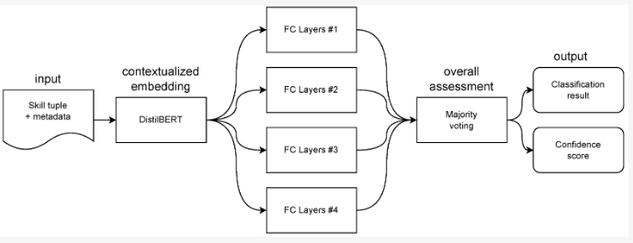

Figure 3 Deep Learning Ensemble DistilBERT (Weichselbraun, et al., 2024)

Comparing the performance of these models, DistilBERT and ensemble methods consistently outperformed others, achieving high accuracy in classifying skills. On the other hand, GPT-based heuristics showed lower performance which makes fine-tuning and domain-specific training data very important. Datasets also play a crucial role in training these models, with high-quality annotations by domain experts ensuring reliable classification. Distinguishing between randomly selected and rule-based datasets is essential, as it impacts model training and evaluation processes.

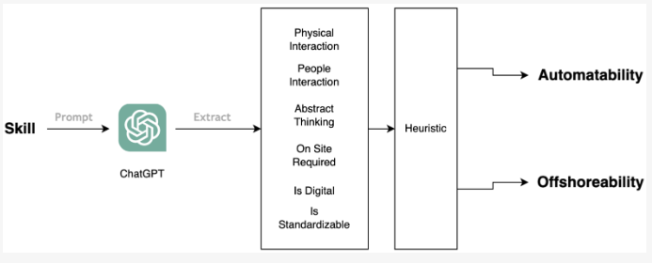

Figure 4 LLM on GPT API (Weichselbraun, et al., 2024)

In short, advancements in skill classification systems have revolutionized the ability to predict future skill demand. Fine-tuning machine learning models on domain-specific datasets is crucial for achieving high accuracy. Moving forward, integrating additional contextual knowledge, and exploring new methodologies will further enhance model performance and effectiveness.

### 2.3.2 Logpop + Two-step Classifier

In recent years, many researchers have developed systems to predict emerging skills in the job market. One study focused on understanding how well these systems perform and what factors influence their accuracy. The study found that certain models, particularly the Logpop + two-step classifier, consistently outperformed traditional methods, showing promise in identifying upcoming trends in job demand (Yazdanian, et al., 2022).

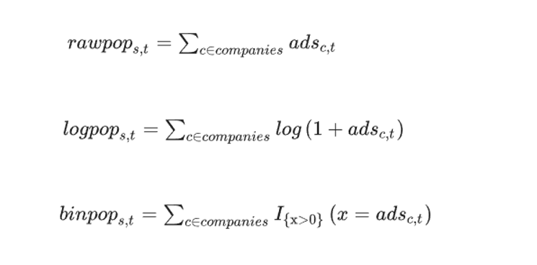

Figure 5 Formula for Popularity Types (Yazdanian, et al., 2022)

However, the study also revealed challenges. Predicting skills further into the future proved difficult, with models performing better at forecasting skills emerging in the near term compared to those emerging later. Additionally, the definition of emerging skills played a crucial role, with stricter definitions leading to better prediction accuracy. Skills with lower previous-year popularity were particularly challenging to predict accurately due to their rapid and unexpected growth. Key features within a skill's job advertisement time series were identified as strong indicators of its future emergence. Non-linear patterns and sudden growth indicators were found to be significant, along with variation-related features. Conversely, the presence of recurring data points was negatively associated with skill emergence, suggesting that uniform time series are less likely to represent emerging skills.

These findings have important implications for educational institutions. By leveraging predictive systems, institutions can better adapt their curriculum to meet evolving job market demands, particularly in the ICT domain. The ability to anticipate emerging skills can facilitate the development of targeted educational programs, enabling quicker adjustments to meet the needs of both current and future workers. As such systems become more widespread, they have the potential to enhance workforce readiness and promote economic adaptability.

### 2.3.3 Deep Learning CNN (LSTM)

The research explores the challenges and opportunities that rapid technological advancements present to the global workforce, emphasizing the need for effective strategies to bridge the skills gap. As the economy increasingly demands skilled labor, many workers face stagnant employment prospects due to their lack of preparedness for a digital economy. This study underscores the critical need for governments and markets to enhance the speed and effectiveness with which the supply of skills responds to changes in demand. One proposed solution is to improve the understanding of labor market intelligence through time series forecasts of skill demand data from online job advertisements (Garcia, et al., 2022).

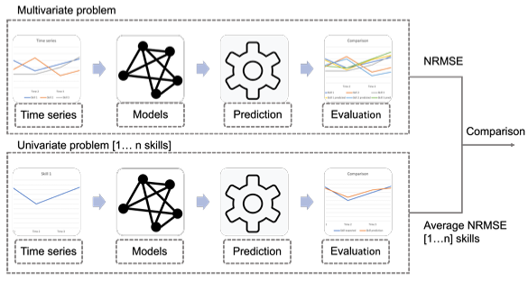

Figure 6 Scheme of Pipeline (Garcia, et al., 2022)

To address this, the researchers developed a pipeline that makes one-shot multi-step forecasts into the future using a decade of monthly skill demand observations. The core of the study involved comparing the effectiveness of multivariate models versus univariate models in predicting future skill demands. They utilized a set of recurrent neural network (RNN) methods to analyze the data, focusing on skills practiced by workers in the information technology industry.

The research methodology involved three state-of-the-art deep learning models: Long Short-Term Memory (LSTM) networks, Convolutional Neural Networks combined with LSTM (CNN+LSTM), and Gated Recurrent Units (GRU) (Fischer & Krauss, 2018). Each model was trained to predict skill shares, which are derived from the frequency of specific skill mentions in online job advertisements. The data, provided by Emsi Burning Glass, was preprocessed to ensure it was suitable for the models. This preprocessing included smoothing the data to remove noise, first-differencing to capture dynamic changes, and standardizing the time series data.

The LSTM model used in the study consisted of three layers, each with varying sizes and neurons, followed by a dense layer tailored to predict the number of months ahead for multiple skills (Hochreiter & Schmidhuber, 1997). The CNN+LSTM model integrated a one-dimensional CNN layer for attribute extraction, followed by three LSTM layers, and concluded with a dense layer. The GRU model, similar to the LSTM, comprised three layers with varying sizes and neurons, ending with a dense layer for prediction.

The similar system review highlighted the trade-offs between multi-step and univariate forecasting methods. Multivariate models were posited to better capture the correlations between skill demands, although they posed challenges in terms of computational complexity and convergence due to the relatively small dataset. The study aimed to demonstrate actionable predictions that could guide human capital investment decisions, emphasizing the need for adaptable and accurate forecasting tools to keep pace with technological advancements in the labor market.

### 2.3.4 Ensembled Regression + Classification Models

Recent research, especially in the IT field, has shed light on the mismatch between the skills taught in educational institutions and what employers are looking for. A study on the IT job market in Saudi Arabia found that while graduates often have strong abilities in areas like development, research, and analysis, they struggle with essential technical skills in things like image and video processing, Unix/Linux systems, and security applications (Al-Khalifa, 2017). These results are in line with my research, which seeks to predict future job requirements in technology to help students and schools better prepare graduates for the workforce.

Both studies point out the need for educational programs to better match what the job market needs. In terms of programming, the Saudi study noted that while Python, C#, and JavaScript are in high demand but not as widely used among graduates (Al-Dossari et al., 2020), which matches my findings on the demand for certain programming languages and tools. Both studies stress the importance of education that meets industry needs, which is a key goal of mine to forecast future job skills to avoid problems like underemployment and mismatched skills.

Moreover, the study looks into the value of IT certifications, highlighting that certifications like Cisco, ITIL, and PMP are sought after by employers but are held by a small percentage of graduates (Al-Khalifa, 2017; Al-Dossari et al., 2020). My research also aims to address the need for advanced skills by predicting trends that could guide students towards getting certifications and training to make them more competitive in the job market.

Furthermore, the study points out that while the graduates surveyed generally have good soft skills like teamwork, communication, and leadership, employers often see a gap between what students think they have and what employers actually need (Stevens & Norman, 2016). This mirrors my study's focus on predicting soft skill demands, especially in areas like teamwork, to bridge the gap between what students think they can do and what employers expect. Both studies highlight the need for better collaboration between schools and industries to ensure graduates are well-prepared for the changing job market.

In summary, this study shares similarities with mine in its aim to identify and address gaps in IT skills, including technical, soft, and certification-based abilities. The use of machine learning to predict future job skills adds to the relevance of this study to my own research, as both projects seek to provide insights for improving education and fostering better collaboration between schools and industries to get graduates ready for future job demands. By using data to forecast skills, my research hopes to contribute to the ongoing conversation on how to better align education with the expectations of the job market.

### 2.3.5 ARIMA Model

The COVID-19 pandemic has significantly reshaped the labor market, leading to an evolving demand for various job skills. Recent research highlights that skills such as data visualization, oral communication, proficiency in Excel, and the ability to work under pressure have become increasingly sought after. These skills are particularly pertinent in the context of the pandemic, which has accelerated the digital transformation across industries and heightened the need for adaptability in the workforce (Hoque & Islam, 2023).

A key aspect of understanding job skill demand is the implementation of predictive modeling techniques. The Autoregressive Integrated Moving Average (ARIMA) model has emerged as a robust tool for forecasting the demand for specific job skills. In this study, the ARIMA model was utilized to predict job skills in demand for entry-level, mid-level, and top-level positions over a six-month period. The model focused on critical skills such as sales and marketing, with results indicating a consistent upward trend in demand for these skills from August 2022 to January 2023. For top-level positions, essential skills identified include leadership, project management, business management, data analysis, SAS proficiency, and research capabilities (Carta, Medda, Pili, Recupero, & Saia, 2018).

Moreover, the study employs visual aids, such as word clouds, to effectively represent the most frequently demanded job skills across different employment levels. This visualization technique highlights the distinct skills required at various career stages, illustrating that while entry-level positions prioritize skills like sales and marketing, mid-level positions emphasize customer service and relationship management. In contrast, top-level roles require advanced skills in leadership and data analysis (Mauro & Greco, 2017).

The findings from this research underscore the importance of using advanced predictive modeling techniques, such as ARIMA, to quantify job skill demand effectively. By bridging the gap between employer expectations and graduate competencies, the study contributes to curriculum development aimed at aligning educational outcomes with industry needs. This alignment is particularly vital in the context of rapid technological advancements and shifts in job market dynamics driven by unforeseen events like the COVID-19 pandemic.

## 2.4 Technical Research

### 2.4.1 Hardware

**Device Specification**

The device used for this research along with the data analysis with machine learning models is ASUS TUF Gaming A15 FA506IU.

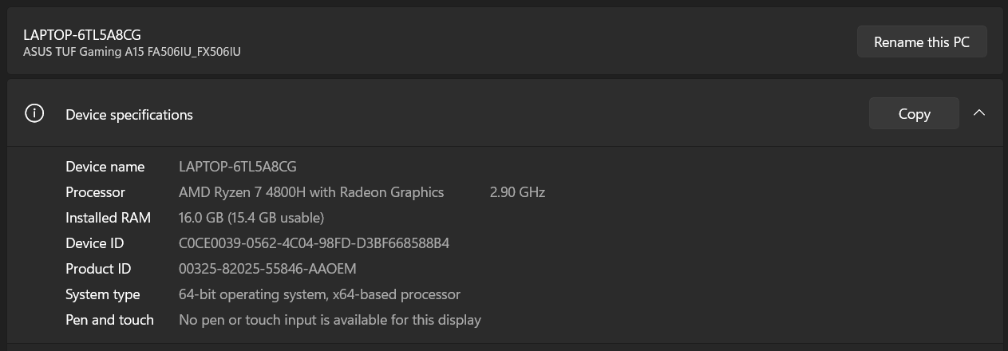

Figure 7 Device Specification Screenshot



Figure 8 Operating System Specifications Screenshot

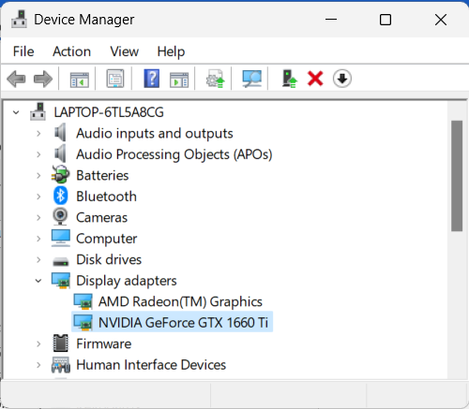

Figure 9 GPU Screenshot



Figure 10 Manufacturer of Device

The hardware specifications of the device, including the AMD Ryzen 7 4800H processor and 16 GB of RAM, they are well-suited for data analysis and running machine learning models. The AMD Ryzen 7 4800H is a high-performance processor with eight cores and sixteen threads, capable of handling multi-threaded workloads efficiently. With a base clock speed of 2.90 GHz, and boost clock speeds up to 4.20 GHz, it provides more than enough processing power for running complex algorithms and handling large datasets.

The 16 GB of installed RAM is sufficient and recommended for most data analysis and machine learning tasks. With this amount of memory, large datasets and run memory-intensive algorithms can be run without experiencing performance bottlenecks. Additionally, having a 64-bit operating system ensures that the device can fully utilize the available memory which allows efficient multitasking and seamless operation of resource-intensive applications.

The inclusion of the NVIDIA GeForce GTX 1660Ti graphics card further enhances the computational capabilities of the device. With 6 GB of dedicated VRAM, the GTX 1660Ti accelerates certain computations, particularly those involving deep learning algorithms and neural networks. GPU-accelerated libraries like TensorFlow and PyTorch can leverage the power of the GTX 1660Ti to accelerate computations, significantly reducing training times for complex models. The hardware specifications are complemented by the Windows 11 Home 64-bit processer operating system, it provides a robust platform for data analysis and machine learning tasks.

|  |  |  |
| --- | --- | --- |
| Components | Minimum Requirements (Bajaj, 2022) | Device Specification Used |
| CPU | Intel Core I5 5th Gen (equivalent or higher) | AMD Ryzen 7 4800H |
| RAM | 8GB | 16GB |
| GPU | NVIDIA GPU with 8 GB or 16 GB of RAM, NVIDIA GPU Driver 450.0 and cuDNN SDK | NVIDIA GeForce GTX 1660Ti  and built in AMD Radeon (TM) Graphics |
| OS | MS Windows 10 (x64 bit) | MS Windows 11 Home (x64 bit) |

Table 1 Hardware Specification Comparison

In terms of meeting minimum requirements for data analysis and machine learning, this device exceeds expectations (Bajaj, 2022). The AMD Ryzen 7 4800H processor and 16 GB of RAM meet or exceed the recommended specifications for running machine learning algorithms on just the CPU. Additionally, the presence of the NVIDIA GeForce GTX 1660Ti GPU provides additional computational power, enabling faster training times and smoother performance for GPU-accelerated tasks.

Overall, this device’s hardware specifications make it well-suited for data analysis and machine learning tasks. The combination of a powerful processor, ample memory, and dedicated graphics card that ensures all the necessary resources to tackle complex computational challenges effectively.

### 2.4.2 Software

**IDE Chosen**



Figure 11: Visual Studio Code Logo

IDE is called Integrated Development Environment which is a software that help to increase efficiency of coding for programmers or developers by providing features like developer tools, user-friendly interface, and many more capabilities (Leino, 2014).

As for this project, Visual Studio Code was chosen to be the IDE because it is an open-source, lightweight yet very powerful code editor created by Microsoft. VS Code is highly versatile and adaptable as it supports a wide range of programming languages and comes with a large ecosystem of extensions.

One of the key features of VS Code is its extensive marketplace that offers extensions for different languages, debuggers, and tools, which greatly enhances productivity. Other than that, the integrated terminal allows for running scripts, managing version control with Git, and executing other command-line tasks within the IDE (Sole, 2021).

Advanced code completion and IntelliSense features provide smart completions based on variable types, function definitions, and imported modules, which speeds up coding and reduces errors. Powerful debugging tools, including breakpoints, call stacks, and an interactive console, help in efficiently diagnosing and fixing issues in the code (Tan, Chen, & Jiao, 2023).

**Programming Language Chosen**



Figure 12: Python Logo

Python is selected as the primary programming language for data analysis and machine learning for this Final Year Project due to its simplicity, readability, and extensive library support. Python’s syntax is clear and concise, which makes it easy to learn and use for complex data analysis tasks, in addition to that, python is one of the most popular programming languages for data analysis for a long time.

There are many advantages of Python for data analysis, such as easy to learn and use, Python’s simple syntax reduces the learning curve, programmers can quickly adopt it and begins to code efficiently. Other than that, Python has a rich ecosystem of libraries specifically designed for data analysis and machine learning, its comprehensive libraries makes it a powerful tool for this project. Furthermore, due to its popularity, there are a large and active community of Python users, which means abundant resources, tutorials, and support forums are available, which is beneficial for troubleshooting and learning best practices (Terra, 2024).

**Essential Libraries for Data Analysis:**

Libraries are repositories of prewritten code that programmers can utilise to conserve time and effort in programming. Instead of having developers write every function, class, and module from scratch, they offer reusable solutions to common issues, enabling them up to concentrate on the distinctive aspects of their projects. Several functions, including as data manipulation, machine learning, visualisation, numerical computations, and more, are covered by libraries (Woke, 2023).

|  |  |  |
| --- | --- | --- |
| Index | Library | Introductions |
| 1 | Pandas | Purpose: Data manipulation and analysis.  Features: Can create data frames for tabular data, powerful tools for reading or writing data from various file formats, and robust data manipulation functions.  Example Use: Cleaning and transforming job postings data, filtering relevant columns, and performing exploratory data analysis (EDA). |
| 2 | Numpy | Purpose: Numerical computing.  Features: Support for multi-dimensional arrays, mathematical functions, random number generation.  Example Use: Performing numerical operations on large datasets, such as matrix multiplications and element-wise operations. |
| 3 | Scikit-Learn | Purpose: Machine learning.  Features: Tools for classification, regression, clustering, dimensionality reduction, and model selection.  Example Use: Implementing machine learning algorithms like Random Forest and XGBoost for predicting future skill demand. |
| 4 | Matplotlib and Seaborn | Purpose: Data visualization.  Features (Matplotlib): Creating static, animated, and interactive visualizations.  Features (Seaborn): High-level interface for drawing attractive statistical graphics.  Example Use: Visualizing trends and patterns in skill demand over time, creating plots for data analysis reports. |
| 5 | TensorFlow and Keras | Purpose: Deep learning.  Features: High-level APIs for building and training neural networks, support for GPU acceleration.  Example Use: Developing LSTM models for time series forecasting to predict future trends in job skills. |

Table 2 Python Libraries

# CHAPTER 3: METHODOLOGY

## 3.1 Introduction

This chapter outlines the method used for creating and applying the predictive model for forecasting future demand for skills. It provides a thorough explanation of the entire strategy, methods, and steps taken to meet the project goals. The section explains the selected approach, including the reasons for its choice and the different phases in the system's creation. It also discusses the research framework, which includes the necessary tools, technologies, and resources for the project's successful completion. In this section, the emphasis is on detailing the systematic processes that led to the project's creation, starting with identifying the business issue to the deployment of the model. Each stage of the approach is detailed to give an understanding of how the data was gathered, preprocessed, analyzed, and modeled to generate precise predictions of future skill demand. The rationale for choosing the specific approach is discussed, along with the necessary hardware and software elements used during the development. This section aims to demonstrate the organized method used to ensure the predictive model's reliability, validity, and ability to scale in solving the problem at hand.

## 3.2 Methodology

### 3.2.1 Comparison of Methodologies

In the context of developing a predictive model for future in-demand skills, selecting the appropriate system development methodology is very critical. Agile methodologies, known for their flexibility and iterative approach, are particularly suited for this type of project. However, Agile is not a singular framework but an umbrella term that includes different methodologies (Laoyan, 2024). This section compares several Agile methodologies, such as Scrum, Kanban, Lean, Extreme Programming (XP), and Adaptive Project Framework (APF), to determine the most suitable approach for the project. Additionally, the CRISP-DM methodology, while not an Agile framework, is included for comparison due to its relevance in data mining and predictive modeling projects.

**Comparison Table**

|  |  |  |  |  |
| --- | --- | --- | --- | --- |
| Methodology | Key Characteristics | Pros | Cons |  |
| Scrum | Iterative, sprints, regular feedback | Highly adaptable, frequent reassessment, continuous improvement | Requires high team commitment, may be challenging for beginners (Srivastava, Sukriti, & Saraswat, 2017) |  |
| Kanban | Visualizes progress, steady task output | Easy tracking, flexible, adapts to changing priorities | May lack structure for complex projects (Wakode, Raut, & Talmale, 2015) |  |
| Lean | Focuses on eliminating waste, improving efficiency | Streamlined processes, customer-focused | Too rigid for experimental and iterative projects (Pernstål, Feldt, & Gorschek, 2013) |  |
| Extreme Programming (XP) | Continuous testing and integration, customer satisfaction | High software quality, responsive to changes | Demanding, requires discipline and experience (Shrivastava, Jaggi, Katoch, Gupta, & Gupta, 2021) |  |
| Adaptive Project Framework (APF) | Iterative cycles, adapts to evolving client needs | Highly flexible, handles unclear project details well | Less structured, requires constant stakeholder communication (Herath & Perera, 2023) |  |
| Cross-Industry Standard Process for Data Mining (CRISP-DM) | Structured, six phases: business understanding, data understanding, data preparation, modeling, evaluation, deployment | Specific to data mining, clear stages, comprehensive documentation | Less flexible for iterative changes, can be time-consuming (Hotz, 2024) |  |

Table 3 System Development Methodology Comparison Table

### 3.1.2 Justifications

Each Agile methodology offers unique strengths and weaknesses, making them suitable for different project requirements. This comparison aims to highlight why one might be more appropriate than another for a project focused on predictive modeling for future in-demand skills.

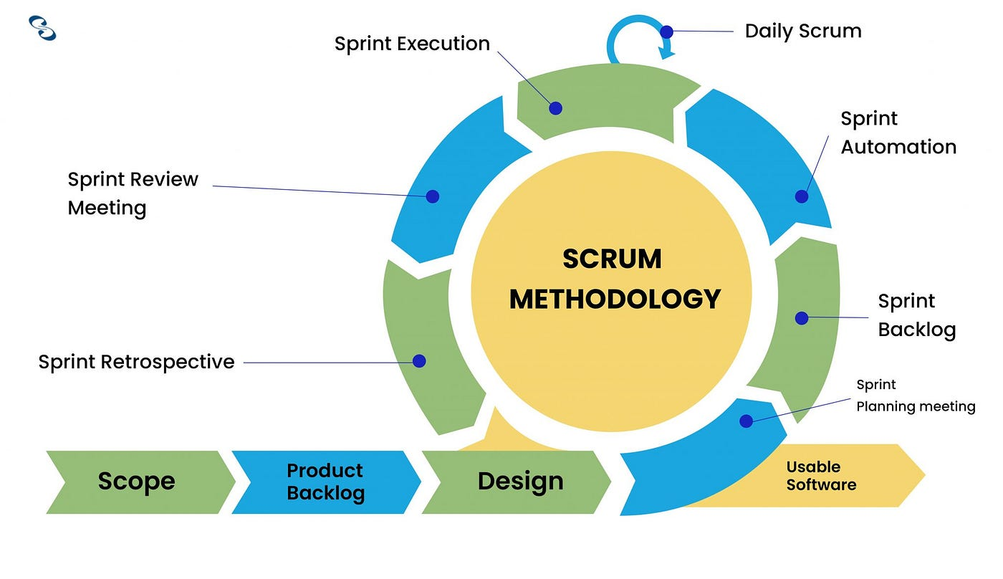

Figure 13 SCRUM Methodology Processes (Korkut, 2023)

Scrum stands out due to its iterative development cycles and regular feedback loops, which are essential for projects with rapidly changing requirements. The structure of short sprints enables frequent reassessment and realignment with project goals, ensuring that the project stays on track. However, Scrum demands a high level of team commitment and strict adherence to its practices, which can be challenging for teams new to this methodology (Schwaber & Sutherland, 2020).

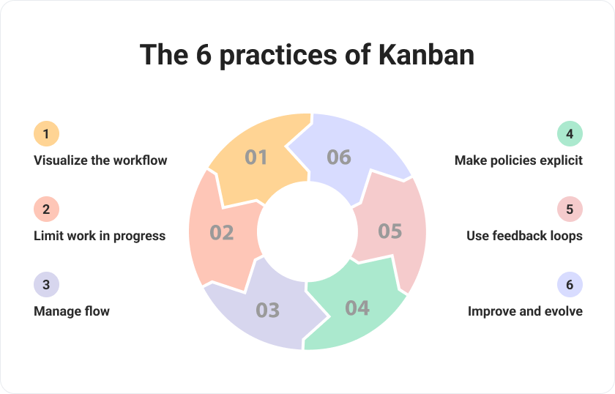

Figure 14 Kanban Practices (Udodov, 2023)

Kanban excels in visualizing progress and maintaining a steady workflow. Its flexibility allows teams to adapt to changing priorities without the need for fixed iterations. This can be advantageous for managing ongoing tasks and responding to immediate needs. Nonetheless, Kanban might lack the structured approach required for more complex projects, potentially making it less suitable for sophisticated data analysis endeavors that benefit from defined stages and milestones.

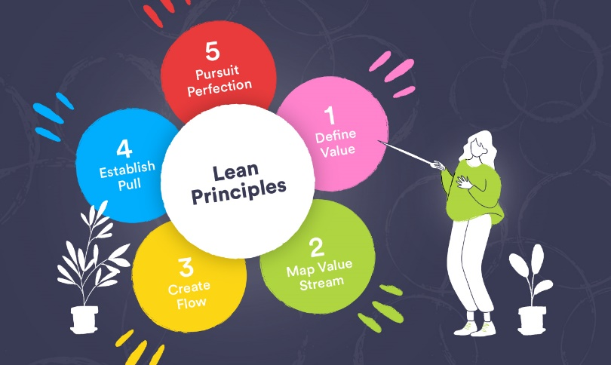

Figure 15 Lean Principles (Lavender, 2022)

Lean methodology focuses on maximizing efficiency and eliminating waste, which streamlines processes and enhances customer value. While this approach is beneficial for operational efficiency, it may be too rigid for projects that necessitate significant experimentation and iterative development, such as those involving predictive models where continuous learning and adjustment are key.

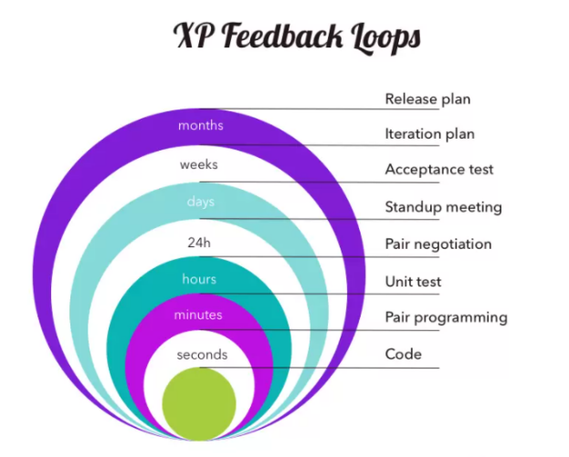

Figure 16 Extreme Programming XP Feedback Loops (Editor, 2021)

Extreme Programming (XP) emphasizes continuous testing, integration, and close customer collaboration, ensuring high software quality and responsiveness to changes. This makes XP ideal for projects where software reliability and quick adaptability are paramount. However, XP's practices are demanding and require significant discipline and experience from the team, which can be a barrier for those unfamiliar with its rigorous standards.

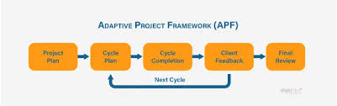

Figure 17 Adaptive Project Framework (APF) Cycle (Imran, 2023)

Adaptive Project Framework (APF) offers a high degree of flexibility, making it suitable for projects with unclear details and evolving requirements. Its iterative cycles allow for constant adaptation to client needs, which is beneficial for projects where the end goals are not fully defined from the outset. However, the lack of a structured framework can make APF less organized compared to methodologies like Scrum, requiring continuous stakeholder communication to ensure alignment and progress.

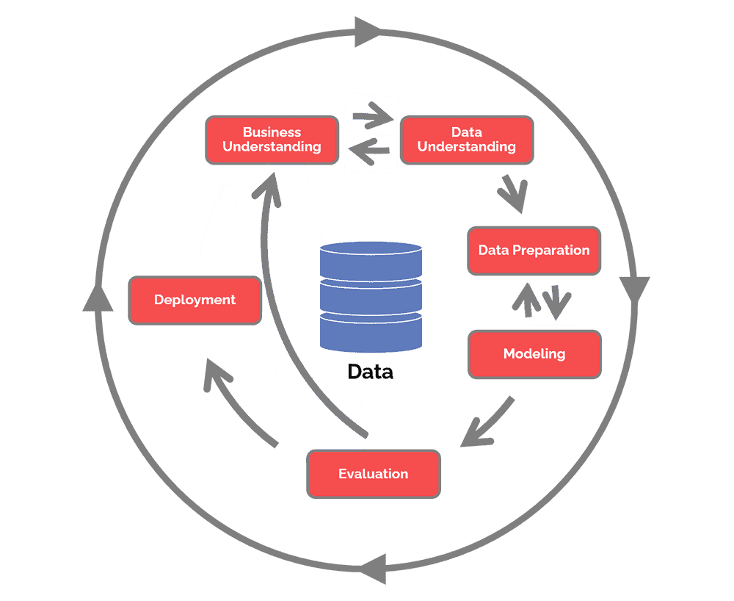

Figure 18 CRISP-DM Process Flow (Hotz, 2024)

CRISP-DM (Cross-Industry Standard Process for Data Mining) is particularly relevant for data mining and predictive modeling projects. It involves a structured, six-phase process: business understanding, data understanding, data preparation, modeling, evaluation, and deployment. This methodology is beneficial due to its comprehensive documentation and clear stages, providing a systematic approach to data analysis. However, CRISP-DM can be less flexible for iterative changes and may be time-consuming, making it less suitable for projects requiring rapid development and frequent adjustments.

### 3.1.3 Chosen Methodology

Selecting the appropriate system development methodology is a critical step in the success of any project, particularly for my Final Year Project, which focuses on developing a predictive model for future in-demand skills. Given the nature of the project, which involves extensive data analysis and modeling, the CRISP-DM (Cross-Industry Standard Process for Data Mining) methodology has been chosen. CRISP-DM is widely recognized for its structured approach to data mining and predictive modeling, making it an ideal framework for projects that require a thorough and systematic analysis of data to extract meaningful insights.

The choice of CRISP-DM as the methodology for this project is based on its comprehensive and iterative nature, which aligns well with the project's objectives. CRISP-DM is designed specifically for data mining projects and consists of six well-defined phases: Business Understanding, Data Understanding, Data Preparation, Modeling, Evaluation, and Deployment. This methodology provides a clear roadmap for managing data-driven projects, ensuring that each phase is meticulously planned and executed. Unlike Agile methodologies, which are more flexible and iterative, CRISP-DM offers a more structured approach, which is beneficial for the systematic exploration and validation required in predictive modeling. Additionally, its iterative cycles allow for continuous refinement and improvement, which is crucial for achieving high accuracy in predictive analytics.

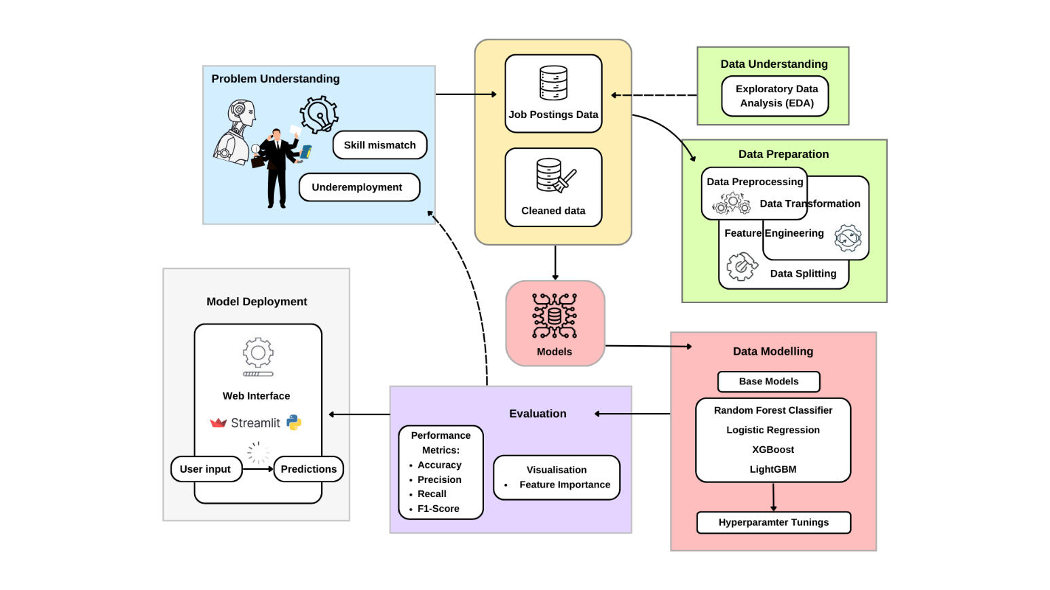

Figure 19 CRISP-DM Flowchart with Description of Each Phases

The flowchart above illustrates the CRISP-DM (Cross-Industry Standard Process for Data Mining) methodology for this FYP, which consists of six interconnected phases, Business Understanding, Data Understanding, Data Preparation, Data Modeling, Evaluation, and Deployment. Each phase is designed to build upon the previous one, ensuring a systematic and thorough approach to developing a predictive model. This structured methodology is particularly effective for projects involving extensive data analysis, such as predicting future in-demand skills, as it allows for iterative refinement and continuous improvement based on feedback and evaluation.

In the Business Understanding phase, the primary objective is to define the problem within the labor market, enhance understanding of potential solutions, and set clear goals for the desired outcomes. This phase lays the foundation for the entire project by ensuring that the objectives are aligned with business needs. The Data Understanding phase involves gathering relevant data, such as job postings and skill requirements, and performing Exploratory Data Analysis (EDA) to identify patterns or data quality issues. Following this, the Data Preparation phase focuses on preprocessing the data by handling missing values, selecting relevant features, and transforming categorical values into numerical ones to facilitate modeling. The Data Modeling phase involves testing different machine learning algorithms, such as random forests and neural networks, and tuning hyperparameters to optimize performance. The Evaluation phase is critical for validating the models using cross-validation techniques and measuring their accuracy, precision, F1-score, and recall ensuring they meet the project goals. Finally, the Deployment phase involves implementing the predictive model in a user-friendly interface and setting up monitoring systems to track its performance in real-world applications. This structured approach ensures that each phase contributes to the overall success of the project, from initial understanding to final deployment.

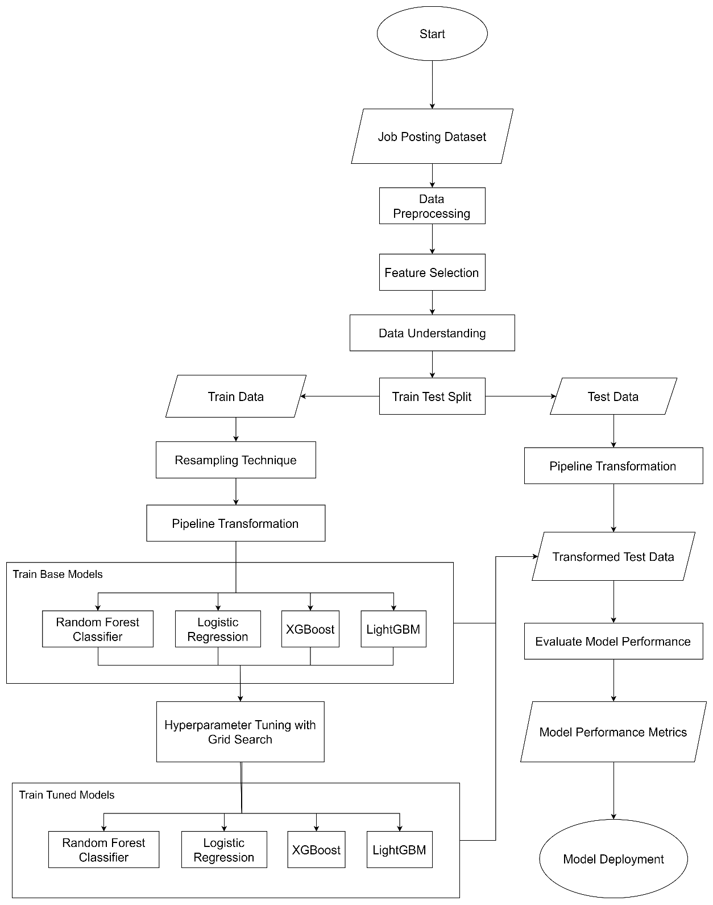

Figure 20: Data Analytics Project Flowchart

This project flowchart outlines the process of building a machine learning model for predicting job-related skills from a job posting dataset, aligning closely with the CRISP-DM methodology. It starts with Business Understanding by defining the objective of predicting required skills for job postings. Data Understanding is addressed by exploring and preprocessing the job posting dataset, followed by Data Preparation, where resampling and feature selection are applied to refine the data. The workflow then proceeds to the Modeling phase, training multiple base models like Random Forest, Logistic Regression, XGBoost, and LightGBM, and performing hyperparameter tuning to optimize these models. Evaluation is achieved by assessing the models using performance metrics on transformed test data. Finally, the flow concludes with Deployment, where the best-performing model is deployed for practical use. This structured approach ensures a comprehensive analysis, covering all key steps of the CRISP-DM framework.

## 3.3 Summary

This section outlines the process used to create a model for predicting future demand for skills, utilizing the CRISP-DM framework. It starts by describing the organized method of the CRISP-DM framework, which encompasses steps like Business Understanding, Data Understanding, Data Preparation, Modeling, Evaluation, and Deployment. It also compares different Agile methodologies, including Scrum, Kanban, Lean, XP, and APF, to explain why CRISP-DM was selected for this project due to its comprehensive and systematic approach to analyzing data and creating predictive models. The section breaks down each step of the CRISP-DM framework within the scope of this project, focusing on the procedures for data cleaning, creating models, adjusting model parameters, and launching the predictive model. The section wraps up by highlighting the significance of this organized approach in ensuring precise and dependable forecasts for future in-demand skills.

# CHAPTER 4: DESIGN AND IMPLEMENTATION

## 4.1 Introduction

This chapter describes the creation and execution steps for the forecasting model designed to predict future needs for specific skills. It starts by giving a summary of how the data was gathered, including the information collected and its origin, laying the groundwork for the analysis. The section then moves on to the process of preparing the data, which involves important steps like dealing with missing information, identifying and handling outliers, and applying transformations, standardizations, and normalizations. After the data preparation, the section delves into understanding the data, which involves examining the variables in the dataset, the observations made, and visualizing the data using histograms and other techniques to extract insights. The concluding part of the section is dedicated to creating the model, where different methods are tried out and assessed to create an efficient forecasting model. This section offers a detailed explanation of how each step contributes to the creation of a strong forecasting model.

## 4.2 Data Collection

For this project, the dataset was sourced from Kaggle, a renowned platform for data science and machine learning datasets. The dataset titled "Job Dataset" is a comprehensive collection of synthetic job postings, meticulously curated to facilitate research and analysis in the domains of job market trends, natural language processing (NLP), and machine learning. This dataset, created for educational and research purposes, includes a diverse array of job listings across various industries and job types, providing a rich resource for conducting detailed analyses and building predictive models (Rana., 2023).

Link: <https://www.kaggle.com/datasets/ravindrasinghrana/job-description-dataset>

The dataset comprises multiple columns, each offering specific details about the job postings. Here is a brief overview of the key columns in the dataset:

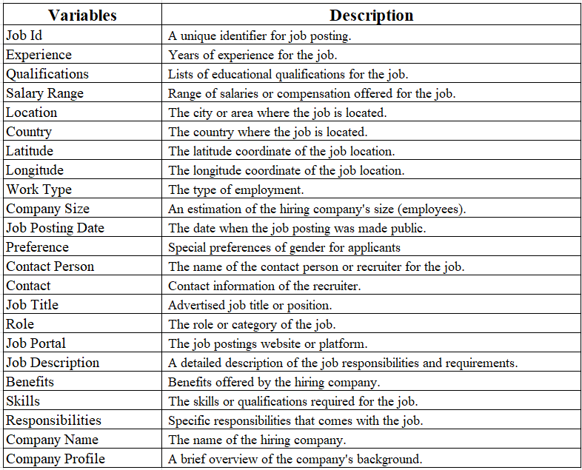

The dataset is contained in a file named job_descriptions.csv, with a size of approximately 1.74 GB. The dataset includes comprehensive details about job roles, responsibilities, required skills, and qualifications that mirror the real-world complexity and demands of the job market in the tech industry. This aligns well with the research aim to explore and forecast in-demand skills, especially in data science within computer science.

The dataset's generation was greatly supported by the Python Faker library, which was instrumental in creating realistic synthetic data. Additionally, guidance from ChatGPT helped fine-tune the dataset, ensuring its quality and adherence to ethical standards. This dataset is intended for research, educational, and analytical purposes. It can be used to develop and evaluate machine learning models, natural language processing algorithms, and other data-related projects in the field of job market analysis. The Job Dataset is released under an open data license, which permits free and open use for research and analysis, while strictly prohibiting any real-world applications, such as recruitment or job searching.

## 4.3 Data Pre-processing

### 4.3.1 Import Libraries and Data Loading

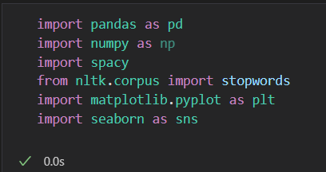

Figure 21 Data Preprocessing – Imports

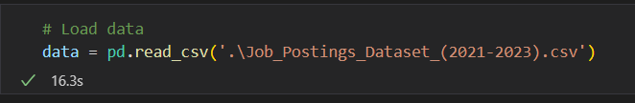

Figure 22 Read CSV

First, the necessary libraries are imported. These include pandas for data manipulation, spacy for word lemmatization, NumPy for numerical operations, Matplotlib and Seaborn for visualization, and scikit-learn for model preparation. Load the 1.7GB dataset from a CSV file into a Pandas DataFrame.

### 4.3.2 Initial Data Exploration

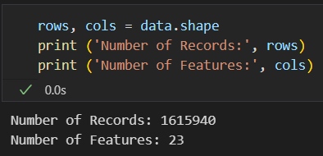

Figure 23: Shape of dataset

There are 1.6 millions of records and 23 columns or features in this dataframe.

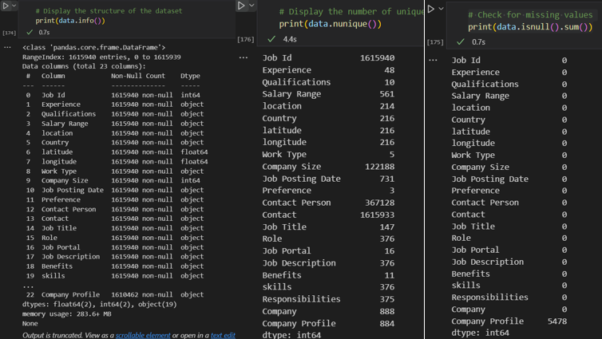

Figure 24 EDA, Data Info, Unique Data, Missing Data

Next, these codes provides a summary of the dataset, including its structure, data types, and the presence of any missing values. This initial exploration is vital for understanding the dataset and identifying potential issues that need addressing. Checking for missing values and the number of unique values in each column helps in understanding the data's completeness and variability. Identifying unique job titles gives an overview of the variety of positions in the dataset.

### 4.3.3 Filtering ‘Job Title’ into Tech Related Industry

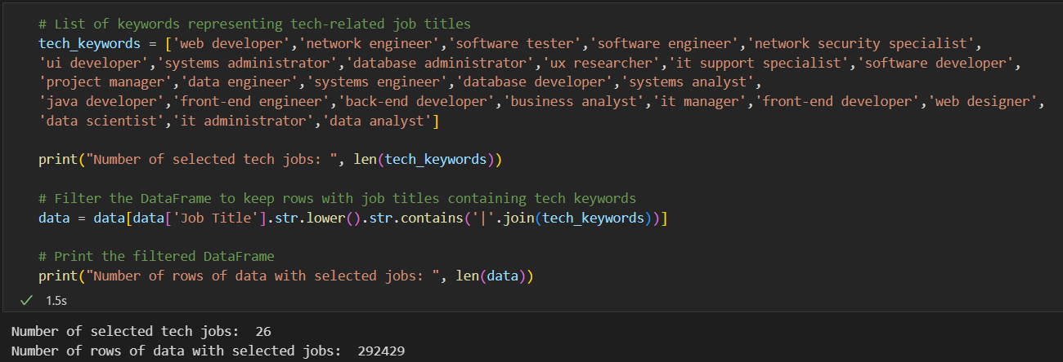

Figure 25 Filter Job Titles

The dataset is filtered to include only rows with job titles related to technology. This is achieved by defining a list of keywords representing various tech job titles and using these keywords to filter the dataset. This step ensures that the analysis focuses on relevant data, making the subsequent insights more meaningful and actionable.

### 4.3.4 Preprocess ‘Job Posting Date’

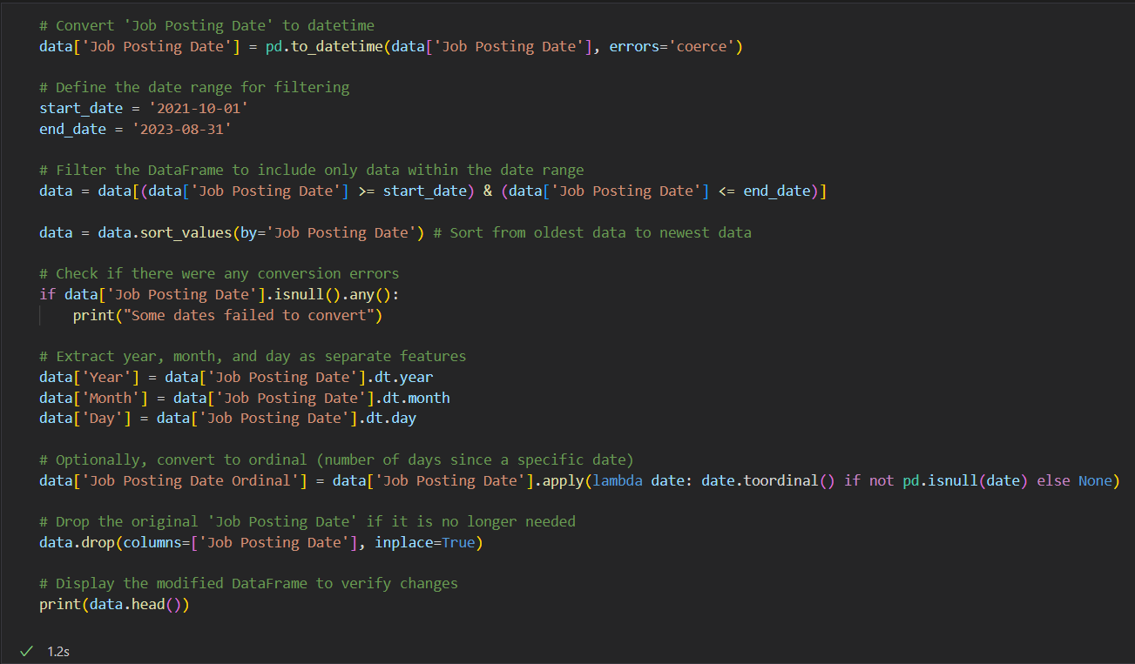

Figure 26: Preprocessing ‘Job Posting Date’ and create other temporal features – coding



Figure 27: Output of ‘Job Posting Date’ preprocessing

This code performs data preprocessing on the "Job Posting Date" column, converting it to a datetime format and filtering it within a specified range from October 1, 2021, to August 31, 2023. The reason for converting to a datetime format is to facilitate efficient date-based filtering, sorting, and feature extraction. Dates that fail to convert are handled using errors='coerce', which replaces invalid entries with NaT, and a conditional check is included to inform if any conversion issues occurred. After filtering the data within the specified range, the dataset is sorted chronologically, ensuring that the oldest records come first. Additionally, the year, month, and day components of the job posting date are extracted into separate features, which can be useful for analysis or modeling that benefits from identifying seasonal or temporal patterns. The date is also converted to an ordinal representation, which reflects the number of days since a fixed point in time, providing a continuous numerical format for models requiring such inputs. Lastly, the original "Job Posting Date" column is dropped, as its information has been captured in the newly derived features.

### 4.3.5 Preprocess ‘skills’ Column

The ‘skill’ feature is the most important feature of the project because it will become the target variable of the project, therefore, proper pre-processing steps must be taken to ensure the data is usable for model training. The ‘skills’ column is a string of values which stores multiple skills, in some rows, it also store the examples of the skills. For example, frontend programming skills (HTML, CSS, JavaScript), for some rows, the skills are separated by comma, some with white spaces.

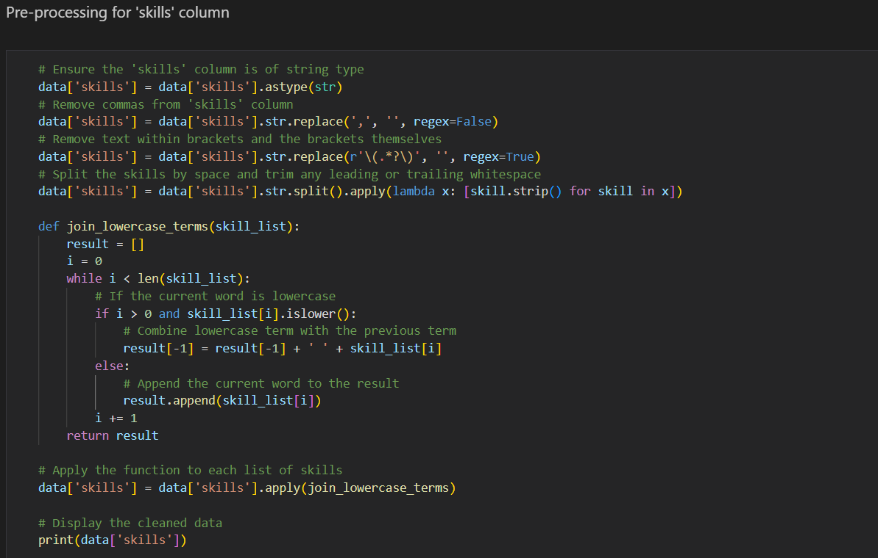

Figure 28: Preprocessing ‘skills’ column step 1

In step one, based on the observations of the sample ‘skills’ data, I have found the pattern and solution to clean the data. First, it ensures that the ‘skills’ column is of string type and removes any commas. Next, it eliminates any text within brackets, along with the parentheses themselves using regular expressions as shown. The code then splits the skill strings by blank space and trims any leading or trailing whitespace. A custom function join_lowercase_terms, is applied to the lists of skills to combine consecutive lowercase terms with the previous skill, effectively creating more meaningful skill phrases (e.g., turning "data analysis" into "data analysis" instead of “data” and “analysis”). Finally, the cleaned skill lists are printed for verification.

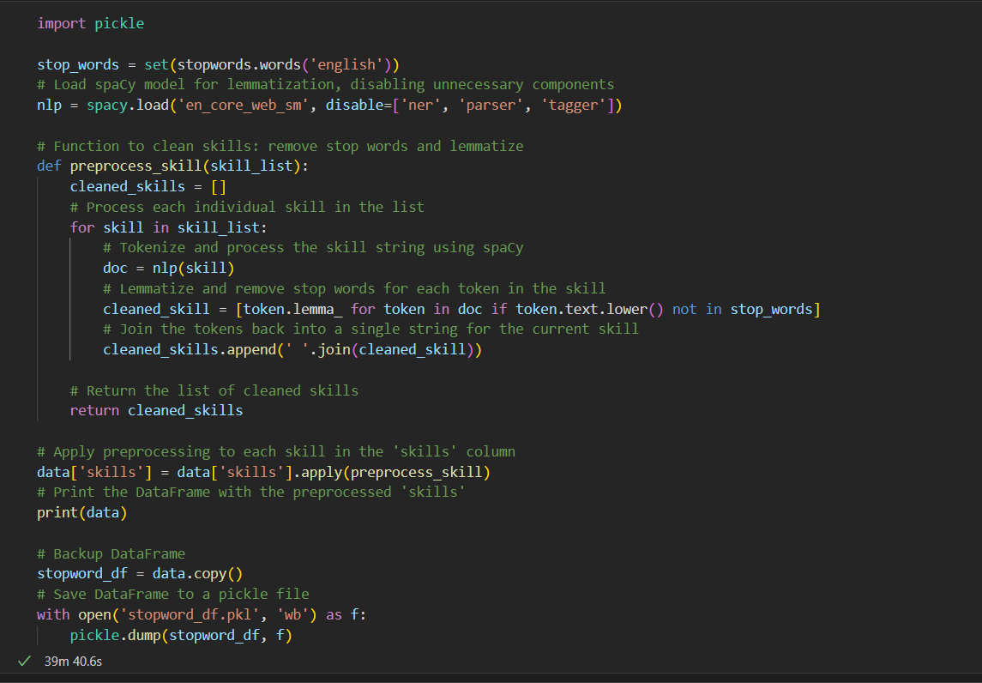

Figure 29: Preprocessing ‘skills’ column step 2

In step two of preprocessing ‘skills’ column, it imports the necessary libraries and sets up a list of stop words from the NLTK library to filter out common English words that typically do not contribute meaningful information to the analysis. Then it loads a spaCy model with only the essential components enabled to optimize performance. It defines a function `preprocess_skill` that takes a list of skills, tokenizes each skill using spaCy, and filters out the stop words while also applying lemmatization to each token to convert words to their base or dictionary form. This cleaned list of skills is then reassembled into a single string per skill and updated in the original DataFrame. Additionally, using pickle dump to make a copy of the DataFrame to serve as a backup. Reason .pkl file chosen over .csv is because it can capture text data especially ‘skills’ in list more accurate. Since the running time is a bit long, about 40 minutes, its good to save the df to save time.

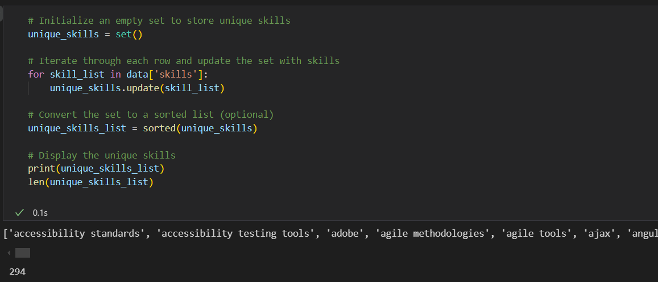

Figure 30: Unique skills before mapping

As shown in the code snippet’s output, there are 294 unique skills in the ‘skills’ column, which will then be our target for our multioutput classification model, and its way too many classes.

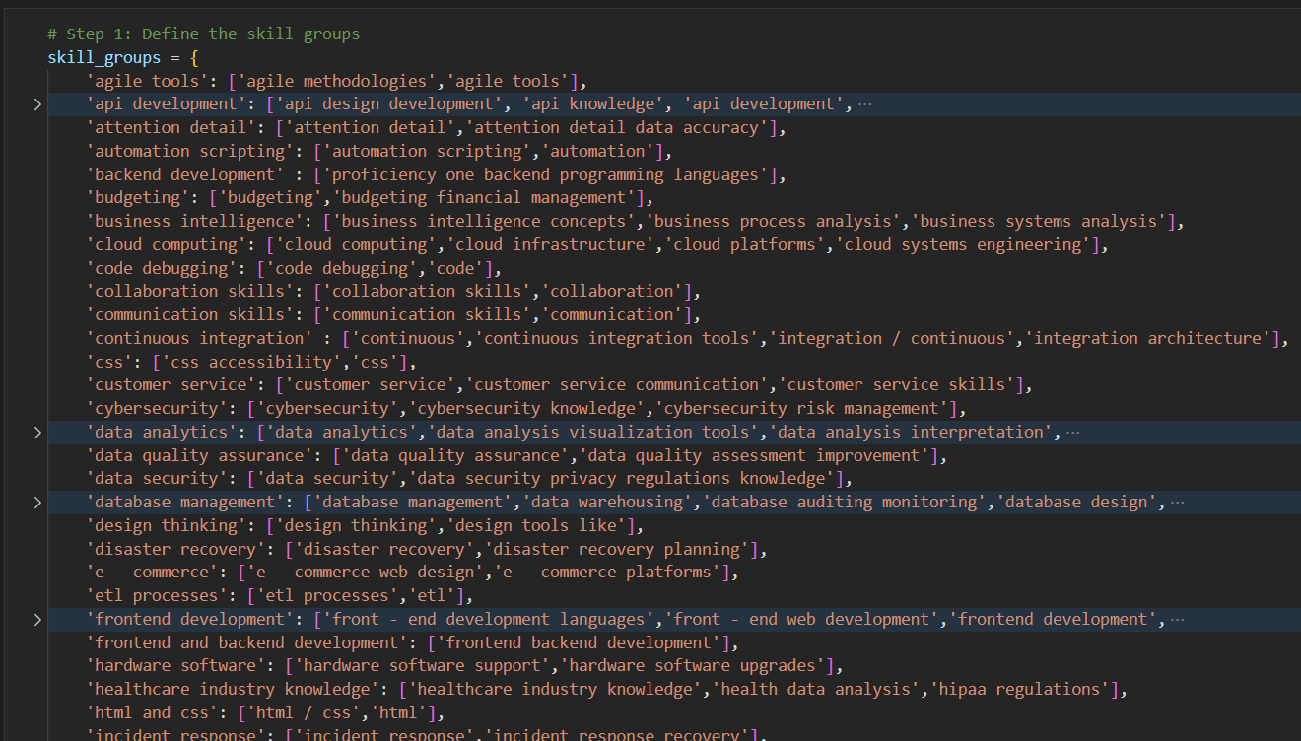

Figure 31: Skill Mapping 1

Hence, a manual skill group is done the first time, by grouping related skills together, but the first time is just very subtle changes. For example, grouping “css accessibility” and “css” together as “css”. Just group those with similar key words, and are describe differently but are the same skills.

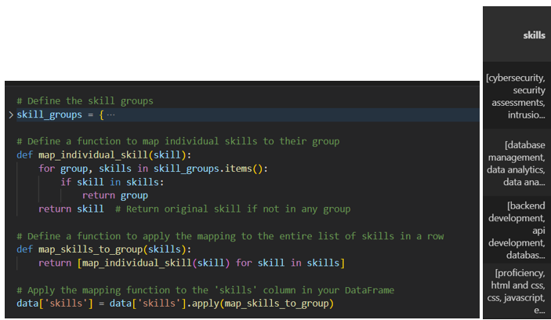

Figure 32: Skill mapping 1 – Code and Output

This two function follows the manual grouping map and map the skills accordingly, the right screenshot showed the output after grouping.

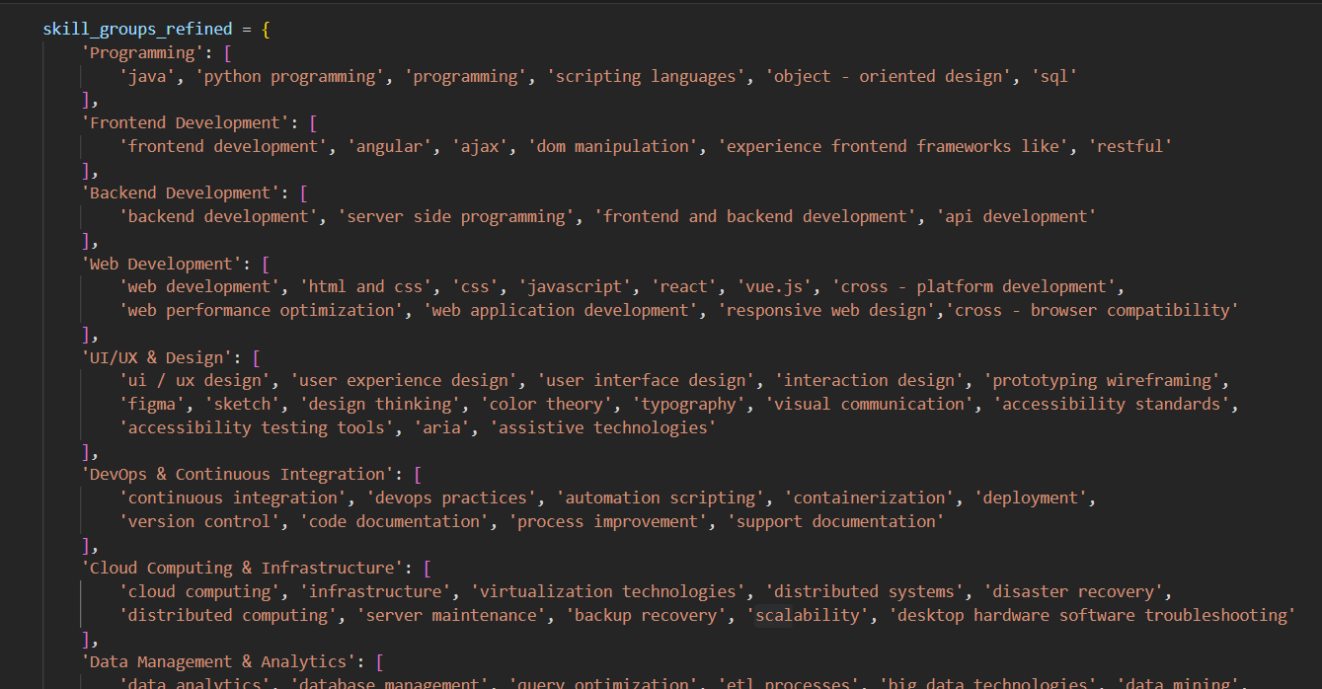

Figure 33: Skill mapping 2 : Further reduce classes

Since, there are still a lot of unique skills after the first grouping, the researcher decided to take a leap to group the skills even further. This process aims to simply the analysis by reducing the complexity of ‘skills’ and only extract more predefined categories. While taking note that this might include biasness and definition difference, therefore, the researcher grouped the skills referencing an external source from O*Net organization this organization offers a comprehensive database of occupational information, including job titles and associated skills (O*NET 29.0 database at O*NET Resource Center, n.d.). Referencing such a framework ensures that the categorization is aligned with recognized standards and can be defended as objective and reliable in academic or professional settings. The final grouping resulted in total 23 unique skills that are tech related only.

Link to download O*Net database files: <https://www.onetcenter.org/database.html#all-files>

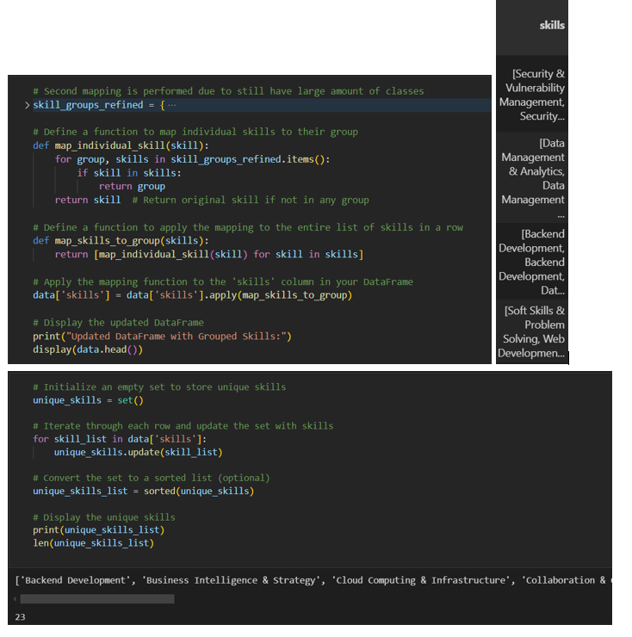

Figure 34: Skill mapping 2: Code and Output

A dictionary (skill_groups_refined) is created where each key represents a broad skill category like "Programming", "Web Development", and each value is a list of specific skills associated with that category. This categorization helps in grouping similar skills under a unified group which simplifies analysis and visualizations. (map_individual_skill) function checks if a skill matches any of the skills listed under the predefined categories. If match, it returns the category name, otherwise, it returns the skill as it is. After mapping, prints a list of unique skill categories to check the effectiveness of the mapping.

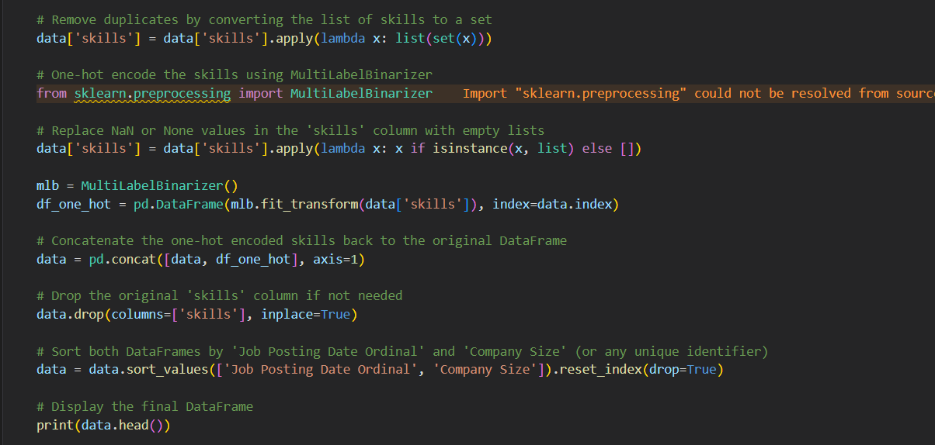

Figure 35: One-hot encoding ‘skills’ list



Figure 36: One-hot encoded skills columns output

This section to clean and prepare skills data for machine learning by removing duplicates, handling missing values, and applying one-hot encoding. By converting the 'skills' list for each record into a set, it ensures that all skills are unique, then replaces any missing values with empty lists to accommodate the encoding process. The `MultiLabelBinarizer` is used to transform each skill into a separate binary column, which indicates the presence or absence of the skill, because machine learning models works best with binary features. After encoding, the original 'skills' column is dropped, and the data is sorted by relevant identifiers to organize it for further analysis. This preprocessing not only cleans the data but also converts it into a format that is suitable for advanced analytical tasks, thereby increasing the accuracy and efficiency of the following data modeling processes.

### 4.3.6 Data Normalization and Standardization

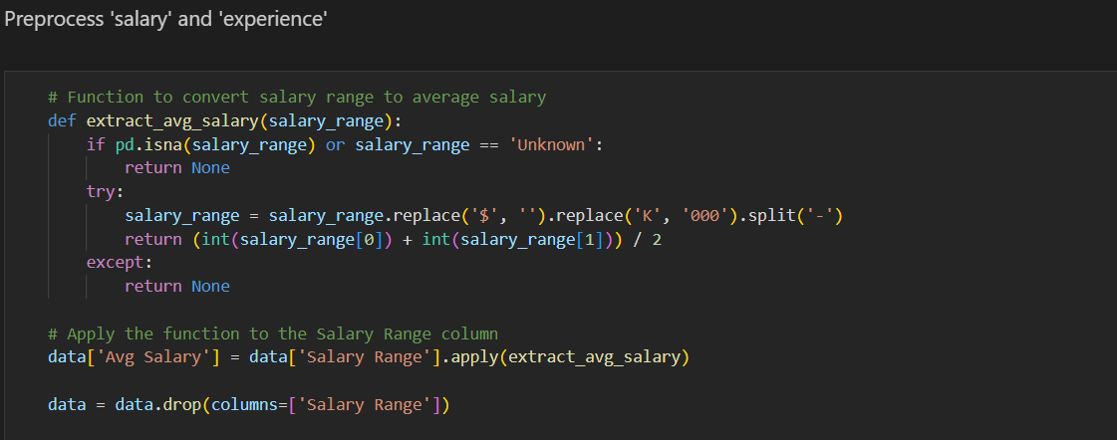

Figure 37: Preprocessing ‘salary’ code

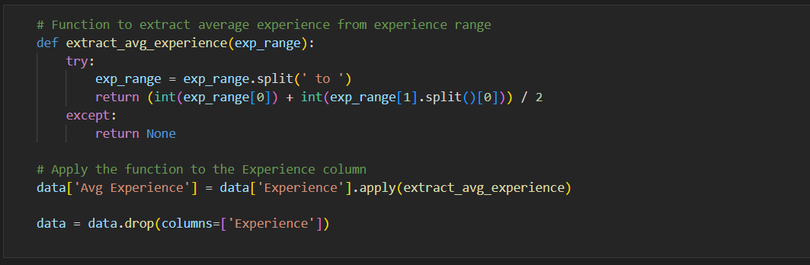

Figure 38: Preprocessing ‘experience’ code

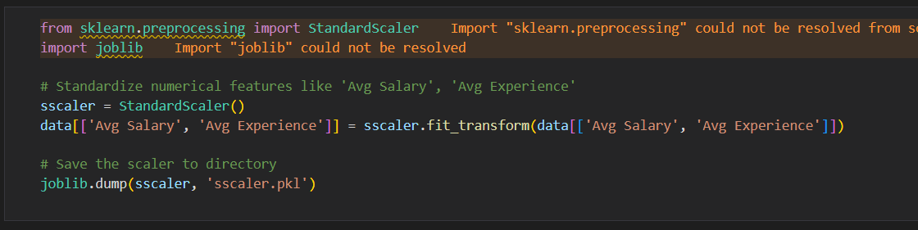

Figure 39: Apply StandardScaler

The three figures above utilize transformation functions to clean and standardize ‘salary’ and ‘experience’ column. At first, both of the feature in the dataset are stored as string value where it represent a range. The ‘extract_avg_salary’ function converts a salary range into a single average value by removing currency symbols and other characters. Similarly, the ‘extract_avg_experience’ function also calculates the average number of years of experience from a given range. Once these transformations are applied to their respective columns, the original columns ('Salary Range' and 'Experience') are dropped to streamline the dataset. But that is not enough, because machine learning models work well on standardize and normalize data more, therefore, the code employs the ‘StandardScaler’ from scikit-learn to standardize the newly calculated average salary and experience data, ensuring that these numerical features have a mean of zero and a standard deviation of one, which is a common requirement for many machines learning models.

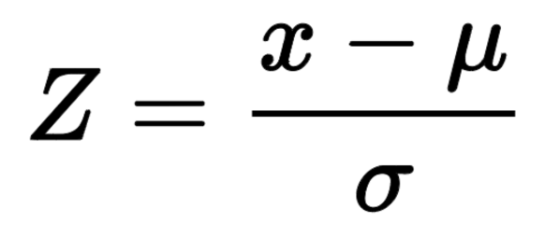

Finally, the scaler is saved to a file using ‘joblib’, for the purpose of reusing the same scaler for the input data in model deployment phase, its very crucial.

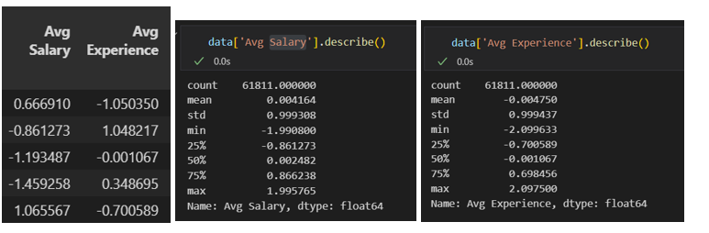

Figure 40: Output and Description after scaler

From the output can confirm that the two feature has been correctly standardize as the values are around 0.

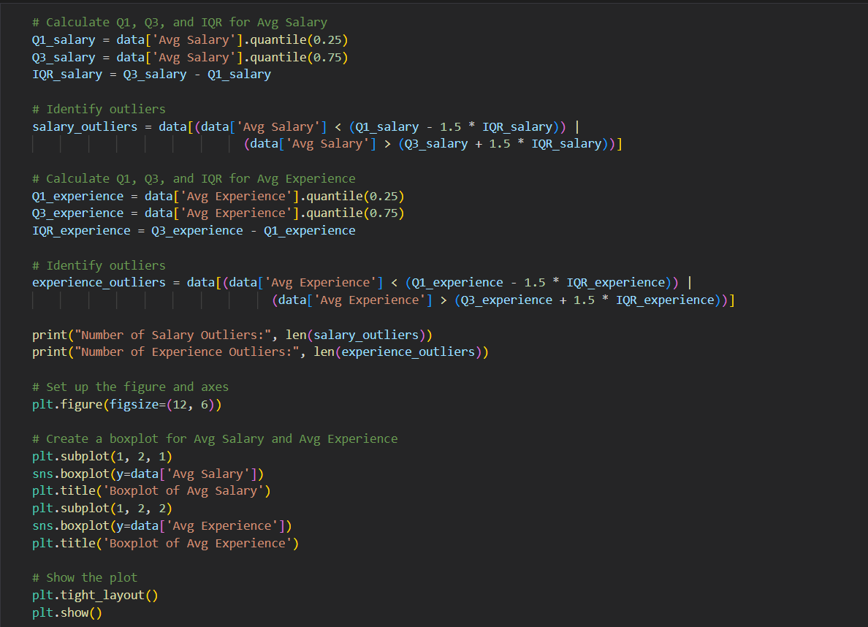

Figure 41: Check outliers for ‘Avg Salary’ and ‘Avg Experience’ code

This code segment focuses on identifying and visualizing outliers in average salary and average experience data. It calculates the first quartile, third quartile, and the interquartile range for both features. These stats are the thresholds for identifying outliers. Any average salary or experience value that falls below the lower quartile or above upper quartile is considered an outlier. The script then counts and prints the number of outliers found in both categories.

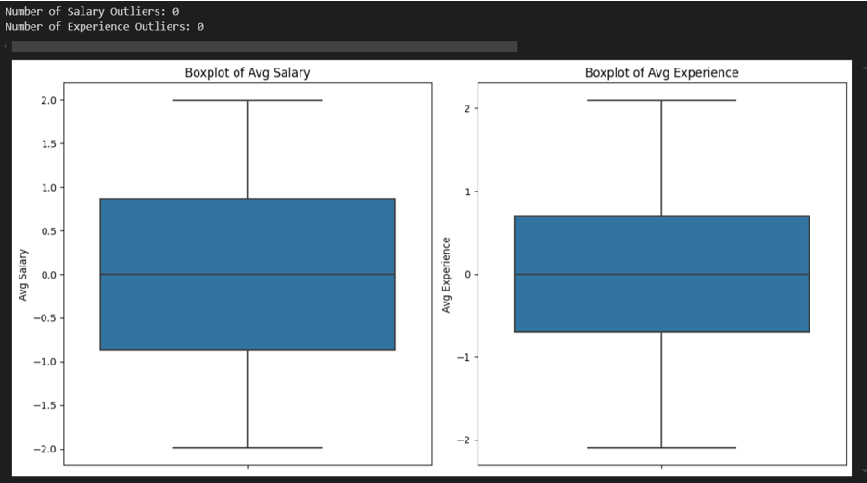

Figure 42: Output of outliers

To visually represent this data, it uses Seaborn to create boxplots for average salary and average experience, which help illustrate the distribution of values and highlight any outliers. The boxplots are displayed side by side for easy comparison.

**Company Size**

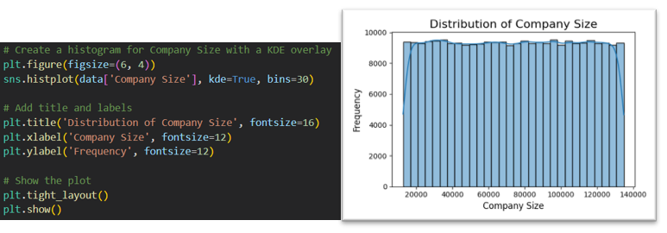

Figure 43: Company Size Plot

The dataset appears to contain a balanced representation of all company sizes, as evidenced by the graphic, which indicates that all of the bars in the company size histogram have equal heights, suggesting that each size group has roughly the same number of observations. Because it minimises bias, this can be regarded as beneficial for analyses that call for balanced data. It can also suggest, though, that there isn't much variation in the data, which means the distributions contrast with reality, where smaller and medium-sized businesses usually dominate larger ones.

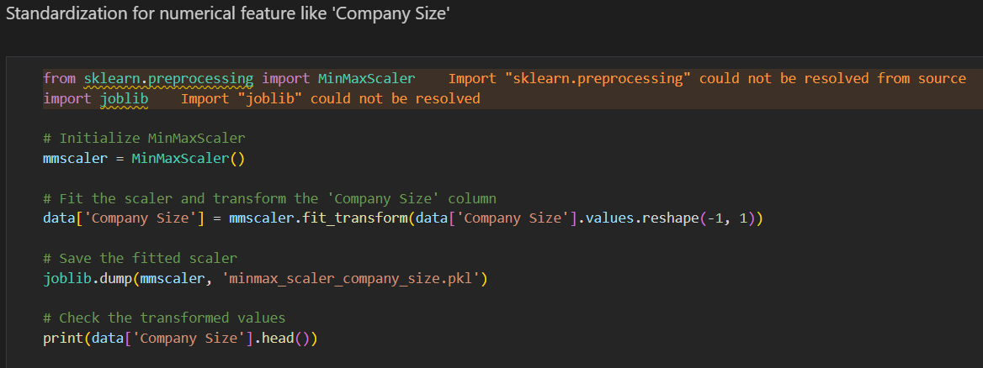

Figure 44: Min Max Scaling ‘Company Size’

To preprocess ‘Company Size’, the `MinMaxScaler` from scikit-learn is used to normalize this feature. The purpose of applying Min-Max scaling is to transform the values of the "Company Size" feature into a range between 0 and 1, making the data suitable for machine learning models that are sensitive to the scale of input features. After fitting and transforming the data, the fitted scaler is saved using `joblib` to ensure the consistency if the same scaling needs to be applied to new or unseen data during model deployment. The choice of Min-Max scaling is ideal here because it preserves the relationships between the original valuee, preventing large values from dominating models like XGBoost.

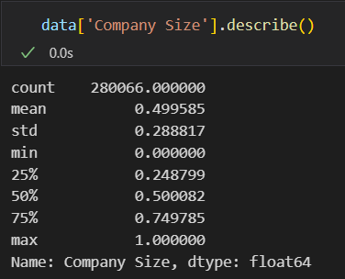

Figure 45: ‘Company Size’ after Min Max Scaling

The lowest is 0 and the highest is 1 after Min Max Scaling for, mean is 0.499 which can say that it formed a normal distribution bell curve.

### 4.3.7 Categorical Features Encoding

\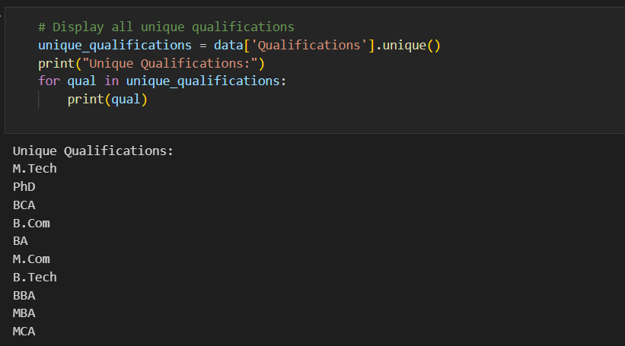

Figure 46: Unique ‘Qualifications’ before preprocessing

As shown in figure above, there are many classes of ‘Qualifications’ that can actually be grouped together, like ‘B. Tech’, ‘BBA’, ‘BCA’, these are all bachelor’s degree holder.

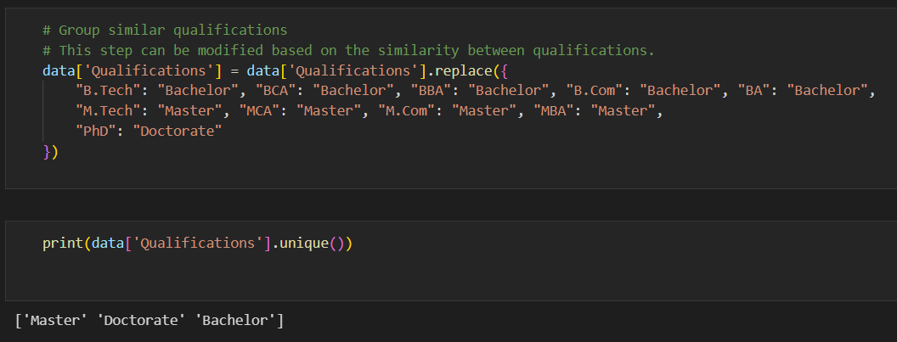

Figure 47: ‘Qualifications’ grouping

Hence, a manual grouping is performed in the code segment in Figure 45. This categorization helps in reducing the number of unique qualifications, so that it is easier to analyze the educational background of individuals in relation to other features in the data. The result is now cleaner, more manageable with only three categories remaining, 'Master', 'Doctorate', and 'Bachelor'.

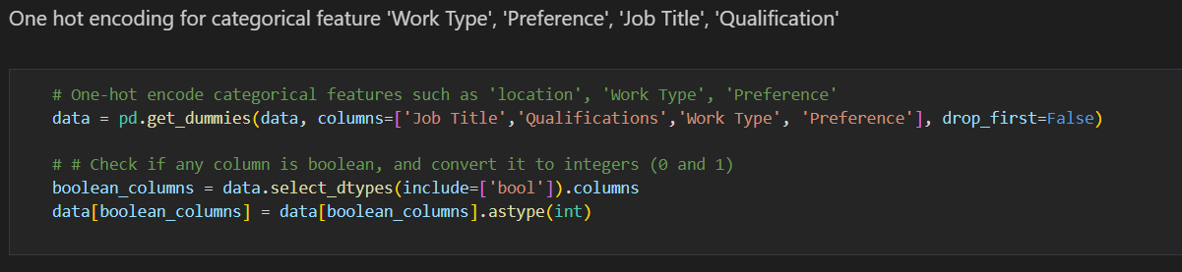

Figure 48: Categorical feature One-Hot Encoding

Moving on to address categorical feature, the columns are ‘Job Title’, ‘Qualifications’, ‘Work Type’, and ‘Preference’. By using the `pd.get_dummies()` function, it creates binary columns for each unique category within these features, therefore machine learning models can get to interpret the data effectively. The parameter `drop_first=False` ensures that all dummy variables are retained by preserving all information. Additionally, the code checks for any boolean columns in the data frame and converts them to integers (0 and 1) for uniformity. This transformation is crucial for preparing categorical data for the next steps, as ML models algorithms require numerical input.

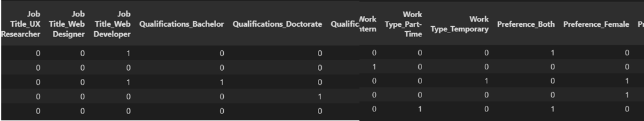

Figure 49: One-Hot Encoding results

These are the newly added columns from one-hot encoding, and all the values are in binary form, either 0 or 1, representing the presence or absence of that class.

### 4.3.8 Feature Selection

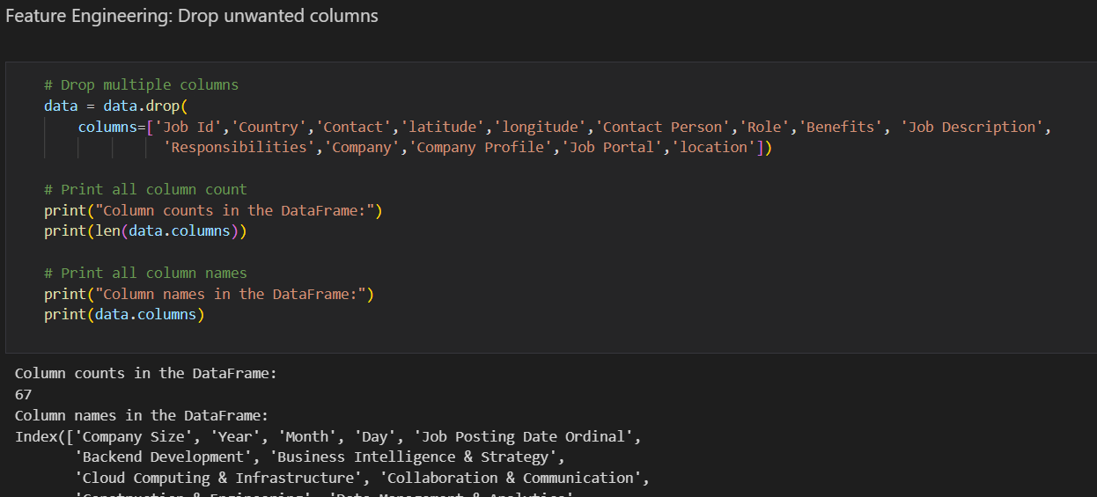

Figure 50: Dropping columns

Feature selection is performed by removing several columns deemed unnecessary for the analysis or modeling process. The features to be removed are based on the researcher’s judgement from the previous analysis, because the researcher believed these columns does not fit or provide valuable information for the project. The ‘drop()’ method is used to specify which columns to eliminate, including identifiers like ‘Job Id’, geographic data (‘Country’, ‘latitude’, ‘longitude’), and other non-essential details such as ‘Job Description’ and ‘Responsibilities’. This step is important as it simplifies the dataset, only relevant features are retained for further analysis or modeling, which can improve performance and interpretability.

### 4.3.9 Class Imbalance Resampling Technique

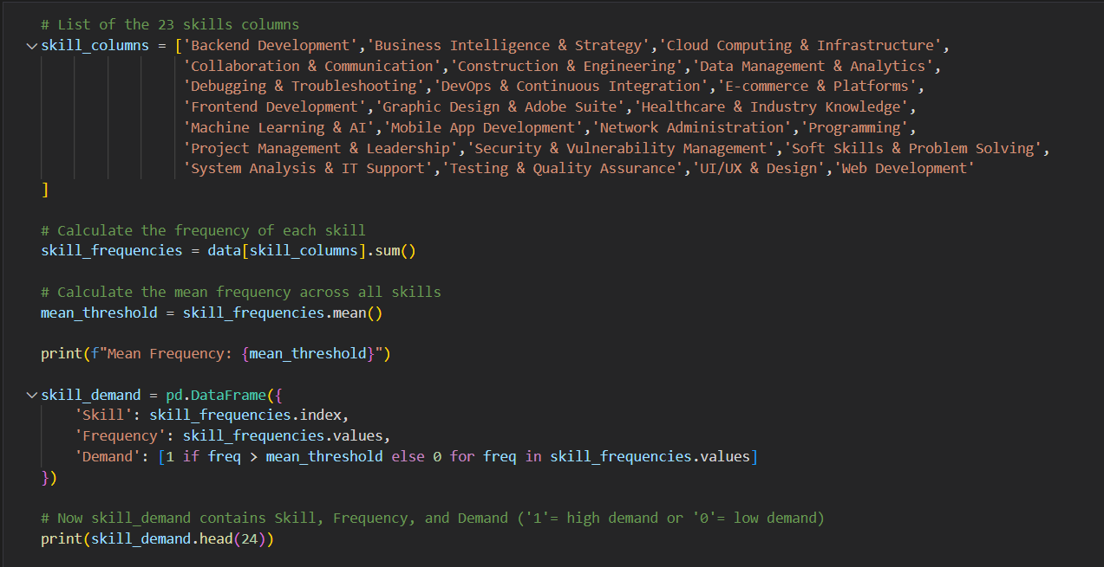

Figure 51: Identify Potential Class Imbalances

Class imbalance needs to be addressed because it can lead to biased model performance, where the model may favor the majority class and overlooked the minority class or important patterns in the data. To check whether there is class imbalance especially in the target columns, the total frequency of all 23 skills are calculated by summing the corresponding columns. Next, the mean frequency across all skills is computed to establish a threshold for skill demand. The ‘skill_demand’ data frame is created to summarize this information, containing three columns: ‘Skill’, ‘Frequency’, and ‘Demand’. The ‘Demand’ column is populated with a binary indicator—'1' for skills that have a frequency exceeding the mean (indicating high demand) and '0' for those that fall below it (indicating low demand). Finally, the first 24 rows of the `skill_demand` DataFrame are printed, providing insights into the skills that are in high demand relative to the average frequency. This approach helps in identifying which skills may need to be prioritized for training or recruitment efforts based on their demand in the job market.

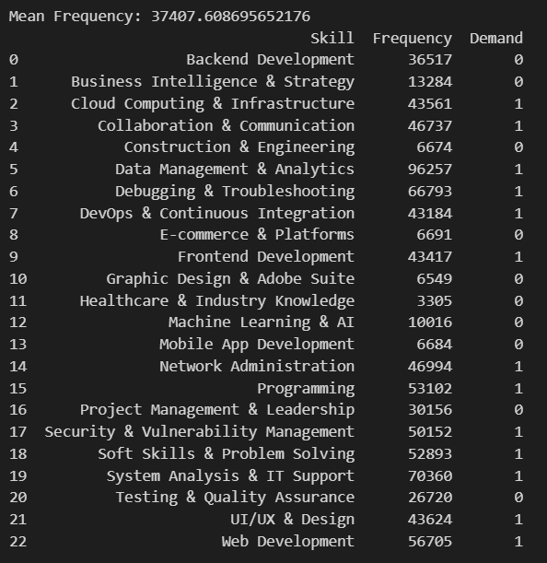

Figure 52: Skills Grouped by their Total Frequency

Based on the results of total frequency of each skills, there are huge class imbalances, likt the frequency for “Data Management & Analytics” is at 96257 count, maybe due to the manual grouping of skills, a lot of data related skills are grouped as one, but this also means that data skills are highly demanded in the industry, employers are looking for job seekers with some data skills. The lowest frequency is ‘Healthcare & Industry knowledge” with only 3305, could be due to small sample size because it is a niche in tech sector.

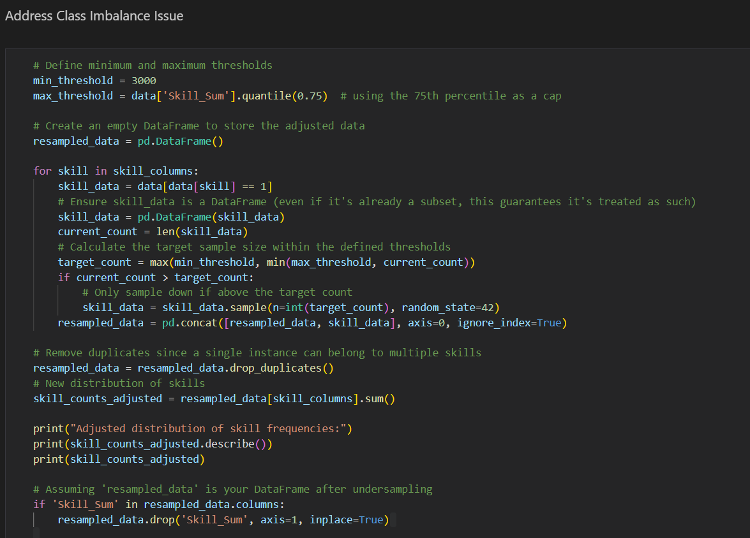

Figure 53: Resampling Technique Code

Hence, resampling technique has to be performed to address the class imbalance issue. First, it sets a minimum threshold of 3,000 for each skill and the 75th percentile of ‘Skill_Sum’ a max threshold to cap the number of samples for each skill. ‘resampled_data’, is initialized to store the adjusted records. Then, the code iterates through each skill column to select only those records where the skill is present indicated by a value of 1. For each skill, it calculates the current count of records and determines a target sample size that follows to the established thresholds. If the current count exceeds the target count, the code downsamples the data for that skill to match the target, so to ensure randomness with a fixed seed for reproducibility. After processing all skills, is then cleaned of any duplicate records. Finally, the code drops the ‘Skill_Sum’ to make sure that the final dataset only contains relevant columns for subsequent analyses.

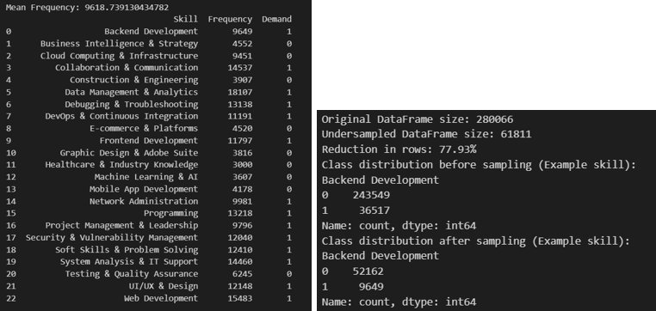

Figure 54: Data after Resampling

The output show that the resampling process in addressing class imbalance within the dataset is effective. Initially, the original data frame has 280,066 rows, with a substantial disparity in class distribution, particularly for skills like "Backend Development," where there were 36,517 instances labeled as present (1) compared to 243,549 instances labeled as absent (0). After applying the resampling code, the data frame size was reduced to 61,811 rows, reflecting a significant reduction of 77.93%. This adjustment was crucial in creating a more balanced representation of the classes. For "Backend Development," the resampling resulted in a decrease in present instances from 36,517 to 9,649, while the absent instances dropped to 52,162. This shows that the class imbalance code worked effectively, as it managed to reduce the overwhelming presence of the majority class (0) while retaining a sufficient number of samples from the minority class (1). Overall, the resampling process successfully minimized class imbalance which then allows for more reliable analyses and modeling.

### 4.3.10 Data Splitting

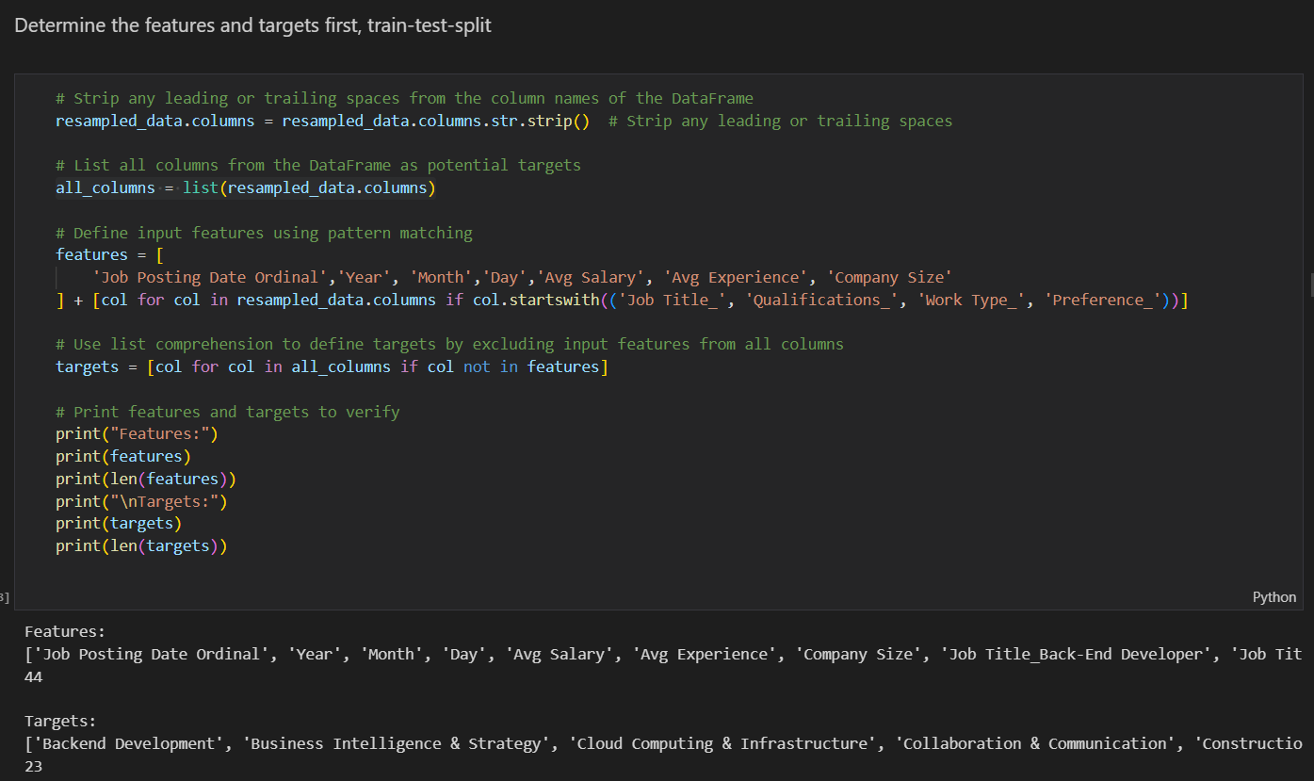

Figure 55:Data Splitting Part 1

The last part of data preprocessing is after, data transformation, standardization, resampling and all, now its comes to the part of data splitting. Before that, the first thing here as shown in Figure 53 is to first identify the feature columns and target columns. There are total of 44 features and 23 target variables.

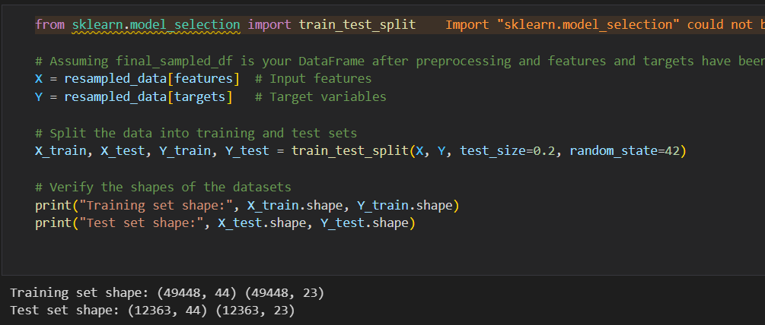

Figure 56: Data Splitting Part 2

After grouping all the data to ‘features’ and ‘targets’, data splitting is then performed by utilizing train_test_split function from sklearn model. The data will be splitted to 80% training data and 20% testing data. The output of this function are the followings:

X_train = training data (features)

X_test = testing data (features)

Y_train = training data (targets)

Y_test = testing data (targets)

Then, print out the shape of training and testing data to validate the split, the results showing the correct shape for both training (49,448 rows, 44 features) (49,448 rows, 23 targets) and testing data (12,363 rows, 44 features) (12,363 rows, 23 targets).



Figure 57: Save preprocessed data frame to csv

To ensure that the cleaned and transformed dataset is readily available for future use and saving time and effort by avoiding the need to repeat the preprocessing steps. The researcher has saved the dataset into a csv. Additionally, having a backup ensures consistency across analyses and experiments, reducing the risk of discrepancies caused by potential changes in raw data or preprocessing errors.

## 4.4 Data Understanding

### 4.4.1 Distribution of ‘Qualifications’, ‘Work Types’ and ‘Preference”

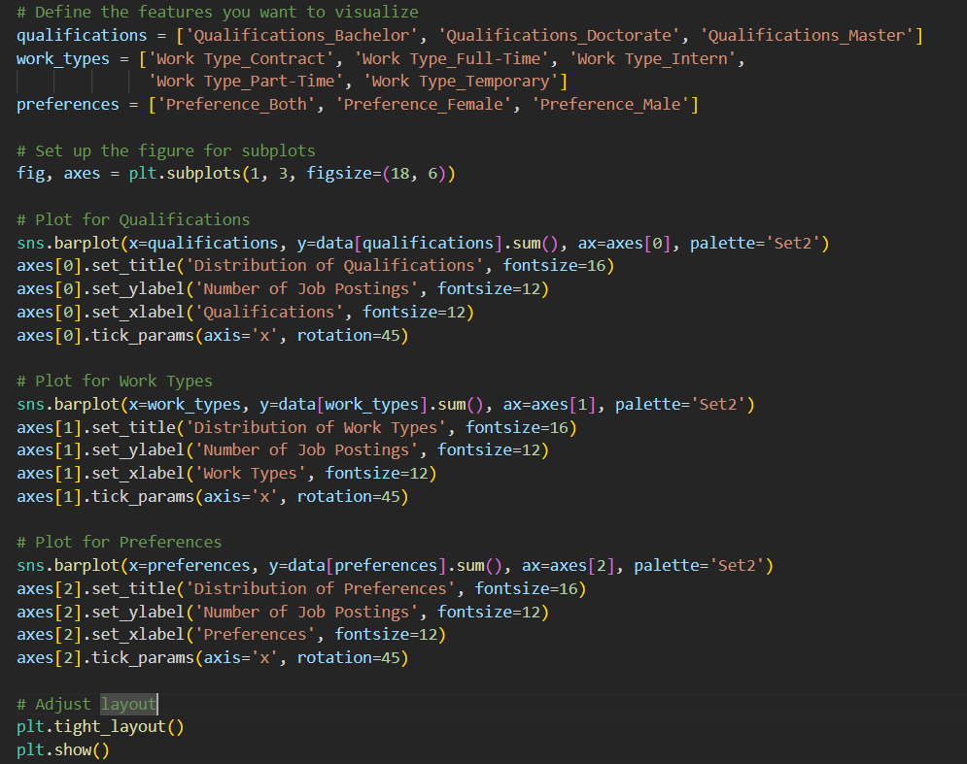

Figure 58: Distribution of ‘Qualifications’, ‘Work Types’ and ‘Preference” Code

First, this code uses matplotlib and seaborn to create a series of bar plots to help visualize the distribution of qualifications, work types, and preferences. Each category is represented in a separate subplot within a single figure, so that its easy to compare across these dimensions. The bar plots display the sum of occurrences for each attribute within the dataset, aiming to see the frequency of various qualifications, the types of work arrangements (such as full-time or part-time), and the preferences stated in job postings (gender). The visualization is designed to help identify which attributes are most common or rare within the job market data being analyzed.

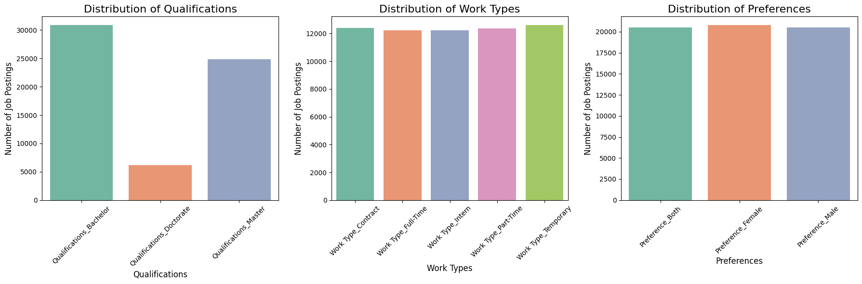

Figure 59 Distribution of ‘Qualifications’, ‘Work Types’ and ‘Preference” Graphs

1.Qualifications: The majority of job postings require a bachelor’s degree, significantly outnumbering those that require a Doctorate or Master's degree. This might suggest that entry-level or undergraduate qualifications are more in demand across the dataset, possibly reflecting a candidate with a bachelor’s degree might be just sufficient for most job roles.

2. Work Types: The distribution across different work types is relatively even, with Full-Time work slightly leading. This uniformity indicates a diverse job market catering to various employment preferences, though full-time positions remain slightly more prevalent, or this dataset is just balanced to begin with.

3. Preferences: The gender preference distribution is nearly equal among all three classes, this pattern is similar to the work type. This balance might indicate an effort towards diversity and inclusion in hiring practices or could reflect that the dataset is already been filtered.

### 4.4.2 Skill Distribution Across Job Titles

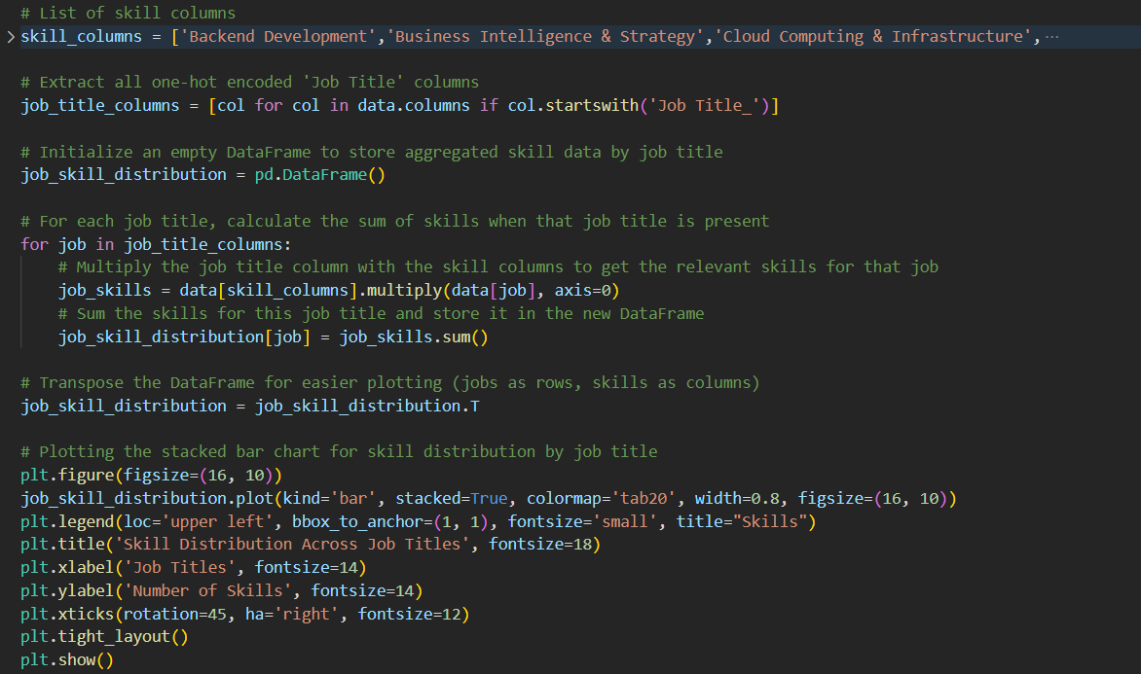

Figure 60: Skill Distribution Across Job Titles Code

A stacked bar chart is used in Figure 59 code to illustrate how all skills are distributed among various job titles. Because job titles were one-hot encoded, in order to isolate the abilities associated with each job, it aggregates skill data for each job title by multiplying the relevant skill columns by the job title columns. In order to align job names along the x-axis and skills along the y-axis, the resultant data is then totalled and transposed. The final plot gives a thorough picture of which abilities are most common or required for each job title by showing a stacked depiction of skills for each job title. The skills are colour-coded to distinguish between various skills. Understanding the skill needs unique to various occupations in the labour market is made easier with the aid of this visualisation.

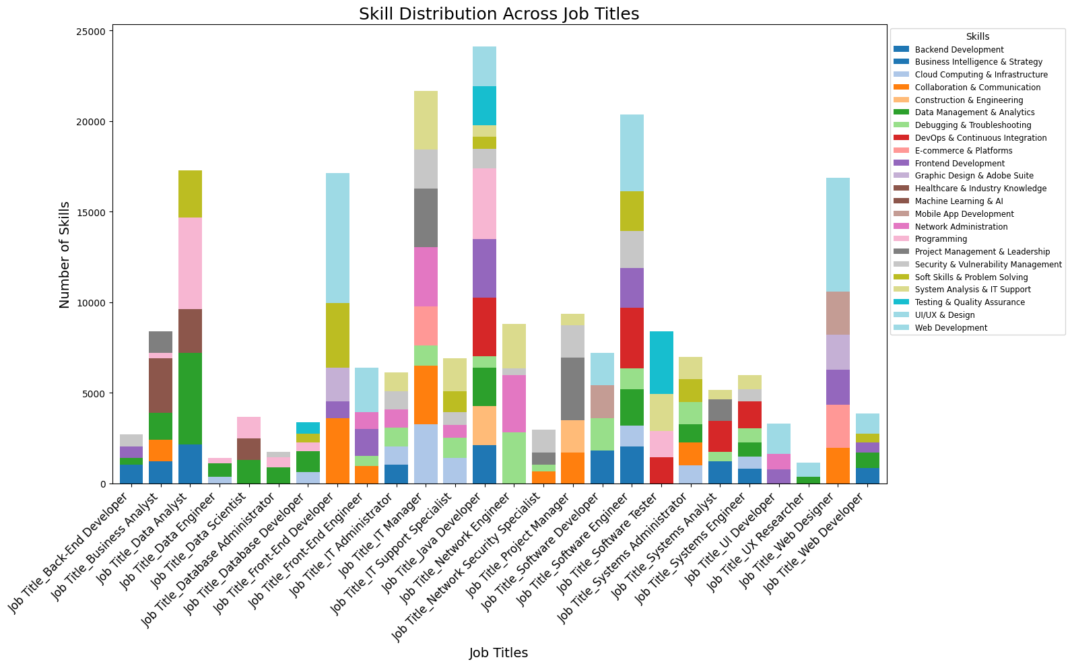

Figure 61: Skill Distribution Across Job Titles Graph

A thorough representation of the variety and diversity of skills needed for different work tasks is given by the stacked bar chart, which also highlights important distinctions and similarities in skill requirements. The fact that technical skills like "Backend Development," "Web Development," and "Programming" are common in a wide range of roles shows how important they are in the tech sector. Conversely, specific competencies like "Machine Learning & AI" are essential yet limited to particular positions, indicating the demand for specialised knowledge in these fields. The overall number of abilities needed for each job title varies significantly, as the chart demonstrates. Some professions have a broad and balanced skill set, which may indicate a requirement for versatility or multidisciplinary expertise. Understanding the complexity and particular requirements of various work tasks with the use of this visualisation can help with recruitment that is more focused, individual career development, and organisational training initiatives.

### 4.4.3 Skill Combinations Analysis

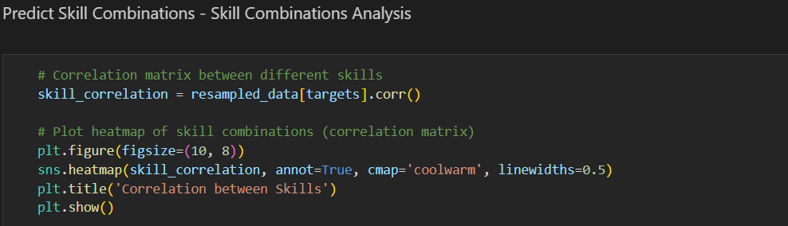

Figure 62: Skill Combinations Analysis Code

This code produces and displays the correlation matrix for a group of skills, giving information about the relationships or co-occurring skills in a dataset. In particular, it uses the resampled data to calculate the correlations between pairs between distinct skills (stored in {targets}). The outcomes are then shown as a heatmap, where the strength and type (positive or negative) of the correlations are represented by a colour gradient. Annotated with correlation coefficients, this visualisation facilitates the rapid identification of the skills that are most likely to coexist across job profiles, suggesting potential mutually beneficial abilities or frequent combinations in industry demands. This analysis is helpful in comprehending the synergy between skills and can direct the development of curriculum, training initiatives, and workforce planning tactics.

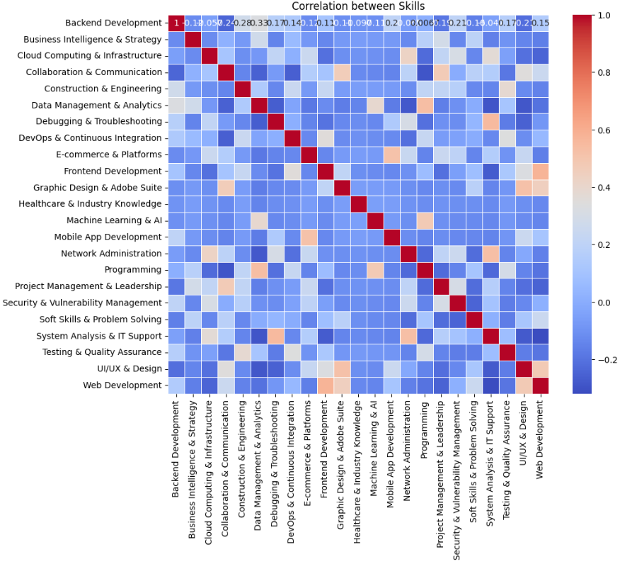

Figure 63: Skill Combinations Analysis Graph

The correlation between skills is shown in the heatmap above, which also reveals interesting dependencies and relationships. Upon closer examination, specific skill sets, such as "Backend Development" and "Web Development" or "Mobile App Development" and "UI/UX & Design," showcase strong positive correlations, indicating that these skill sets tend to be required in combination for job roles. This is probably because the technological domains overlap. On the other hand, skill like "Healthcare & Industry Knowledge" have little to no connection with more technical skills, like "Programming," underlining their uniqueness and specialisation in the labour market. With the help of this visualisation, professionals looking to upskill in related industries or educational institutions seeking to create integrated courses may find it easier to identify skill clusters that regularly coexist. Although, the researcher expected there will be more correlation between skills, but the result shown otherwise.

### 4.4.4 Feature Importance

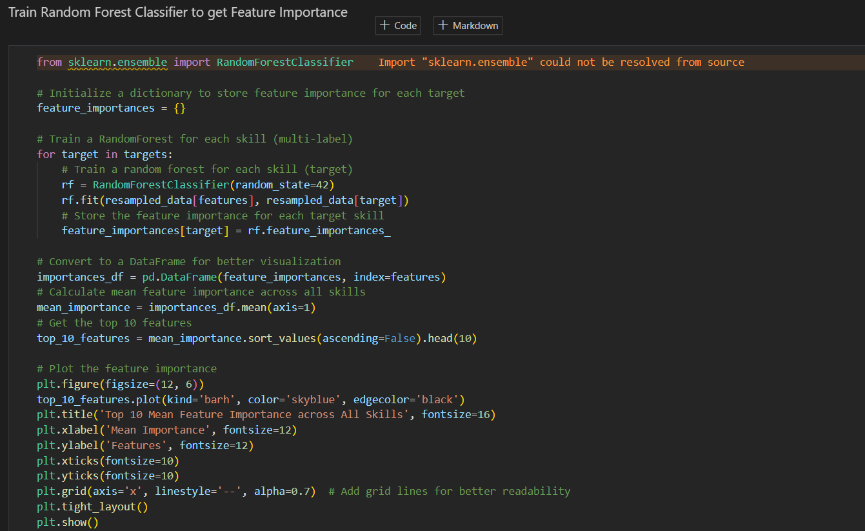

Figure 64: Feature Importance Code Using Random Forest Classifier

This code evaluates the importance of different features in predicting distinct skills across a dataset using a RandomForestClassifier. To evaluate the overall relevance of each feature, a RandomForest model is trained for each skill, the value of each attribute in predicting that skill is extracted, and these importance scores are then aggregated across all skills. A horizontal bar chart highlighting the top 10 most important features is used to visualise the result. In addition to providing useful insights for identifying important drivers in skill prediction and maybe directing data-driven decisions in fields like talent acquisition and resource allocation, this visualisation offers a straightforward summary of the attributes that are most significant across all talents. The method works well for comprehending feature importance in challenging, multi-label classification tasks that are frequently found in workforce analytics.

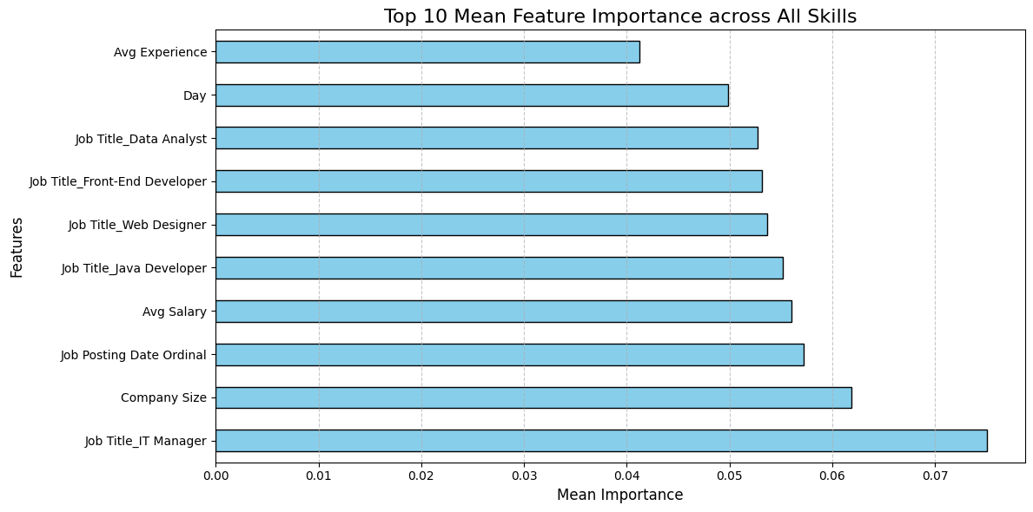

Figure 65: Feature Importance Using Random Forest Classifier Chart

The most important variables for forecasting various skills listed in job postings are clearly broken down in the bar chart. The most significant characteristic is the job title "IT Manager," which denotes that this specific role has unique abilities that make it stand out from others. Additional noteworthy job names are "Web Designer," "Java Developer," and "Front-End Developer," indicating that certain technological positions have certain skill sets that are very indicative of job duties. Furthermore, more generic characteristics like "Company Size" and "Avg Salary" are also significant, suggesting that organisational environment and compensation are important determinants of the skills needed. surprisingly the "Day" and "Job Posting Date Ordinal" are also included in the list, suggesting that talent demand could reflect seasonal or timing-related patterns.

## 4.5 Model Building

This section will discuss all the models built including, Random Forest Classifier, Logistic Regression, XGBoost and LightGBM, and their respective hyperparameter tunings. This section also dive deep into the reasoning for choosing each models and their parameters grid for hyperparameter tuning.

### 4.5.1 Random Forest Classifier

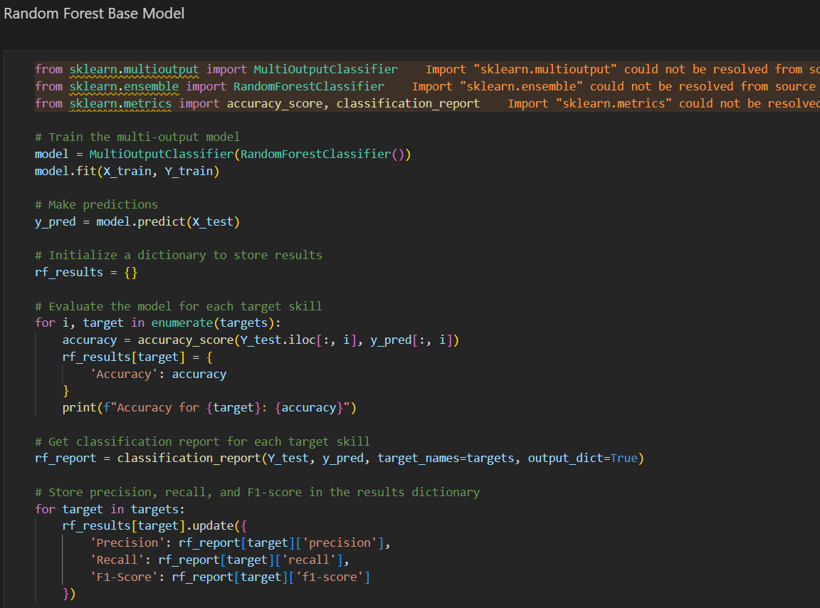

Figure 66: Random Forest Base Model Code

The reason to use a MultiOutputClassifier with a RandomForestClassifier as the foundation for this project is because of characteristics of the data, which demand the prediction of several target skills at once, a common situation in multi-output classification (Sharma, Nguyen, Singh, & Ongwere, 2024). The RandomForestClassifier is selected due to its strength and adaptability, celebrated for its ability to handle intricate datasets rich in features efficiently. It is particularly good at dealing with complex relationships and interactions among features without the necessity for extensive data preparation like normalization.

In the code, following the training of the model on (`X_train`, `Y_train`), it is applied to (`X_test`) for making predictions. The performance of the model is then evaluated using various metrics such as accuracy, precision, recall, and F1-score for each skill, the results will be discussed thoroughly in Chapter 5. These indicators allow for a detailed assessment of the model, focusing on accuracy, the ability to identify all relevant instances, and precision. This strategy not only save time and resources by eliminating the need for separate single-target models but also deepens the understanding of the relationships among different skills.

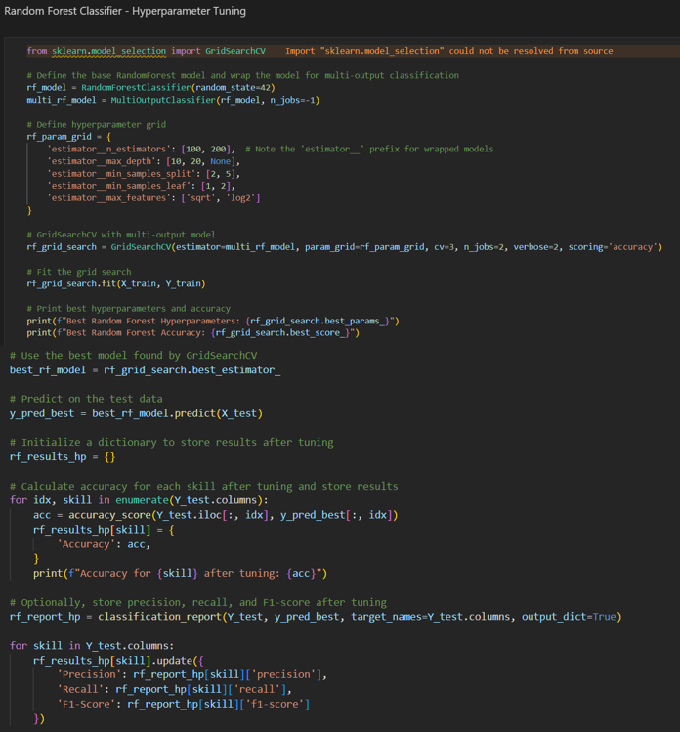

Figure 67: Random Forest Hyperparameter Tuning Code

Hyperparameter tuning for RandomForestClassifier is through GridSearchCV to pinpoint the ideal settings in a task involving multiple outputs. GridSearch systematically investigates and identifies the best settings for a model by testing various setups. The range of settings (`rf_param_grid`) is set up to evaluate different options for essential settings such as the number of trees (`n_estimators`), the maximum depth of each tree (`max_depth`), the minimum number of samples needed to divide a node (`min_samples_split`), and the number of features to consider when dividing (`max_features`). These settings are selected to improve its ability to generalize. For example, varying the depth of the trees can prevent the model from overfitting, while tweaking the number of features (using `sqrt` or `log2`) can adjust how the model deals with a variety of features. Although this exhaustive approach increases the likelihood of discovering the optimal model, it can be computationally demanding and time-consuming, particularly when dealing with numerous combinations of parameters. GridSearchCV employs a cross-validation method (3-fold) to assess each combination, enhancing its reliability but at the cost of being more resource-intensive. The refined model is then applied to the test data, and metrics such as accuracy, precision, recall, and F1-score are computed for each skill.

### 4.5.2 Logistic Regression

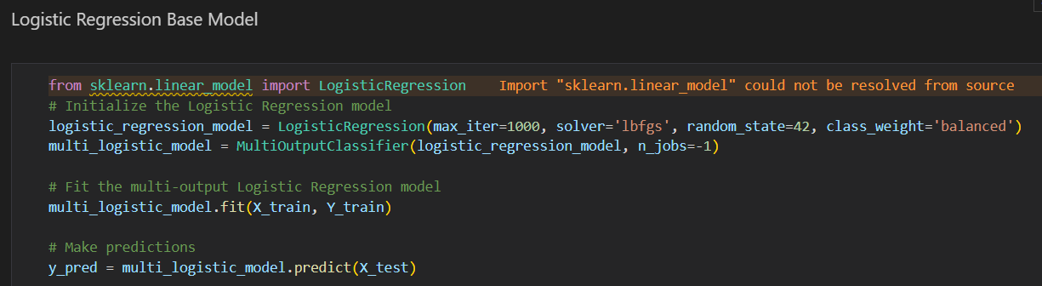

Figure 68: Logistic Regression Base Model Code

The reason for using logistic regression for this project is that it is simple and efficient when addressing binary classification problems, which aligns with the features of the dataset in which each skill is classified as either existent or missing (Xu, et al., 2019). For many tasks with several outputs, logistic regression provides clarity in its functioning, making it easier to grasp how the factors impact the prediction of each ability. In this case, the MultiOutputClassifier is used to handle the multi-label aspect of the project, making sure the model can predict multiple skills simultaneously, eliminating the need for separate models for each skill. In terms of parameter selection, 'lbfgs' is used since it works well with small to medium-sized datasets and can handle multiclass problems. The 'max_iter' is set to 1000 in order to ensure that the model converges, especially when handling complex, multi-output tasks. Additionally, class_weight='balanced' ensures that the model does not unfairly favour the majority class in the forecast of each ability, hence mitigating any potential imbalance among classes. The rest of the code follows a standard protocol, whereby the model is trained using the training dataset, predictions are made using the test dataset, and different performance metrics are calculated for each skill, including accuracy, precision, recall, and F1-score.

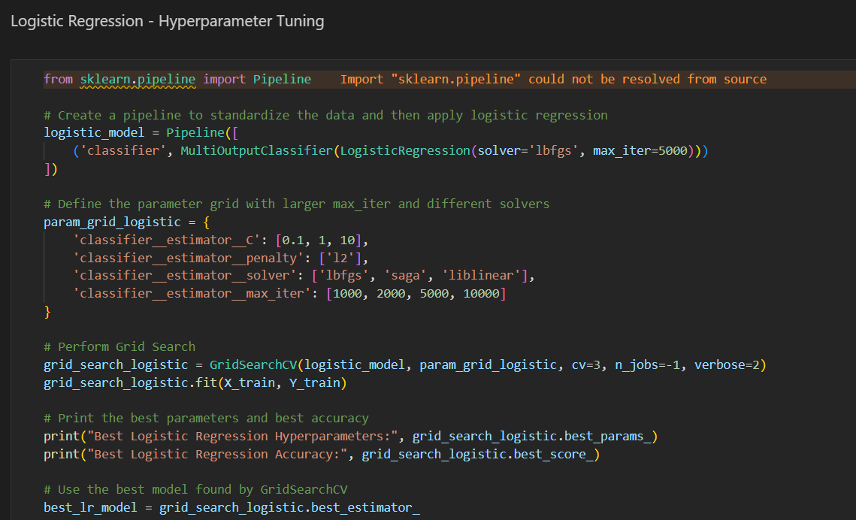

Figure 69: Logistic Regression Hyperparameter Tuning Code

Using GridSearchCV, this code performs hyperparameter tuning to a Logistic Regression model, emphasising on optimising important parameters such as the maximum iterations (max_iter), penalty type (l2), regularisation strength (C), and solver method. Several solvers ('lbfgs,''saga,' and 'liblinear') are included in the param grid; these solvers are all appropriate for Logistic Regression, although their effectiveness varies according on the size and complexity of the dataset. Finding the ideal balance between overfitting and underfitting is made possible by testing various values for C, the regularisation control. Additionally, experimenting with different max_iter values guarantees that the model has enough iterations to converge, which is especially important when working with intricate multioutput jobs. While this grid search provides a comprehensive method for determining the optimal parameters, it can be computationally costly and time-consuming, especially when trying a large number of possibilities or huge datasets. The advantage, though, is that fine-tuning these parameters will ensure the model operates at peak efficiency, which could result in improved generalisation and more precise predictions across a range of skill sets. The code remains structured in the same way: it trains the model, makes predictions, and then, after hyperparameter adjustment, assesses each skill's accuracy, precision, recall, and F1-score.

### 4.5.3 XGBoost

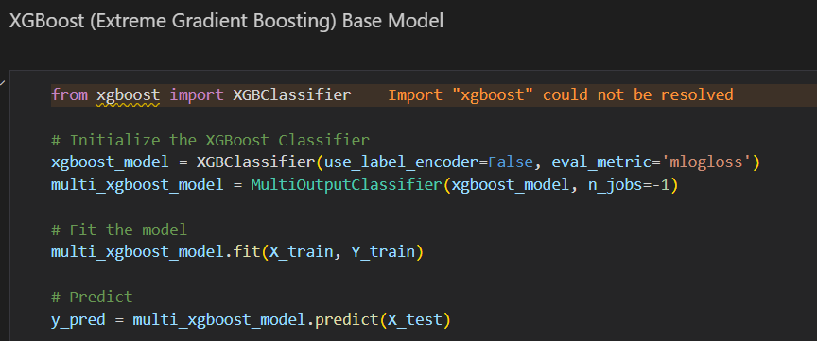

Figure 70: XGBoost Base Model Code

XGBoost is known for being a strong, effective algorithm that works well with complicated datasets that have numerous target variables and high dimensionality, exactly what this multi-output classification problem requires. XGBoost is a great option for skill prediction since it works well with structured data and is especially useful for applications that require capturing non-linear connections between characteristics. Because of its gradient boosting structure, which constructs trees consecutively while learning from the mistakes of the previous ones, XGBClassifier, when used in this code, provides great accuracy.Use_label_encoder=False (to prevent warnings in later versions of XGBoost) and eval_metric='mlogloss' (which minimises log loss to optimise the model for multi-class classification) are two of the code's important parameters. The model is wrapped in a MultiOutputClassifier to handle many target skills simultaneously. Because XGBoost boosts features iteratively and has a large number of features and outputs in the dataset, it can be computationally intensive even though it is known for producing excellent accuracy and efficient performance. The potential improvements in prediction accuracy and the capacity to capture intricate feature interactions outweigh the higher processing cost in this case. The code provides a thorough assessment of the model's performance across several skill categories by going through the standard procedures of fitting the model, generating predictions, and figuring out accuracy, precision, recall, and F1-scores for each skill.

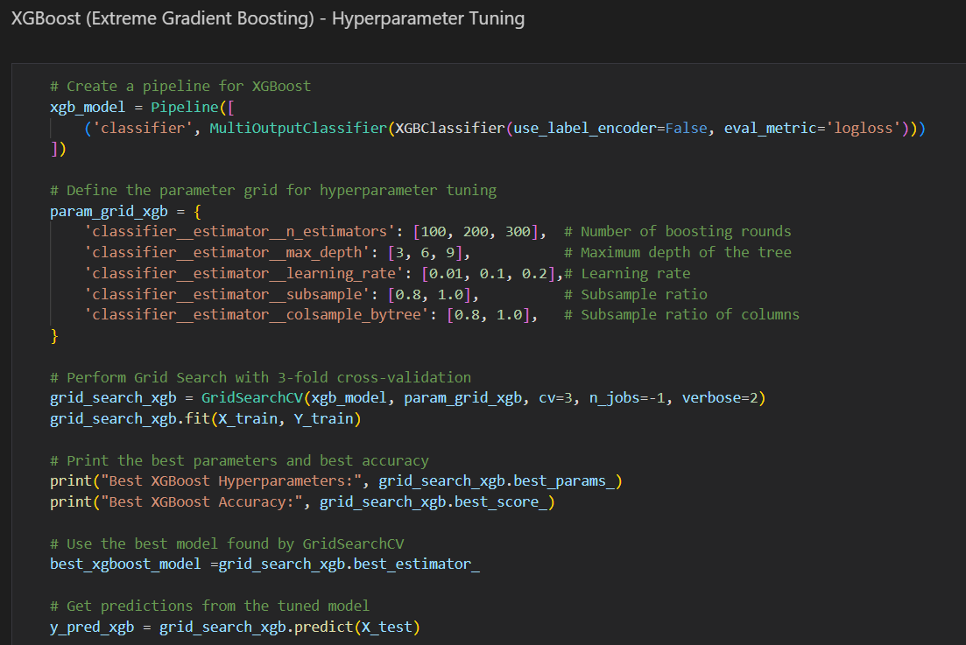

Figure 71: XGBoost Hyperparameter Tuning Code

This XGBoost hyperparameter tuning algo modifies important parameters such as the n_estimators, tree depth (max_depth), learning rate, and subsample ratios using GridSearchCV to maximise the model's performance. These factors are covered by the parameter grid that was selected to discover the ideal ratio between model complexity and performance. For instance, max_depth determines the complexity of each tree, whereas n_estimators sets the number of boosting rounds. Deeper trees have the potential to overfit, but they may also capture more complicated patterns. Similar to this, subsample and colsample_bytree are used to prevent overfitting by randomly picking subsets of the data and features during training, while learning_rate balances the amount of information the model learns from each cycle. The extensive parameter grid makes it possible to examine model configurations in great depth, but it also adds to the computational cost and time—especially when dealing with huge datasets and various talents that need to be predicted. But the resulting refined model, which provides noticeably higher predictive performance, makes this effort and processing resource investment worthwhile. After tuning, accuracy, precision, recall, and F1-scores are used to assess the model's performance across a variety of abilities, giving valuable information on the model's effectiveness following optimisation.

### 4.5.4 LightGBM

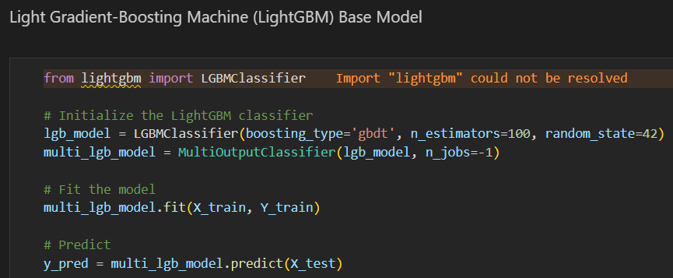

Figure 72: LightGBM Base Model Code

The reason LightGBM was selected for this project was that, in comparison to other models of a similar kind, such as XGBoost, it was quicker and used less memory. It also performed very well with huge datasets and intricate multi-label classification problems thanks to its gradient boosting structure. This is particularly beneficial for issues with several target skills, since it can manage the complexity while being more computationally efficient. The LGBMClassifier, which uses 100 estimators and boosting_type='gbdt,' guarantees a balance between accuracy and learning speed. Because of its highly optimised decision tree algorithms, LightGBM is renowned for its capacity to analyse enormous volumes of data with a high degree of accuracy, especially in situations where speed is crucial. the model is well suited for datasets with a high dimensionality and a large number of features because to its inherent ability to handle categorical features and its automated optimisation of leaf-wise splits. The speed of LightGBM, paired with its capacity to handle complicated feature interactions, makes it a great solution for applications where both accuracy and computational economy are critical. In multi-output circumstances, where time and processing resources are limited, this is very helpful.

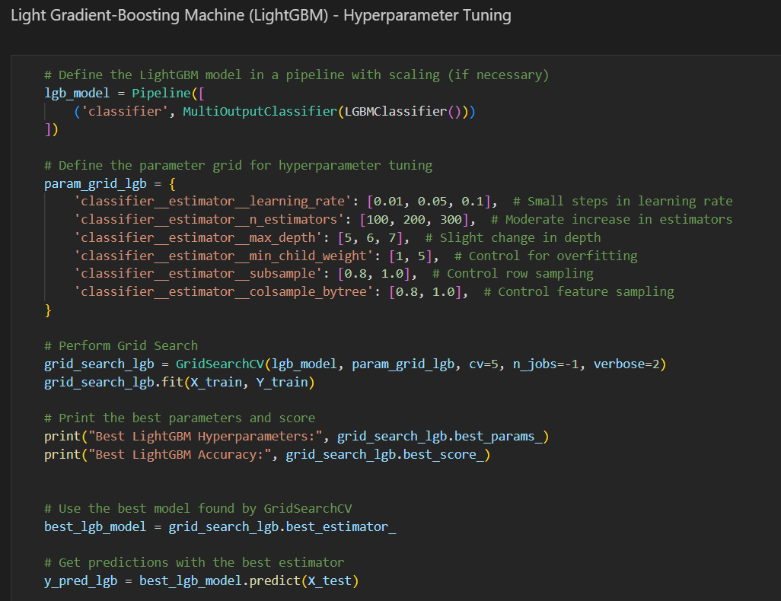

Figure 73:LightGBM Hyperparameter Tuning Code

Hyperparameter tuning of LightGBM also using GridSearchCV, important choices like {learning_rate}, regulates the step size during training and accepts tiny values for more slow learning. In order to prevent overfitting, ‘max depth’ restricts the complexity of each tree, while ‘n estimators’ regulates the number of boosting rounds. ‘min_child_weight’ is used to also control overfitting by mandating a minimal quantity of samples inside a leaf. Furthermore, random sampling of rows and features is done using ‘subsample’ and ‘colsample_bytree’, which lowers variance and aids in the model's generalisation. Due to the large dimensionality of the dataset and parameter space, this grid search is computationally expensive and takes longer to complete than other methods, even if it covers a wide range of possible configurations. However, the extensive study ensure that the LightGBM model is properly tweaked to produce greater prediction performance. The model is retrained, predictions are produced, and the typical evaluation metrics (accuracy, precision, recall, and F1-score) are computed for each skill, demonstrating the performance gains following adjustment, once the optimal hyperparameters have been identified. By configuring the LightGBM model properly, this technique balances computational efficiency and accuracy.

### 4.5.5 Save Models

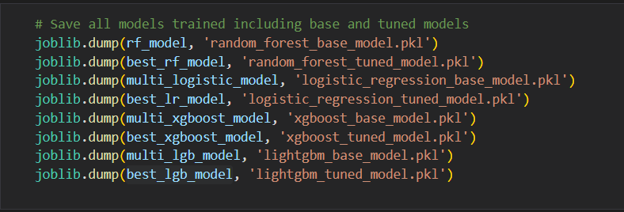

Figure 74: Save All Models

Lastly, using `joblib` to save all trained models, both the base and tuned versions, into `.pkl` files. The purpose of saving these models is to avoid retraining them each time they're needed, which can save a huge amount of time and computational power, especially with large datasets. By storing the models, they can be quickly loaded later for further evaluation, predictions, or comparison, streamlining the workflow and preserving the final models for future use.

## 4.6 Summary

In Chapter 4, the predictive model that was created for predicting future skill requirements was designed and put into practice. The first section of the course covered data collecting, where to find the Kaggle dataset, which contains fictitious job advertisements which are filtered in data preprocessing steps to the tech sector. Following data collection, a comprehensive data preparation step was carried out, entailing data cleaning, manual grouping of skills, and normalising important attributes including experience, salary, and company size. The skills column was thoroughly cleaned and mapped, and then resampling techniques were used to solve the class imbalance. In order to prepare for the construction of the model, the data was separated into training and test sets.

A number of machine learning models were put into practice, such as XGBoost, Random Forest, Logistic Regression, and LightGBM. GridSearchCV was utilised for hyperparameter optimisation in order to maximise performance for every model. Through careful model tuning to predict many talents at once, a balance between computational economy, generalisation, and accuracy was achieved. Metrics including accuracy, precision, recall, and F1-score were used to assess the models, giving rise to a thorough knowledge of their performance. Lastly, joblib was used to preserve all models in order to prevent retraining and simplify analysis in the future.

To summarise, this chapter provided an overview of the procedures involved in gathering data, preprocessing it, developing the model, and fine-tuning its parameters. It also laid the groundwork for the results and discussion that will be covered in the following chapter.

# CHAPTER 5: RESULT AND DISCUSSION

## 5.1 Introduction

In Chapter 5, extensive discussion on the results of the forecasting models created in Chapter 4 are presented with an emphasis on their evaluation, comparison, and deployment. First, a thorough analysis and discussion of each model's performance is provided, using a variety of metrics to evaluate accuracy, precision, recall, and F1-score. The models generated in this project are compared not only with related works in the field but also with each other in order to highlight the accomplishments and possible areas for development. The implementation of these models is then described, with details on how they are incorporated into an actual application. To ensure that the reader understands the actual application of the study in operational settings, this part offers pictures and visual representations that show how the models are used in real-world scenarios. Finally, the chapter concludes with a summary that synthesizes the findings, reflecting on the successes achieved and the challenges encountered during the implementation of these predictive models.

## 5.2 Model Evaluations and Discussions

### 5.2.1 Evaluation of Random Forest Models

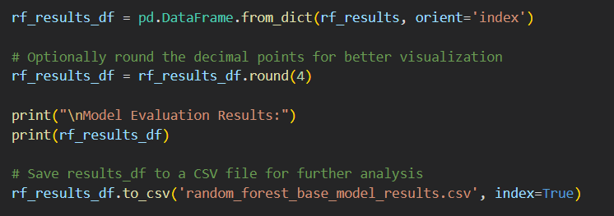

Figure 75: Random Forest Result Code

For easier analysis and visualisation, this code transforms the RandomForest model's performance metrics, which are currently saved in a dictionary format, into a pandas data frame. Next, to improve readability, the data frame is modified by rounding the metric values to four decimal places. The outcomes are then produced, giving a quick summary of the model's performance in terms of many metrics including accuracy, precision, recall, and F1-score. The data frame is then stored as a CSV file with the name "random_forest_base_model_results.csv" making it possible to retrieve the data with ease for more in-depth study or to share it with others for approval or report integration. This method guarantees that the assessment findings are accurate, thoroughly recorded, and easily applied to further phases of the project. This code block is reused exactly for rest of the models, therefore only explaining it once here.

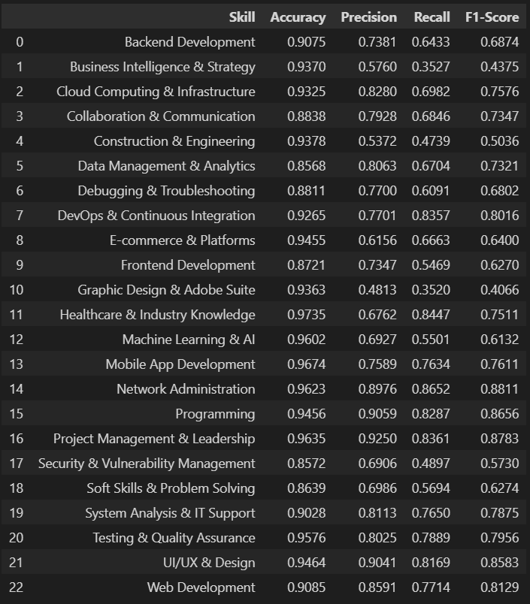

Figure 76: Metrics of Random Forest Base Model

The Random Forest base model's preliminary findings demonstrate competent performance on a range of skills, with comparatively high accuracy and F1-scores indicating the model's overall efficacy in differentiating between the presence and absence of certain skills. Presumably, the model is especially good at predicting specialised, high-impact abilities within the dataset because skills like "Healthcare & Industry Knowledge" and "Machine Learning & AI" have higher F1-scores. Nevertheless, the recall ratings for a few skills, such as "Frontend Development" and "Graphic Design & Adobe Suite," are somewhat low, indicating that the model may be overly conservative and suffers from false negatives, which might cause it to fail to recognise these skills when they are there.

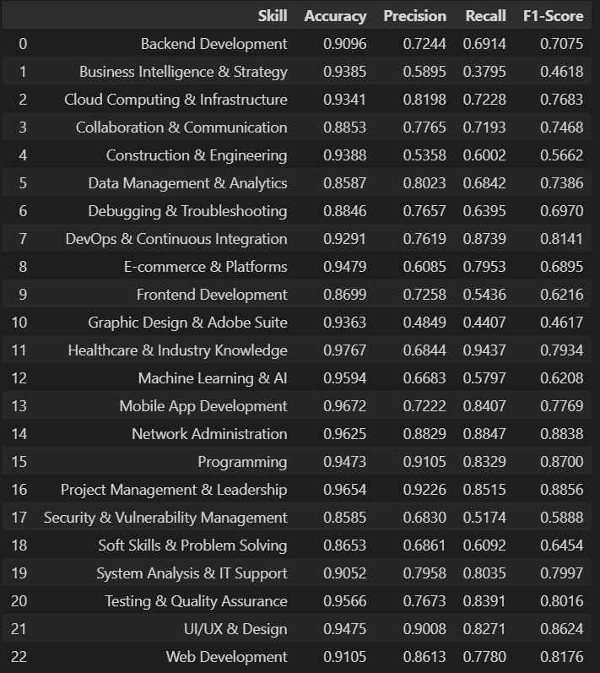

Figure 77: Metrics of Random Forest Tuned Model

Following hyperparameter tuning, practically all skills show a discernible increase in the model's accuracy metrics, indicating a decrease in false positives—fewer irrelevant abilities are being incorrectly detected. This improvement is especially crucial for occupations where recall is less necessary than precision, such specialised tech skills, where incorrectly recognising a talent that is not held might result in ineffective job placements. A few abilities, such as "DevOps & Continuous Integration" and "Data Management & Analytics," showed somewhat higher recall after the adjustment, indicating the model's increased sensitivity in these domains. Even with these gains, recall for several abilities decreased, including "Soft Skills & Problem Solving" and "Healthcare & Industry Knowledge," which may indicate overfitting during the tuning process.

It is evident from comparing the two sets of data that hyperparameter adjustment improved the model's precision at the price of recall in a number of different domains. In real-world applications, this trade-off must be balanced between the relative costs of false positives and false negatives, as well as the particular demands of the labour market. The adjusted model taken as a whole shows a better balance and increased predictive abilty, which is consistent with the project's objective of precisely projecting the skill requirements in the tech sector. The improvements made after fine-tuning show that machine learning approaches may be effectively applied to improve model predictions.

### 5.2.2 Evaluation of Logistic Regression Models

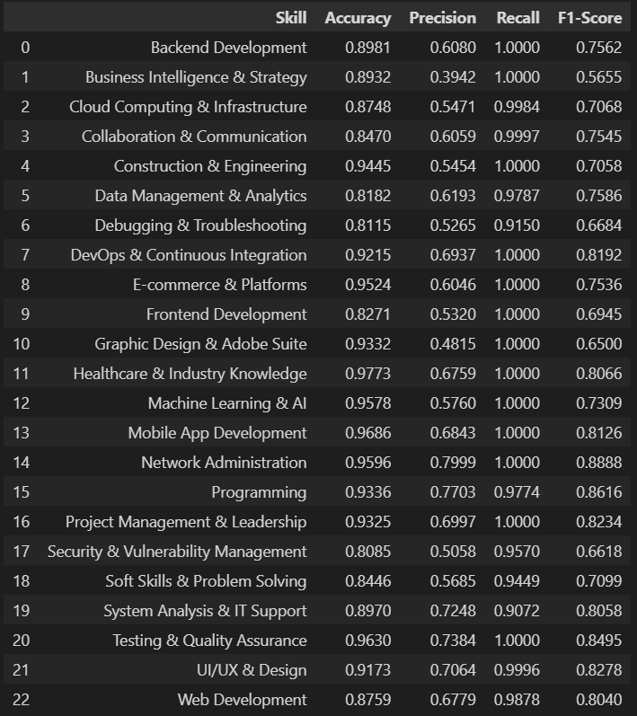

Figure 78: Metrics of Logistic Regression Base Model

The results of the Logistic Regression base model show that performance varies across different skills. For example, "Mobile App Development" and "Healthcare & Industry Knowledge" show strong recall rates, indicating good true positive identification. However, many skills have moderate to low precision and F1-scores. This may suggest that although the model performs well in locating pertinent instances for certain skills, it also has a tendency to predict a higher number of false positives, which lowers its total accuracy. The recall of 1.0000 for the abilities "Healthcare & Industry Knowledge" and "Backend Development" is noteworthy. This means that all true positives were effectively detected, while the accuracy scores show that there may have been a high number of false positives.

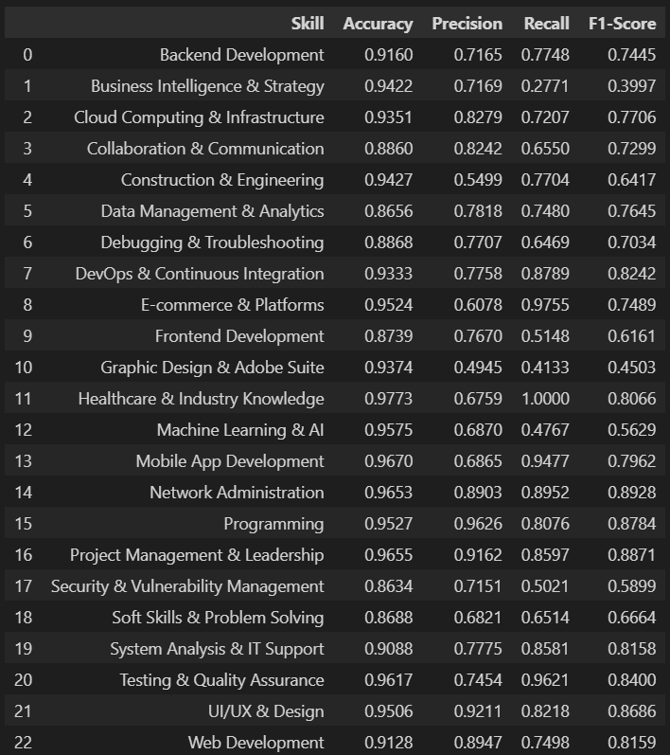

Figure 79: Metrics of Logistic Regression Tuned Model

Higher overall F1-scores result from the Logistic Regression model's demonstrable improvements in recall and precision for a number of abilities following hyperparameter adjustment. Proficiency in "Cloud Computing & Infrastructure" and "Data Management & Analytics" yields significant improvements in accuracy and F1-score, showing the value of fine-tuning model parameters for improved data generalisation. But after fine-tuning, performance drops for some abilities, such as "Graphic Design & Adobe Suite," indicating that the model may be overfitting or mismatched with the subtleties of those specific skill categories.

On the other hand, tweaking the hyperparameters has made the model better at finding the right balance between remembering things correctly and getting the answers right for most tasks. The consistent improvements in how right the answers are and the f1-scores, which are key for a fair check-up in situations where dealing with more than one output, like predicting skills, show this. So, making the model more precise by adjusting its settings has been crucial for boosting its ability to predict things accurately and get it closer to what's needed in the real world to accurately spot different skills in the job market. This shows that the project's main aim is to provide a trustworthy tool for predicting future job skills, and it suggests that even more accurate results could be achieved by tweaking it and possibly adding other elements or using different methods together.

### 5.2.3 Evaluation of XGBoost Models

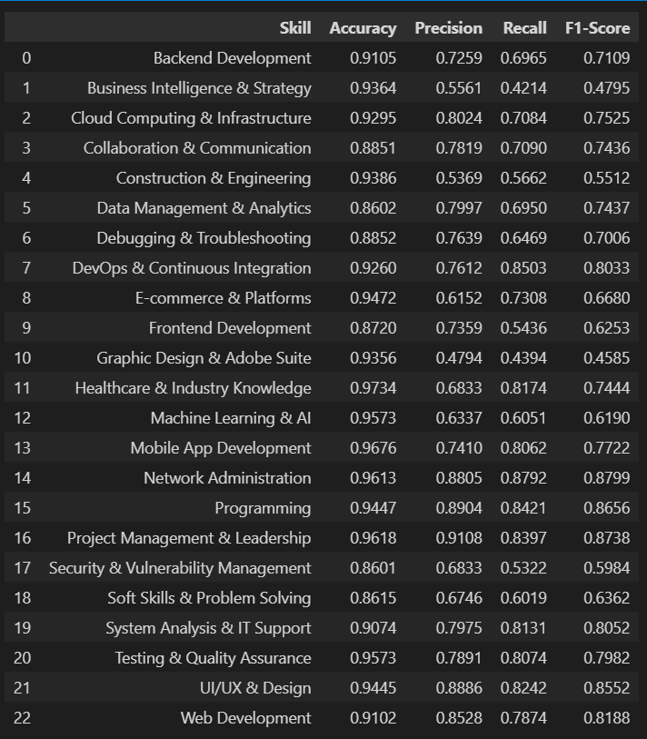

Figure 80: Metrics of XGBoost Base Model

The metrics data table shows how well the basic XGBoost model did, covering a bunch of skills and pointing out its strong and weak spots. With most skills hitting over 0.90 in accuracy, the model actually did extremely well, meaning it has good capability at telling the difference between existing of a skill or not. However, there's some variabilty in how well it can spot the true , especially in keeping track of all the true positives for different skills. For example, skills like "Backend Development" and "Healthcare & Industry Knowledge" demonstrate good recall, showing effective identification of all relevant instances, yet there's room for improvement in precision to minimize false positives.

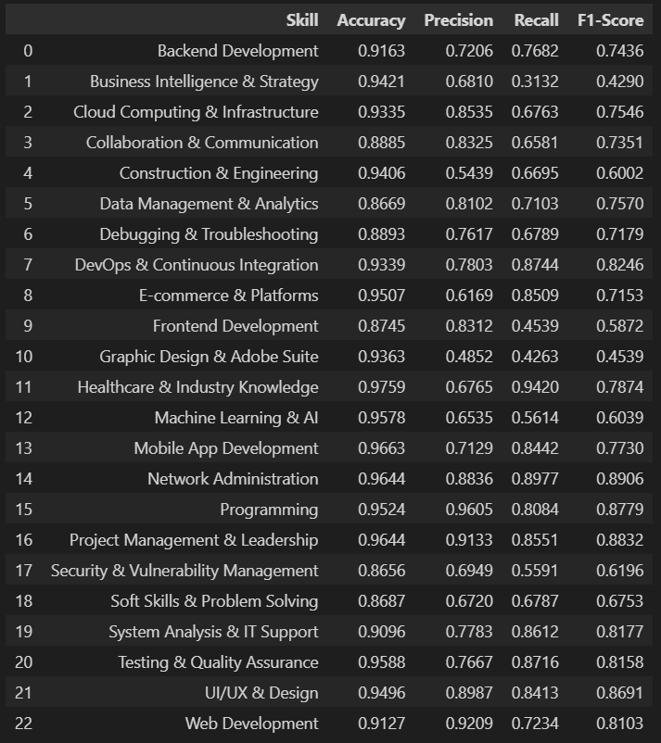

Figure 81: Metrics of XGBoost Tuned Model

The metrics after hyperparameter tuning reflects the performance of the XGBoost model after adjusting its hyperparameters. In general, there's a noticeable enhancement in both precision and recall across most competencies, suggesting that the adjustment process has effectively improved the model's capacity to accurately identify and classify the necessary skills with fewer mistakes. Skills such as "DevOps & Continuous Integration" and "Mobile App Development" have seen significant enhancements in precision, which is crucial for roles that require these skills. The adjustment appears to have particularly aided in finding the right balance between recall and precision, resulting in higher F1-scores for several competencies. When comparing the two datasets, it's clear that the adjustment of hyperparameters has brought about significant advantages, augmenting the model's overall accuracy and its ability to generalize across various data types.

This enhancement is vital for achieving the project's objective of accurately predicting skill requirements in the technology sector, where precision directly affects hiring and training decisions. The rise in F1-scores following the adjustment suggests a more dependable model that can act as a reliable instrument in strategic planning and operational modifications within the technology industry, making the XGBoost model with adjusted parameters an invaluable resource for ongoing analysis and application in your studies on Services Economic and your wider academic endeavors.

### 5.2.4 Evaluation of LightGBM

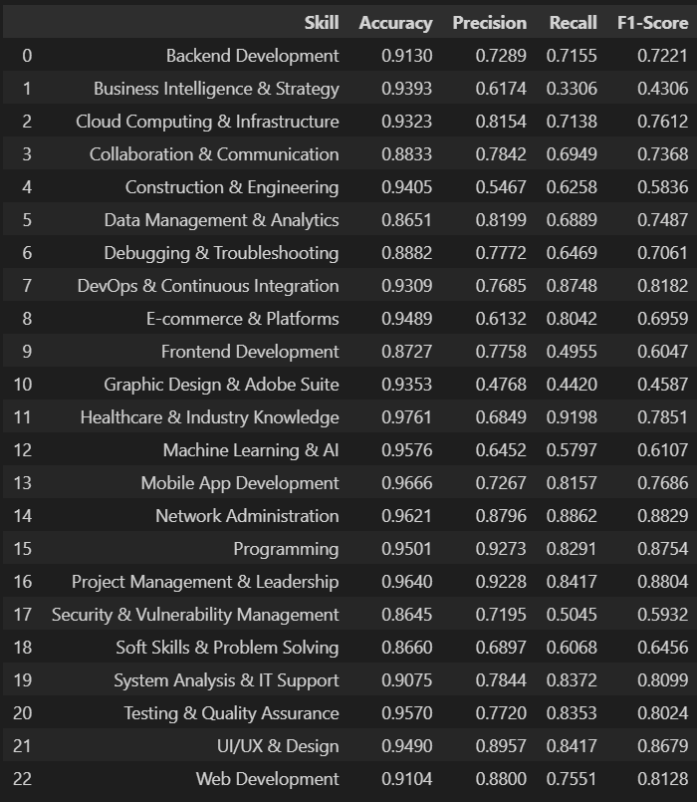

Figure 82: Metrics of LightGBM Base Model

The outcomes from the original LightGBM base model and its version with adjusted hyperparameters reveal a significant divergence, underscoring the model's strengths and weaknesses in the process of optimization. Taking a look into the basic LightGBM model it shows that there are strong performance across various domains, achieving a good balance between accuracy, precision, recall, and F1-scores. Particularly, domains such as "Healthcare & Industry Knowledge" (recall = 0.9198, f1-score = 0.7851) and "Machine Learning & AI" stand out for their high recall and F1-scores, this is suggesting that the model is effective at pinpointing relevant examples of these domains with minimal false negatives.

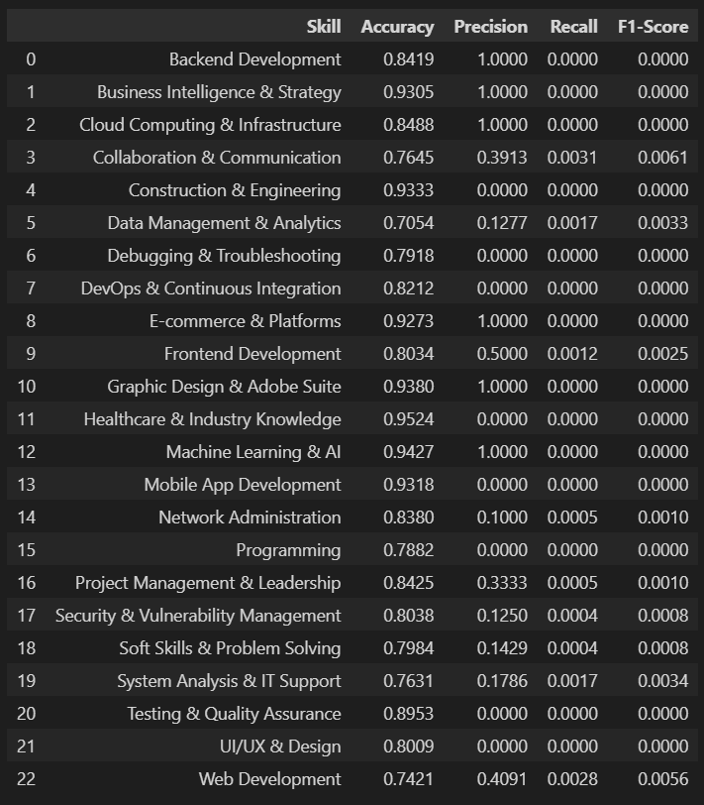

Figure 83: Metrics of LightGBM Tuned Model

Moving on to hp tuned model, however, following the adjustment of hyperparameters, there's a noticeable decline in performance across multiple measures, which is unexpected given that the adjustment is supposed to improve the model's efficiency. The adjusted model shows extreme outcomes, with some domains achieving precision of 1.0 but recall of 0.0, resulting in F1-scores of 0.0. This suggests that while the model accurately identifies a very specific set of positive examples, it misses the majority of positive instances, significantly affecting its overall usefulness. This outcome might be due to overfitting during the adjustment, where the model's parameters were excessively optimized for the training data, leading to a loss of generalizability.

When comparing this two models, it's obvious that the original LightGBM model is more effective and maintains a better balance between correctly identifying true positives and negatives than the adjusted model. The significant differences observed after adjustment highlight the importance of choosing appropriate ranges and values for hyperparameters, as well as the necessity of validating the model on an independent dataset to ensure that the enhancements made during training are applicable in real-world scenarios. This analysis clearly points out the difficulties of adjusting models, especially in complex scenarios with multiple classes, and emphasizes the need for a more sophisticated strategy, time resources and computational resources in optimizing hyperparameters to have a model that have the ability to generalize.

### 5.2.5 Comparison and Discussions

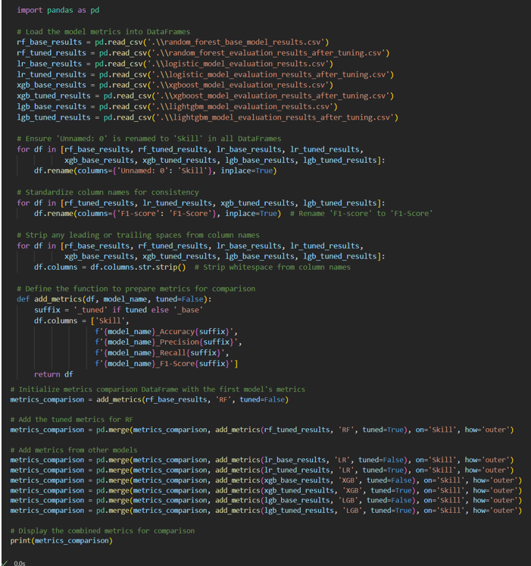

Figure 84: Comparison of Metrics- All Models - Code

This code snippet effectively evaluates performance indicators for all four of the machine learning algorithms, Random Forest, Logistic Regression, XGBoost, and LightGBM, both prior to and following adjustments to their hyperparameters. It begins by importing data from CSV files, normalizing the names of the columns, and eliminating any unnecessary white space to avoid mistakes. A method, `add_metrics`, is used to rename the columns to clearly indicate each model and its adjusted state (whether it's base or tuned), making it easier to understand the data. The program then combines all these datasets into one dataframe, making sure they are aligned by the 'Skill' column. This detailed dataframe, `metrics_comparison`, presents a side-by-side analysis of accuracy, precision, recall, and F1-score for each skill across all models and settings, making it simple to assess the performance of the models and the effects of making adjustments.

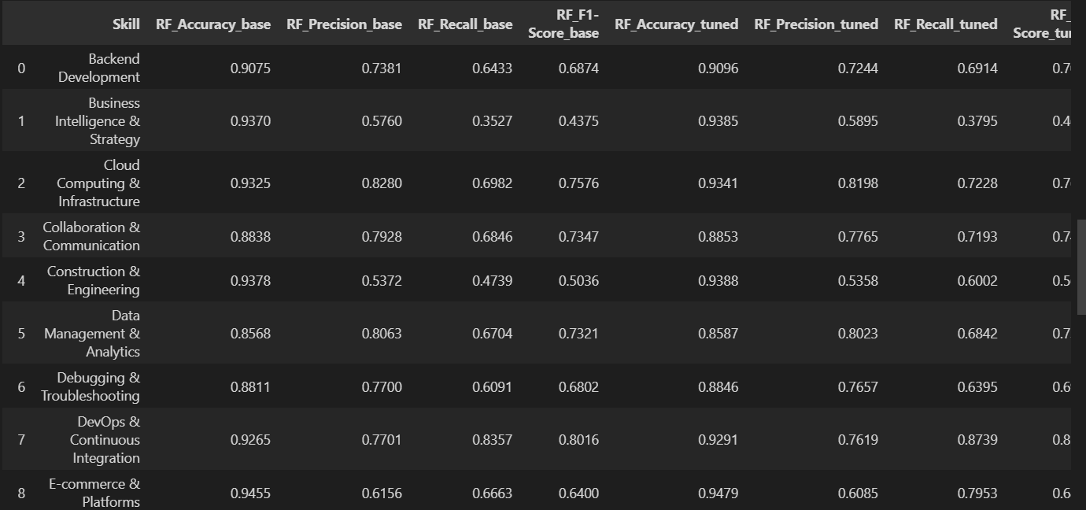

Figure 85: Comparison of Metrics- All Models – Result

This is the results of the concatenation of metrics for all models (based and tuned combined).

Performance Analysis Summary

The Random Forest model has consistently shown better performance following adjustments to its hyperparameters, leading to higher F1-scores across various skills. This indicates that tweaking aspects such as tree depth and the number of trees improved the model's ability to understand the complexities of the data. Both Logistic Regression and XGBoost have also seen improvements after making these adjustments, showing that tweaking learning rates, regularization strengths, and other factors enhanced the models' capacity to perform well across different tasks. LightGBM, however, stands out as an exception, with many skills achieving perfect precision but low recall after tuning, leading to F1-scores of 0. This points to a situation of overfitting, where the model accurately predicts a specific part of the training data but struggles to generalize, likely due to overly aggressive hyperparameter settings during the tuning phase.

Understanding and Application to Goals

The goal of predicting in-demand skills is effectively supported by the models, particularly Random Forest and XGBoost, where the improvements after tuning highlight the models' better ability to manage the complexities and variations in job data. The challenge with LightGBM after tuning calls for a re-examination of the tuning strategy or perhaps a different method for addressing the dataset's inherent biases or imbalances, ensuring that while precision is important, recall cannot be overlooked, leading to a balanced approach for both metrics.

Conclusions and Next Steps

The findings emphasize the need for careful hyperparameter tuning and model selection tailored to the characteristics of the dataset, such as the distribution of features, skewness, and potential class imbalances. Given the varied outcomes with LightGBM, further research into feature engineering, sampling techniques, or even combining models could be considered to boost the model's robustness and accuracy. Continuing to improve these models will directly lead to more precise predictions of skill demand, which is essential for educational institutions, policymakers, and the job market to adjust effectively to future needs.

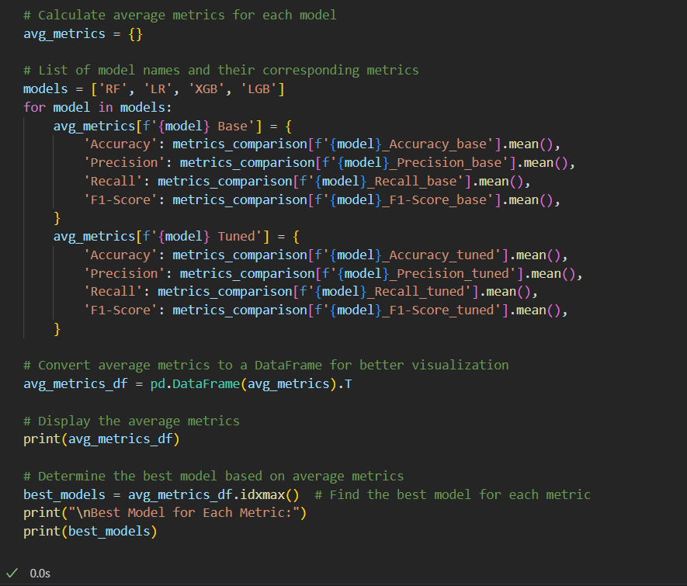

Figure 86: Average Metrics Comparison Code

Moving on, to provide better insights in overall model’s performance, this code block helps to calculates the average performance metrics for both the base and optimized versions of each model. The reason for calculating and comparing the average performance metrics across different machine learning models is to establish a clear benchmark for understanding which models perform best under specific evaluation criteria. This approach is beneficial as it provides a holistic view of each model's effectiveness across all the skills and it helps to identify which model configuration yields the most reliable and robust predictions for in-demand job skills. Such comparisons are crucial for optimizing model selection in this project, ensuring that the final deployment is backed by data-driven decisions that maximize accuracy, precision, recall, and F1-scores in real-world applications. So, the average performance metrics for each model are recorded in a dictionary and then transformed into a pd dataframe for better understanding and visualization. This method offers a clear view of how each model performs before and after adjusting its hyperparameters, providing insights into the effectiveness of the tuning process in enhancing the model's performance.

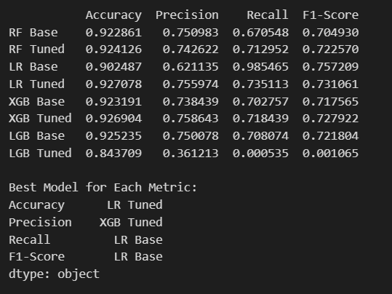

Figure 87: Average Metrics Comparison Code Result

Based on the calculated averages, Logistic Regression (LR) experienced a notable increase in accuracy following optimization and also achieved the highest average recall and F1-score in its original setup, this is maybe due to its efficiency in handling binary data. XGBoost demonstrated improvements in all metrics after optimization, showing its ability to manage complex data with multiple outputs. LightGBM, although it is strong in its base model metrics, but it has experienced a significant drop in performance after tuning, especially in recall and F1-score. This could suggest potential overfitting or insufficient adjustments during the optimization phase.

In short, the code identifies and presents the model with the best performance for each metric, helping in the selection of the best model or configuration for predicting future in-demand job skills effectively. The results of best model for each metrics, logistic regression top at three metrics, accuracy, recall and f1-score. Based on the nature of this project, recall and f1-score will be more important as well as accuracy. In this project, accuracy and F1-score are particularly crucial metrics. Accuracy is important because it measures the overall correctness of the model across all predictions, which is vital when each correct prediction translates directly into valuable insights for job market trends. The F1-score is also critical as it balances precision and recall, providing a more nuanced view of model performance. This balance ensures that the model not only identifies relevant skills accurately but does so in a way that maintains a low rate of incorrect skill predictions.

### 5.2.6 Analysis

Performance of all models in forecasting the high demand technology skills has been evaluated thoroughly here in this Final Year Project and therefore, it has provided an insight into understanding which machine learning algorithms possess capability to forecast for trending skills in Technology domain. A Logistic Regression model has been implemented which showed high accuracy but also balanced F1-score, reflecting a strong capability of this model in identifying important patterns inside the data. These features used in training, for example company size, salary and qualification contribute a lot to the explanation of the dynamics around job requirements in tech related fields. Indeed, this highlights the need to incorporate a variety of fields when looking to improve prediction.

For models, some significant gains were achieved for model performance through hyperparameter tuning on two algorithms Logistic Regression and XGBoost. Of course, the project objectives was achieved brilliantly well as refining these models resulted in dramatic gains in precision, recall and overall accuracy. This underlies the importance of iterative tuning and finding the right algorithm, which again reinforces the notion of agility in machine learning.

These models give huge insights as to the skills that are in demand, and the ones which are not. For instance, the continued demand for skills like Machine Learning, AI and Data Management across disparate models gives vital insights to Job seekers as well as professionals planning to further studying & further skilling up These are one of the top skills in demand for job seekers, Backend Development, Cloud Computing. Online courses, certifications and boot camps these areas will go a long way in securing work. But also that jobs in the tech sector are constantly changing, requiring employees have to embrace a culture of continuous learning. Keeping skills up to date and abreast of new technologies will keep them from being left behind in a tightening job market. Using insights derived from predictive models, employees can be aware of the career paths in demand and align their training choices accordingly.

Furthermore, the thorough examination of technical skills and the detailed nature of the model's results provide valuable strategic perspectives for schools and government officials. The reliability and exactness in forecasting in-demand abilities indicate specific areas for curriculum enhancement. Moreover, the variations found in the model's forecasts, especially concerning the lack of proficiency in interpersonal skills and the ability to solve problems, underscore possible shortcomings in current training and educational initiatives, necessitating a review of existing teaching methods.

Given the results and the aim to accurately forecast in-demand skills, the selected Logistic Regression model will be put into use because it offers the highest level of accuracy among the refined models and shows significant improvements in both precision and F1-score compared to its basic version. Although the basic model has a higher recall rate, the overall improvements in all areas make the refined version a more dependable choice. Choosing Logistic Regression, known for its effectiveness and clarity, confirms its appropriateness for predicting skills in the technology field. Its ability to handle multiple output classifications and provide consistent predictions strengthens its position for this purpose. The project's focus extends beyond just accuracy to include precision and recall, showcasing a deep understanding of the complex nature of forecasting skill demand. Highlighting the F1-score as a unified measure emphasizes the importance of balancing the precision of predicting in-demand skills with the recall needed to identify all relevant skills.

The implications of these findings are significant for various stakeholders. For individuals looking for jobs or professionals, the models act as a guide to the latest trends and key skills. For those in education policy and institutions, the insights from the models can be used to update curricula and create targeted training programs that meet the changing needs of the job market.

In conclusion, the models have achieved the project's goals by providing a dependable system for predicting skill demand in the technology industry. However, the variation in model performance indicates that there is room for further investigation, especially in improving models for skills that have limited data or complex definitions.

.

## 5.3 Model Deployment

Streamlit library was used for model deployment because its simplicity and efficiency in creating interactive web applications for machine learning models. With Streamlit, data scientists can quickly turn Python scripts into user-friendly applications without requiring extensive front-end development skills. This allows to showcase model's predictions and insights in an intuitive manner, so that other stakeholders to easily interact with the model and visualize results. Its real-time data processing capabilities and seamless integration with popular libraries like Pandas, NumPy, and Matplotlib further enhance the user experience, making it an ideal tool for demonstrating the practical applications of predictive analytics projects.

### 5.3.1 Streamlit

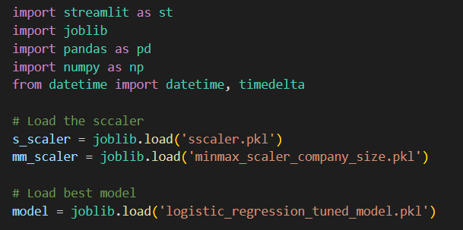

Figure 88: StreamLit Code imports

Firstly, import all the libraries needed. Then, the saved standard scaler pickle file for avg salary and avg experience was loaded for preprocessing use later on. As well as the min max scaler for company size. Lastly, load the best model which is Logistic Regression tuned model for the predictions.

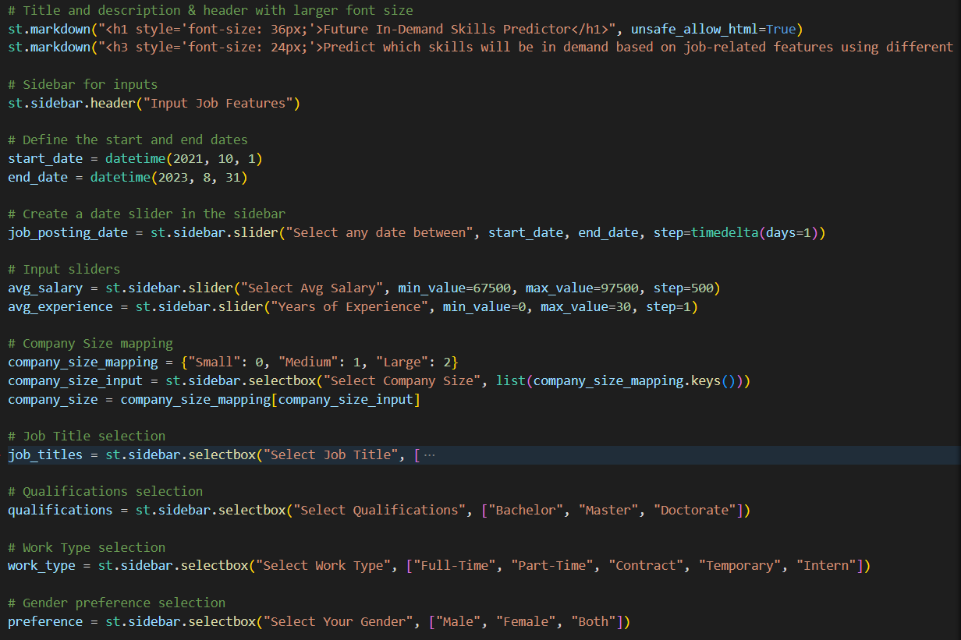

Figure 89: StreamLit code for web interface

This part of the Streamlit code is designed to make it easy for users to add job-related details for predicting in-demand skills. It starts with a clear title and description, with bigger fonts for better readability. A sidebar is used to make it simple for users to input information, like selecting a date range for job postings and adjusting salary and experience levels with sliders. It also has dropdown menus for choosing company size, job titles, qualifications, types of work, and gender preferences, with options to choose from to keep the data consistent. This setup makes it easy for users to provide the necessary details for accurate predictions of in-demand skills based on their job-related information.

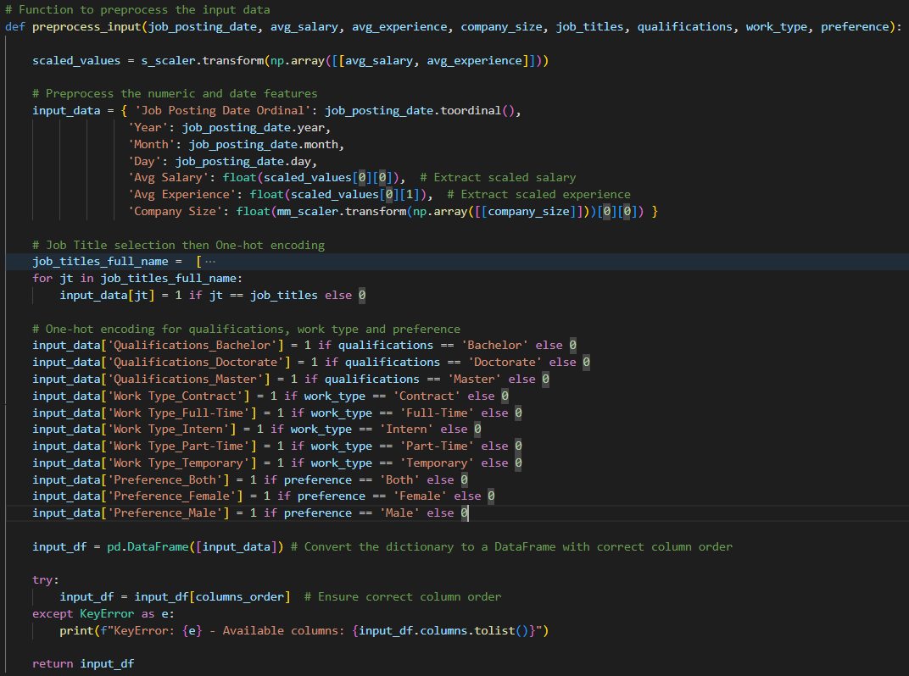

Figure 90: StreamLit Code – Preprocess User Input Function

The `preprocess_input` method is to modify and job-related attributes input by users for input into the Logistic Regression model. First, it employs a scaler to adjust the average salary and years of experience, making sure these numerical inputs are correctly scaled similarity to how it was scaled for the training data for the model. It then transforms the date of the job posting into its numerical order, breaking it down into year, month, and day. Following this, forms a dictionary, `input_data`, to hold these preprocessed input along with the company's size, which is also normalized using a Min-Max scaler. For the job title input, the method uses one-hot encoding by looping over a set of predefined job titles, marking a 1 for the chosen job title and 0 for all others, which helps the model understand categorical data better. This process is repeated for the job title, qualifications, work type, and gender preference inputs, where binary indicators are created based on the user's choices. After filling the `input_data` dictionary with these transformed features, it converts it into a data frame and double check to make sure the columns are in the correct order for the model. Lastly, the method returns the preprocessed df, now ready for use in making predictions.

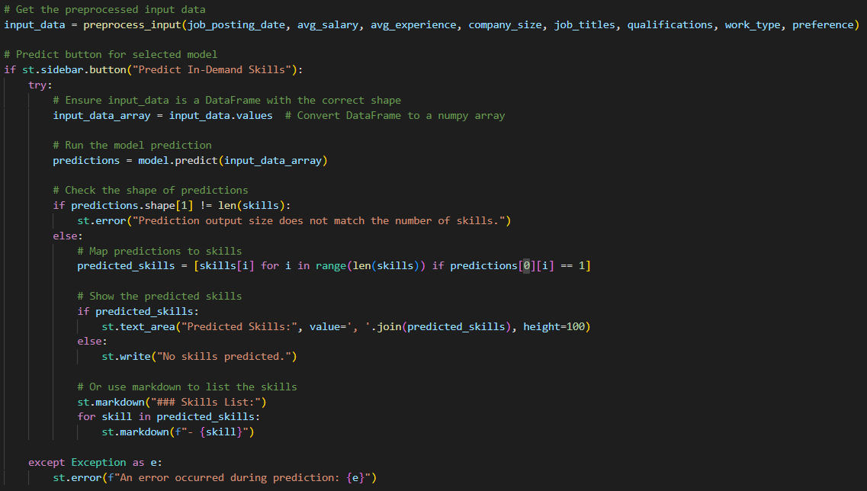

Figure 91: StreamLit Code – Predict Function

This part pulls in the processed data from the `preprocess_input` function and starts predicting in-demand skills when the user presses the "Predict In-Demand Skills" button in the sidebar. When this button is pressed, the app changes the processed df into a numpy array to make sure it works well with the model's prediction function. It then runs the prediction with the logistic regression model and checks if the result matches the expected number of skills. If the result doesn't match, an error message pops up for the user. If the predictions are correct, the app converts the binary values from the predictions into skill names and shows them in a text area. If no skills are predicted, a message is shown to let the user know. The app also uses markdown to make a list of the predicted skills, making the results easier to read and more engaging for the user by showing the results clearly. If there are any problems during the prediction, an error message is shown to let the user know what went wrong.

### 5.3.2 Deployment interface

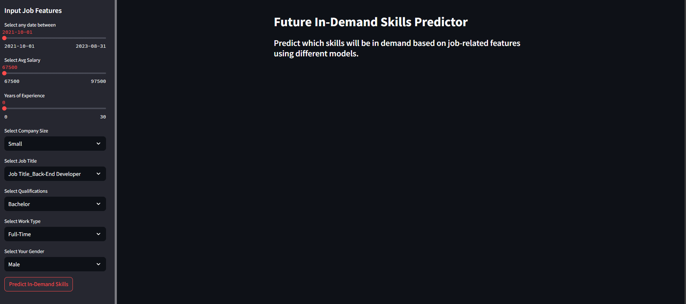

Figure 92: Deployment Interface

So this is how the interface looks like, the input features for the user to choose are at the left hand side, and the output will be shown on right hand side. After selecting all the features the user want to predict, click on predict button and the input will be fetched by the logistic regression model, and it will predict the skills needed for these specific inputs.

### 5.3.3 Predictions

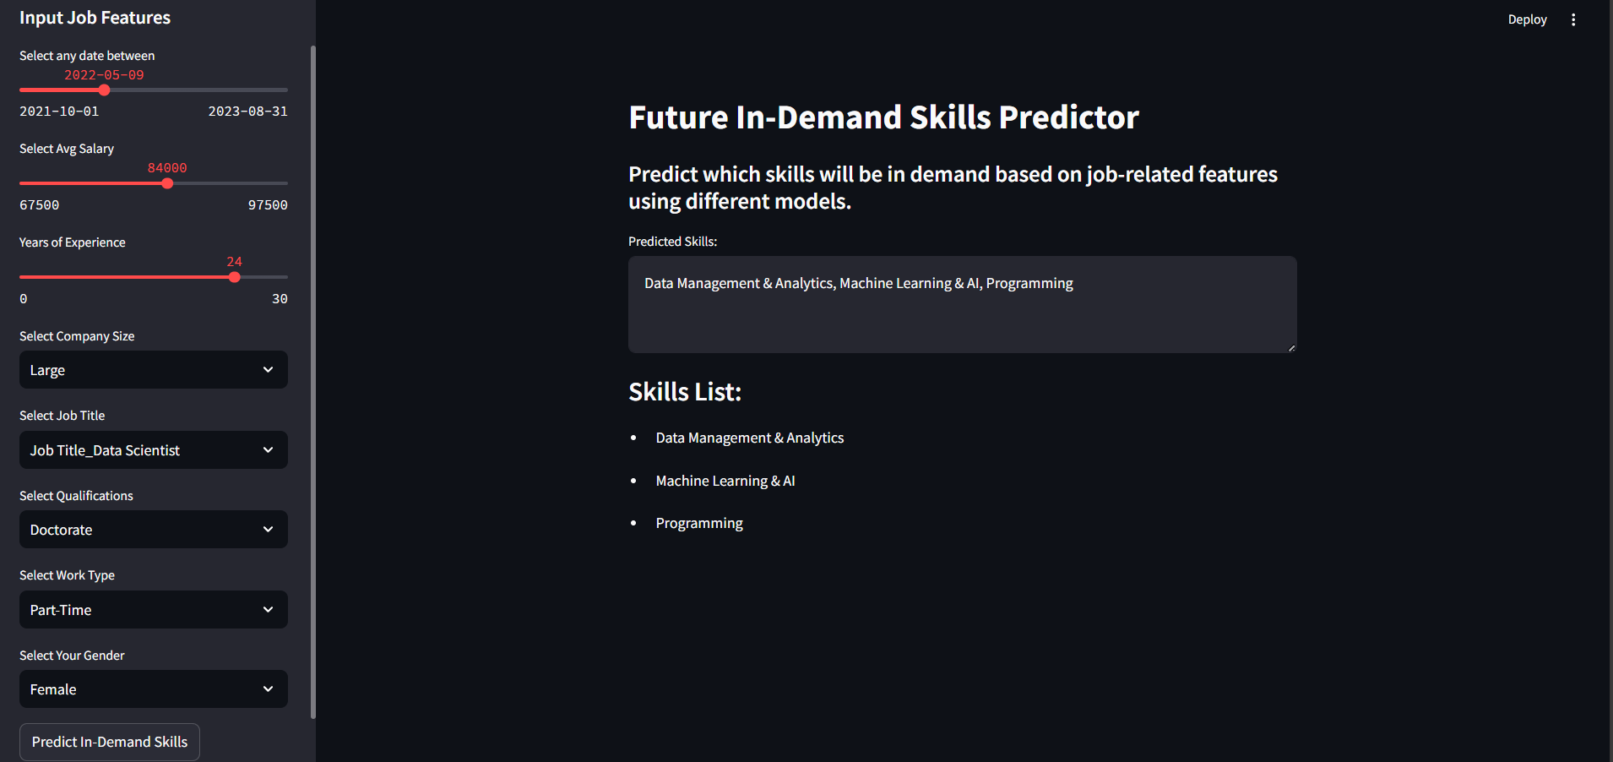

Figure 93: Sample Predictions 1

The results are prominently displayed on the right side, it will list down the predicted skills based on the input features. In this instance, the models predicts that skills such as Data Management & Analytics, Machine Learning & AI, and Programming will be in demand for the specific outputs, it proves that the model’s effectiveness in providing actionable insights for job seekers and professionals aiming to align their skill sets with market needs. Using this clean and organized interface design enhances usability, easier for users to quickly interpret the results of their inputs.

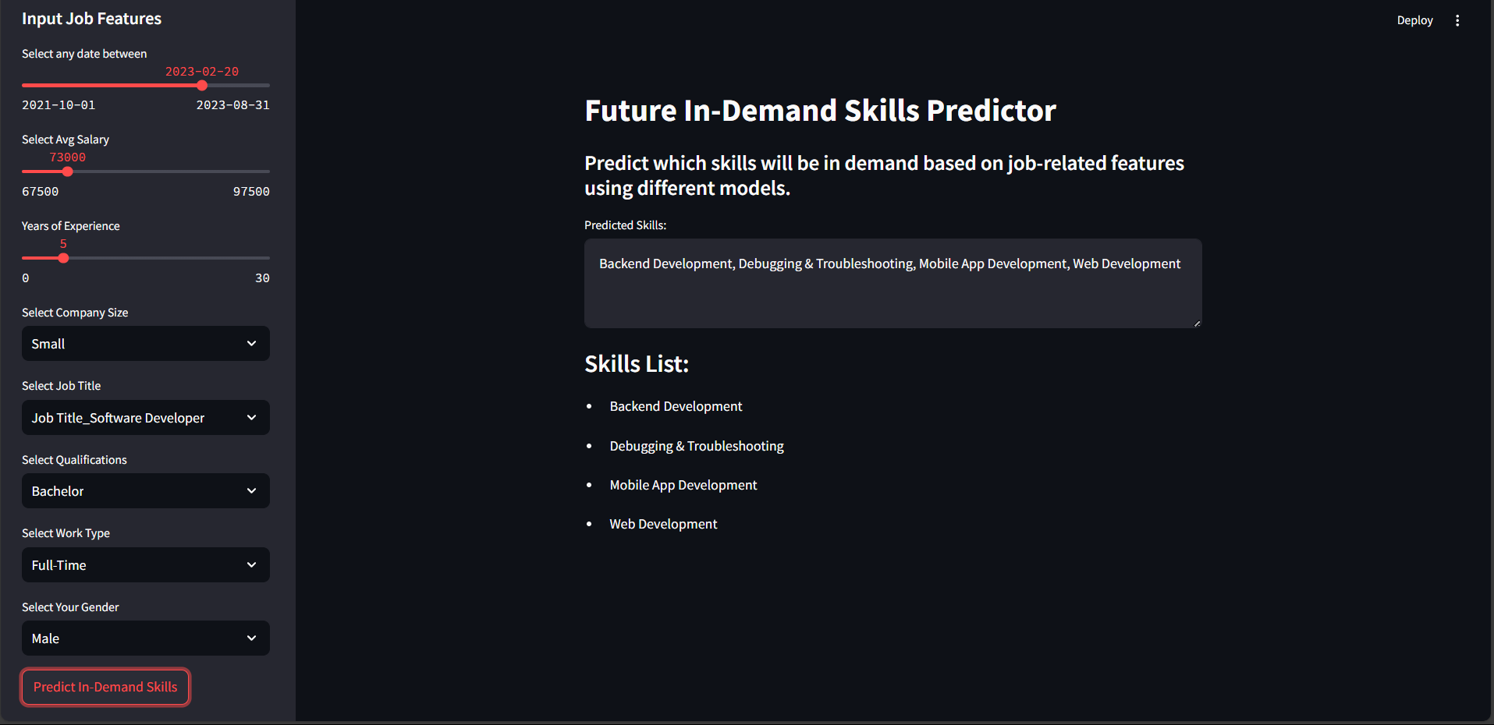

Figure 94: Sample Predictions 2

In this particular sample, the user has chosen "Software Developer" as the job title and set the average salary to 73,000. Upon clicking the "Predict In-Demand Skills" button, the application predicts essential skills and the results are Backend Development, Debugging & Troubleshooting, Mobile App Development, and Web Development. This showcase that the model’s capability to provide targeted insights into the skills that are likely to be in demand, helping job seekers make informed decisions about their career development. The organized layout and clear display of predictions ensure that users can quickly interpret and act on the results, reinforcing the tool's effectiveness in skill forecasting for the tech industry.

## 5.4 Summary

In Chapter 5, a detailed discussion of the results obtained from the deployment and evaluation of various forecasting models developed to predict in-demand skills within the technology sector is presented. Extensive evaluation using metrics such as accuracy, precision, recall, and F1-score assessed the performance of each model, including Random Forest, Logistic Regression, XGBoost, and LightGBM. Each model's performance was rigorously analyzed and compared not only amongst themselves but also against existing benchmarks in the field, leading to insights into their relative strengths and weaknesses.

The implementation of these models was demonstrated through the development of a user-friendly web application using the Streamlit library. This application serves as a practical tool for stakeholders to visualize and interact with the model predictions based on job-related features. Screenshots and visual representations provided in this chapter illustrate the application's functionality, which simplifies the process of skill prediction and enhances the accessibility of the model's insights.Significant improvements were observed through hyperparameter tuning, particularly with the Logistic Regression and XGBoost models, which showed enhanced performance across several metrics. However, challenges such as potential overfitting with the LightGBM model highlighted the delicate balance required in model optimization.

Ultimately, the models developed and deployed successfully met the project's objectives by providing robust tools for predicting skill demand. These tools not only help in strategic planning for educational institutions and policymakers but also empower job seekers to align their career paths with future market needs. The findings from this chapter underscore the importance of continuous model evaluation and adjustment to adapt to the dynamic nature of job market demands, ensuring that the predictive models remain relevant and effective.

# CHAPTER 6: CONCLUSION

This research has navigated through the intricate landscape of job skill demand within the technology sector, with the help of the development of predictive models designed to identify future high-demand skills. The project successfully achieved its goals by employing the CRISP-DM approach to systematically develop, test, and implement machine learning models with practical applications in the real world. Through this effort, the research manage to bridge significant gaps between the skills possessed by workers and the skills required by the job market, thereby contributing to the advancement of **Sustainable Development Goal 8** by facilitating a better match between workforce abilities and labor market needs, thereby promoting productive employment and decent work.

## 6.1 Critical Evaluation

### 6.1.1 Achievements

A major achievement of this project was its direct alignment with its primary objectives: forecasting in-demand skills in the technology sector, enhancing the dependability of machine learning models for such forecasts, and offering actionable insights to stakeholders. The application of various machine learning models, including Random Forest, Logistic Regression, XGBoost and LightGBM, in conjunction with a comprehensive data preprocessing pipeline ensured that the insights were based on robust data practices. Moreover, the deployment of these models through an accessible Streamlit application transformed these findings into a tool that could directly influence decision-making processes, offering essential foresight into the changing needs of the industry with user-friendly interface that is also suitable for all knowledge-based user. The overall project approaches also aligns with SDG 8 by enabling job seekers, students, and professionals to adjust their skills for sustainable economic engagement.

### 6.1.2 Contributions of the Project

The impact of this initiative is wide and substantial. For those looking for employment, the initiative offers a crucial insight into which skills are in high demand, enabling individuals to adjust their education and career paths to meet the needs of the job market. In a rapidly changing job market, this resource is a valuable aid for people seeking meaningful and lasting job opportunities, which directly supports SDG 8 by creating chances for stable employment and economic development.

For employers, this initiative helps overcome the common challenge of identifying candidates with the necessary skills. By forecasting future skill requirements, the model assists companies in making better-informed decisions about hiring and in formulating plans for strategic workforce development that promote organizational expansion and efficiency.

For educators and policymakers, the predictive model offers a reliable foundation for aligning educational programs with the demands of the future workforce. By predicting the emergence of certain skills, educational institutions can develop curricula that are more relevant, adequately preparing students for the ever-changing job market. This also supports SDG 8, especially in ensuring that the workforce is equipped with the skills needed for productive work, helping to decrease underemployment and mismatches in skills.

### 6.1.3 Strength of the Project

A key strength of this project was its application of the CRISP-DM approach, which provided a systematic, progressive process for overseeing the entire data mining lifecycle. This approach guaranteed that every stage—from understanding the business objectives to the implementation of the final model—was in harmony with the project's main goals. The progressive nature of CRISP-DM allowed for ongoing enhancements, ensuring that each iteration improved the accuracy and value of the model.

Another key advantage was the use of multiple models. By applying various machine learning algorithms, each with its own unique capabilities, the project was able to effectively compare and evaluate their performance. This strategy offered a comprehensive analysis of different strategies for solving the prediction challenge and led to a deeper insight into the complexities present in the technology job market.

The third advantage was the application of the model through Streamlit. This application allowed the research to go beyond theoretical studies and be utilized as an interactive, user-friendly tool. Job seekers, students, employers, and other stakeholders could use this tool to access information on in-demand skills, transforming it from an academic exercise into a resource for social and economic growth that aligns with the goals of SDG 8—ensuring access to opportunities for decent employment and economic development.

## 6.2 Limitation

However, the project has its own limitations as well. One significant issue was the **limited scope of the dataset**. The dataset extended only up to 2023, which constrained the analysis's ability to capture long-term trends and shifts in skill demand effectively. Skill requirements in the tech industry can evolve rapidly due to various factors, technological advancements can shift very quickly with new emerging technologies, market dynamics, and economic changes. A dataset that spans a more extended period would allow for a richer historical context, it’s easier to identify of patterns and trends that inform future skill requirements. Additionally, a more extensive and current dataset would enhance the model's capacity to predict not just immediate skills but also those likely to emerge in response to industry changes, thus equipping job seekers with the foresight necessary for proactive career development.

Another considerable challenge faced during the project was **hardware limitations**. The constraints in computational power specifically, insufficient memory and processing speed has restricted the depth and breadth of the analysis. Many machine learning algorithms, particularly those hyperparameter tunings are resource-intensive and require significant computational resources for both training and testing. During the analysis, there were instances where processes failed or took an impractically long time to complete due to memory constraints, therefore causing in delayed insights and a less comprehensive exploration of potential model architectures. These limitations hindered the ability to fine-tune models as deeply as intended, potentially affecting the overall performance of the predictive algorithms. Addressing these hardware challenges in future projects could involve using more robust computing resources, such as cloud computing platforms, which would facilitate more extensive experiments and optimizations.

Moreover, the project predominantly relied on data sourced from **job postings**, neglecting other critical **economic indicators** and comprehensive reports that could provide a broader context. This narrow focus limited the model’s ability to account for macroeconomic factors such as unemployment rates, industry growth trends, and shifts in consumer demand, all of which play a crucial role in shaping skill requirements. Additionally, incorporating qualitative data, such as insights from industry experts or educational institutions, could further enhance the understanding of labor market dynamics. By integrating diverse data sources, the model could improve its predictive accuracy and offer a more holistic understanding of future skill requirements. This broader perspective would not only make the analysis more robust but would also ensure that stakeholders receive well-rounded insights that consider both quantitative and qualitative factors influencing the job market.

## 6.3 Recommendation

For future studies, it is suggested to broaden the sources of data by including various economic reports, trends in technology adoption, and real-time labor market analyses. Incorporating these elements would provide a more detailed understanding of the factors influencing skill demand, offering a more thorough analysis that is more closely aligned with the objectives of SDG 8. Additionally, incorporating a **survey dataset** that captures relevant demographics of job seekers and industry participants could significantly enrich the analysis. Such data would allow for more detailed comparisons and validations against the job posting dataset, providing much deeper insights into the labor market dynamics and the specific needs of different demographic groups.

Moreover, adopting a **temporal approach** could be highly advantageous for enhancing the predictive accuracy of skill demand forecasts. By integrating models that consider time-series data, such as ARIMA or LSTM networks, the analysis could better capture and predict trends over time. These models are designed to recognize patterns and seasonality in historical data, enabling them to identify cyclical fluctuations and long-term trends in skill requirements. For example, seasonal changes may influence the demand for certain skills like increased hiring for software developers during the beginning of the fiscal year or heightened interest in data analytics skills at the end of major project cycles. By incorporating these temporal dynamics, job seekers and policymakers would benefit from a more nuanced understanding of how skill demands evolve, so that they could be proactive and make informed decision in career planning and educational program development.

Furthermore, **combining multiple models into an ensemble** could significantly enhance the robustness and performance of the predictions. Ensemble methods, such as bagging and boosting, leverage the strengths of different algorithms by aggregating their outputs to produce a more accurate and stable prediction. Each model in an ensemble contributes unique insights based on its individual learning patterns and capabilities. For example, a combination of decision trees, logistic regression, and neural networks could provide a comprehensive view of skill demand, addressing different aspects of the data and minimizing the weaknesses inherent in any single model. The variations in their performance across different skills highlight the importance of a mixed strategy. This holistic methodology would be particularly valuable in a complex field like skill demand forecasting, where the relationships between skills and job requirements are often intricate and multifaceted.

# REFERENCES

Acemoglu, D., Autor, D., Hazell, J., & Restrepo, P. (2022). Artificial Intelligence and Jobs: Evidence from Online Vacancies. *Journal of labor economics*, S293-S340.

Asri, H., Mousannif, H., Moatassime, H. A., & Noel, T. (2015). Big data in healthcare: Challenges and opportunities. *2015 International Conference on Cloud Technologies and Applications (CloudTech)*.

Autor, D., & Salomons, A. (2018). Is Automation Labor-Displacing? Productivity Growth, Employment, and the Labor Share. *Brookings Papers on Economic Activity*.

Bajaj, V. (2022). Setup Python environment for data science and machine learning on Visual Studio Code. *Medium*.

Bakhshi, H., Downing, J., Osborne, M., & Schneider, P. (2017). The Future of Skills: Employment in 2030. *Pearson*.

Beilby, J. J. (2018). Workforce innovation: Embracing emerging technologies. *Focus|Profesional*, 522-524.

Cappelli, P. (2015). Skill gaps, skill shortages, and skill mismatches. *ILR Review*, 251–290.

Carta, S., Medda, A., Pili, A., Recupero, D., & Saia, R. (2018). Forecasting E-Commerce products prices by combining an autoregressive Integrated Moving Average (ARIMA) model and Google Trends data. *Future Internet*.

Cohn, M. (2010). Succeeding with agile: software development using Scrum. *Pearson Education*.

Dairu, X., & Shilong, Z. (2021). Machine Learning Model for Sales Forecasting by Using XGBoost. *IEEE*.

Dawson, N., Rizoiu, M.-A., Johnston, B., & Williams, M.-A. (2020). Predicting Skill Shortages in Labor Markets: A Machine Learning Approach. *Social Science Research Network*.

Desjardins, R. (2011). An Analysis of Skill Mismatch Using Direct Measures of Skills. *OECD Education Working Papers*.

Devlin, J., Chang, M.-W., Lee, K., & Toutanova, K. (2018). BERT: Pre-training of Deep Bidirectional Transformers for Language Understanding. *arXiv* , 231-243.

Dubey, A. K., Kumar, A., García-Díaz, V., Sharma, A. K., & Kanhaiya, K. (2021). Study and analysis of SARIMA and LSTM in forecasting time series data. *Sustainable energy technologies and assessments*.

Editor. (2021). *Extreme programming: values, principles, and practices*. Retrieved from AltexSoft: https://www.altexsoft.com/blog/extreme-programming-values-principles-and-practices/

Elazar, Y., & Goldberg, Y. (2018). Adversarial Removal of Demographic Attributes from Text Data. *In Proceedings of the 2018 Conference on Empirical Methods in Natural Language Processing*, 11-21.

Erevelles, S., Fukawa, N., & Swayne, L. (2016). Big Data consumer analytics and the transformation of marketing. *Journal of business research*, 897-904.

Fan, G.-F., Zhang, L.-Z., Yu, M., Hong, W.-C., & Dong, S.-Q. (2022). Applications of random forest in multivariable response surface for short-term load forecasting. *International journal of electrical power & energy systems*.

Fattah, J., Ezzine, L., Aman, Z., Moussami, H. E., & Lachhab, A. (2018). Forecasting of demand using ARIMA model. *International journal of engineering business management*.

Fischer, T., & Krauss, C. (2018). Deep learning with long short-term memory networks for financial market predictions. *European journal of operational research*, 654-669.

Frey, C. B., & Osborne, M. A. (2017). The future of employment: How susceptible are jobs to computerisation? *Technological forecasting & social change/Technological forecasting and social change*, 254-280.

Garcia, D. M., Clarke, W., Lucherini, E., Baldwin, T., Neto, D., Rogerio, D., & Das, S. (2022). Practical Skills Demand Forecasting via Representation Learning of Temporal Dynamics. *AIES*.

Gonen, H., & Goldberg, Y. (2019). Lipstick on a Pig: Debiasing Methods Cover up Systematic Gender Biases in Word Embeddings But do not Remove Them. *In Proceedings of the 2019 Conference of the North American Chapter of the Association for Computational Linguistics: Human Language Technologies, Volume 1 (Long and Short Papers)*, 609–614.

Herath, M., & Perera, P. (2023). Overview of generic project management methodologies, frameworks, and standards. In M. Herath, & P. Perera, *WORLD SCIENTIFIC eBooks* (pp. 9-40).

Hochreiter, S., & Schmidhuber, J. (1997). Long Short-Term memory. *Neural computation*, 1735-1780.

Hoque, M. R., & Islam, M. (2023). Predicting Job Skills in Demand: A Big Data Approach. *Dhaka University Journal of Business Studies,*, 221–239.

Hornstein, A., Krusell, P., & Violante, G. (2005). The effects of technical change on labor market inequalities. In *Handbook of economic growth* (pp. 1275–1370).

Hotz, N. (2024). *What is CRISP DM?* Retrieved from Data Science Process Alliance: https://www.datascience-pm.com/crisp-dm-2/

Hovy, D., & Søgaard, A. (2015). Tagging Performance Correlates with Author Age. *In Proceedings of the 53rd Annual Meeting of the Association for Computational Linguistics and the 7th International Joint Conference on Natural Language Processing*.

Hu, T., & Song, T. (2019). Research on XGboost academic forecasting and analysis modelling. *Journal of physics. Conference series*.

Imran, S. (2023). *Project Management Framework Guide | Sprintzeal*. Retrieved from Sprintzeal.com: https://www.sprintzeal.com/blog/project-management-framework

Johnson, M., Jain, R., Brennan-Tonetta, P., Swartz, E., Silver, D., Paolini, J., . . . Hill, C. (2021). Impact of big data and artificial intelligence on industry: Developing a Workforce Roadmap for a data Driven economy. *Global Journal of Flexible Systems Management/Global journal of flexible systems management*, 197-217.

Kapeliushnikov, R. (2019). The phantom of technological unemployment. *Russian journal of economics*, 88-116.

Koehrsen, W. (2020). *Random Forest Simple explanation - Will Koehrsen - medium*. Retrieved from Medium: https://williamkoehrsen.medium.com/random-forest-simple-explanation-377895a60d2d

Korkut, T. (2023). *Excelling in Software Development with Scrum Methodology Part 2*. Retrieved from Medium: https://blog.stackademic.com/excelling-in-software-development-with-scrum-methodology-part-2-e2d0b29437ce

Kuhrmann, M., Diebold, P., Münch, J., Tell, P., Garousi, V., Felderer, M., & Trektere, K. (2017). Hybrid software and system development in practice: waterfall, scrum, and beyond. *ICSSP 2017: Proceedings of the 2017 International Conference on Software and System Process*, 30-39.

Laoyan, S. (2024). *What is Agile Methodology? (A Beginner’s Guide) [2024] • Asana*. Retrieved from Asana: https://asana.com/resources/agile-methodology

Lavender, A. (2022). *Lean Methodology*. Retrieved from LifeQI: https://blog.lifeqisystem.com/what-is-lean

LeCun, Y., Bengio, Y., & Hinton, G. (2015). Deep learning. *Nature*, 436-444.

Leino, K. R. (2014). The DAFNY Integrated Development Environment. *arXiv (Cornell University)*, 3-15.

Lukauskas, M., & Ruzgaz, T. (2023). Reduced Clustering Method Based on the Inversion Formula Density Estimation. *Mathematics*, 12.

Lukauskas, M., Šarkauskaitė, V., Pilinkienė, V., Stundžienė, A., Grybauskas, A., & Bruneckienė, J. (2023). Enhancing Skills Demand Understanding through Job Ad Segmentation Using NLP and Clustering Techniques. *Applied sciences*.

Lyu, W., & Liu, J. (2021). Soft skills, hard skills: What matters most? Evidence from job postings. *Applied Energy*.

Mauro, A. D., & Greco, M. (2017). Human resources for Big Data professions: A systematic classification of job roles and required skill sets. *Information Processing & Management*.

Maximin Coavoux, S. N. (2018). Privacy-preserving neural representations of text. *In Proceedings of the 2018 Conference on Empirical Methods in Natural Language Processing*, 1-10.

Maynard, D. C., Joseph, T., & Maynard, A. (2006). Underemployment, job attitudes, and turnover intentions. *Journal of Organizational Behavior*, 509–536.

McInnes, L., Healy, J., & Melville, J. (2018). UMAP: Uniform Manifold Approximation and Projection for Dimension Reduction. *arXiv*.

Mokyr, J., Vickers, C., & Ziebarth, N. (2015). The history of technological anxiety and the future of economic growth: Is this time different? *The journal of economic perspectives/The Journal of economic perspectives*, 31-50.

Mukozho, D., & Lisa F. Seymour. (2021). Dealing with the Challenge of Business Analyst Skills Mismatch in the Fourth Industrial Revolution. *In Lecture notes in business information processing*, pp. 111–120.

Mutascu, M. (2021). Artificial intelligence and unemployment: New insights. *Economic analysis and policy*, 653-667.

Naqa, I. E., & Murphy, M. (2015). What is machine learning? In *Springer eBooks* (pp. 3-11).

Nguyen, Q. P., & Vo, D. (2022). Artificial intelligence and unemployment:An international evidence. *Structural change and economic dynamics*, 40-55.

Nilsson, N. J. (1984). Artificial Intelligence, Employment, and Income. *AI Magazine*.

*O*NET 29.0 database at O*NET Resource Center*. (n.d.). Retrieved from https://www.onetcenter.org/database.html#overview

Patil, M., & Suresh, M. (2019). Modelling the Enablers of workforce Agility in IoT Projects: A TISM approach. *Global Journal of Flexible Systems Management/Global journal of flexible systems management*, 157-175.

Pellizzari, M. M., & Fichen, A. A. (2017). A new measure of skill mismatch: theory and evidence from PIAAC. *IZA Journal of Labor Economics*.

Pentland, A. (., Daggett, M., & Hurley, M. (2019). Human-AI Decision Systems. *MIT Connection Science the Technology of Innovation*.

Pernstål, J., Feldt, R., & Gorschek, T. (2013). The lean gap: A review of lean approaches to large-scale software systems development. *Journal of systems and software/The Journal of systems and software*, 2797-2821.

Piva, M., & Vivarelli, M. (2017). Technological change and employment: Were Ricardo and Marx right? *Social Science Research Network*.

Radlińska, K. (2023). Theoretical concept of labor underutilization - how to optimize labor demand? *Forum for social economics/The Forum for social economics*, 1-17.

Rahmani, H., Groot, W., & Rahmani, A. (2023). A predictive analytics solution matching job seekers' talent and employers' demands based on machine learning. *Research Square (Research Square)*.

Rajnai, Z., & Kocsis, I. (2017). Labor market risks of industry 4.0, digitization, robots and AI. *In IEEE 15th International Symposium on Intelligent Systems and Informatics, Proceedings*.

Rana., R. S. (2023). *Job Dataset*. Retrieved from Kaggle.: https://doi.org/10.34740/KAGGLE/DS/3749643

Rostron, M. T. (2024). How will artificial intelligence affect jobs 2024-2030. *Nexford University*.

Roubini, N. (2014). Where will all the workers go? . *Project Syndicate*.

Saad, Z. A. (2023). Systematic Literature Review: An Analysis of Skill Mismatch Measurement. *European Proceedings of Finance and Economics*, pp. 391-408.

Schwaber, K., & Sutherland, J. (2020). *The Scrum Guide.*

Shah, D. S., Schwartz, H. A., & Hovy, D. (2020). Predictive Biases in Natural Language Processing Models: A Conceptual Framework and Overview. *Association for Computational Linguistics.*

Sharma, I. P., Nguyen, T., Singh, S., & Ongwere, T. (2024). Predicting an optimal Medication/Prescription regimen for patient discordant chronic comorbidities using Multi-Output models. *Information*, 31.

Shrivastava, A., Jaggi, I., Katoch, N., Gupta, D., & Gupta, S. (2021). A Systematic review on extreme programming. *Journal of physics. Conference series*.

Siami-Namini, S., Tavakoli, N., & Namin, A. S. (2019). A Comparison of ARIMA and LSTM in Forecasting Time Series. *IEEE*.

Sole, A. D. (2021). Introducing Visual Studio code. In A. D. Sole, *Apress eBooks* (pp. 1-15).

Srivastava, A., Sukriti, S., & Saraswat, S. (2017). SCRUM model for agile methodology. In *2017 International Conference on Computing, Communication and Automation (ICCCA)* (pp. 864-869).

Sun, T., Gaut, A., Tang, S., Huang, Y., ElSherief, M., Zhao, J., . . . Wang, W. Y. (2019). *Mitigating Gender Bias in Natural Language Processing: Literature Review.* Association for Computational Linguistics.

Tan, J., Chen, Y., & Jiao, S. (2023). *Visual Studio code in Introductory Computer Science Course: An Experience Report*. Retrieved from arXiv.org: https://arxiv.org/abs/2303.10174

Terra, J. (2024). *Why Python is essential for data analysis and data science*. Retrieved from Simplilearn.com: https://www.simplilearn.com/why-python-is-essential-for-data-analysis-article

Tseng, F.-M., & Tzeng, G.-H. (2002). A fuzzy seasonal ARIMA model for forecasting. *Fuzzy sets and systems*, 367-376.

Udodov, J. (2023). *Kanban Methodology. What is Kanban?* Retrieved from Bordio: https://bordio.com/blog/kanban-methodology/

Varian, H. R. (2014). Big Data: New tricks for econometrics. *The journal of economic perspectives/The Journal of economic perspectives*, 3-28.

Vaswani, A., Shazeer, N., Parmar, N., Uszkoreit, J., Jones, L., Gomez, A. N., . . . Polosukhin, I. (2017). *Advances in Neural Information Processing Systems.* Curran Associates, Inc.

Wakode, R. B., Raut, L., & Talmale, P. (2015). Overview on Kanban Methodology and its Implementation. *International Journal for Scientific Research & Development*, 2518-2521.

Weichselbraun, A., Süsstrunk, N., Waldvogel, R., Glatzl, A., Braşoveanu, A., & Scharl, A. (2024). Anticipating Job Market Demands—A deep learning approach to determining the future readiness of professional skills. *Future internet*, 144.

Woke, G. (2023). *The difference between libraries and frameworks*. Retrieved from Simple Talk: https://www.red-gate.com/simple-talk/development/other-development/the-difference-between-libraries-and-frameworks/#:~:text=What%20are%20libraries%3F,be%20called%20upon%20as%20needed.

Xu, D., Shi, Y., Tsang, I., Ong, Y.-S., Gong, C., & Shen, X. (2019). Survey on Multi-Output Learning. *IEEE Transactions on Neural Networks and Learning Systems*.

Yazdanian, R., Davis, R., Guo, X., Lim, F., Dillenbourg, P., & Kan, M.-Y. (2022). On the radar: Predicting near-future surges in skills’ hiring demand to provide early warning to educators. *Computers and education. Artificial intelligence*.

# APPENDICES

## Appendix A: PPF



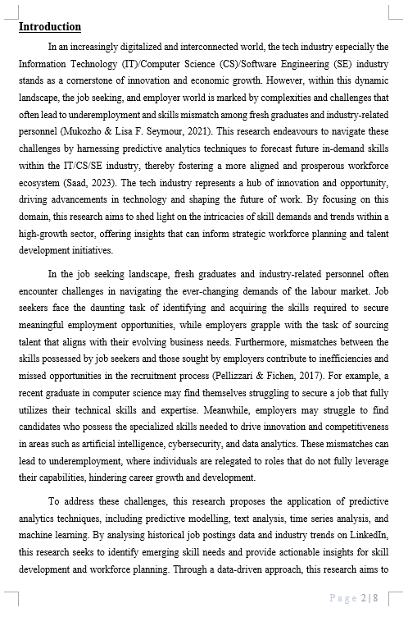

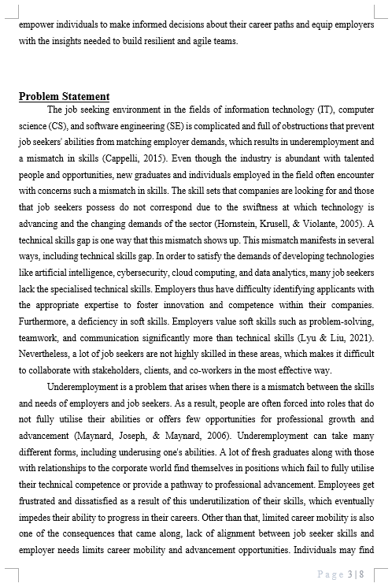

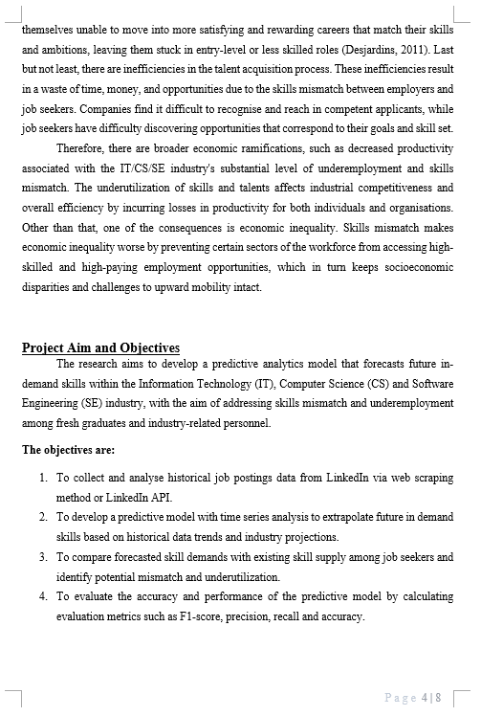

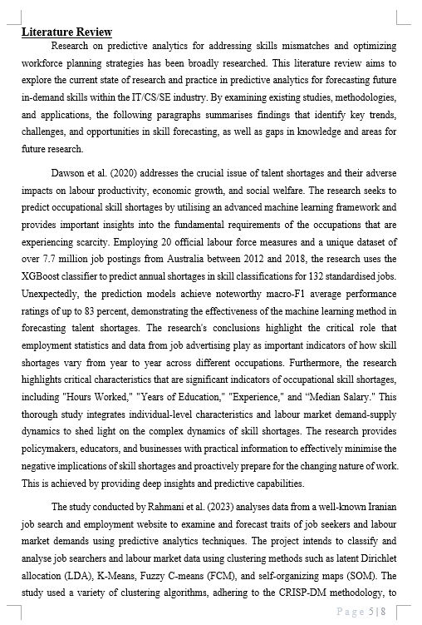

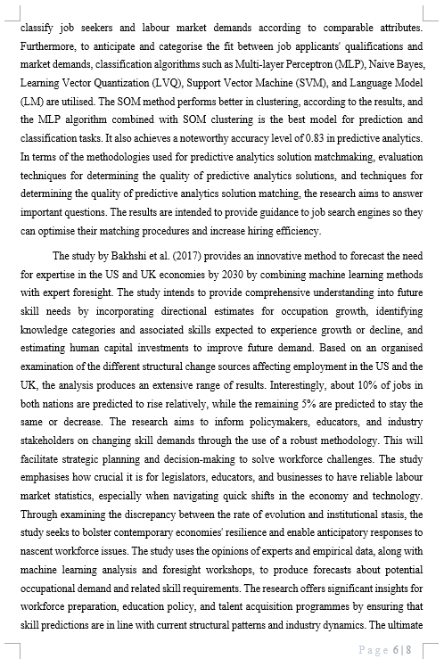

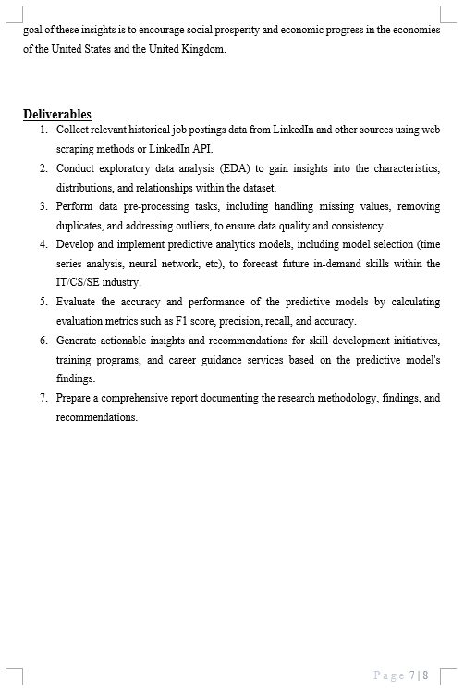

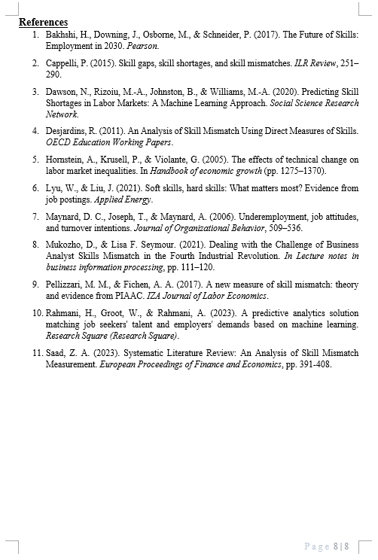

## Appendix B: Ethics Forms









## Appendix C: Log Sheets















## Appendix D: Poster

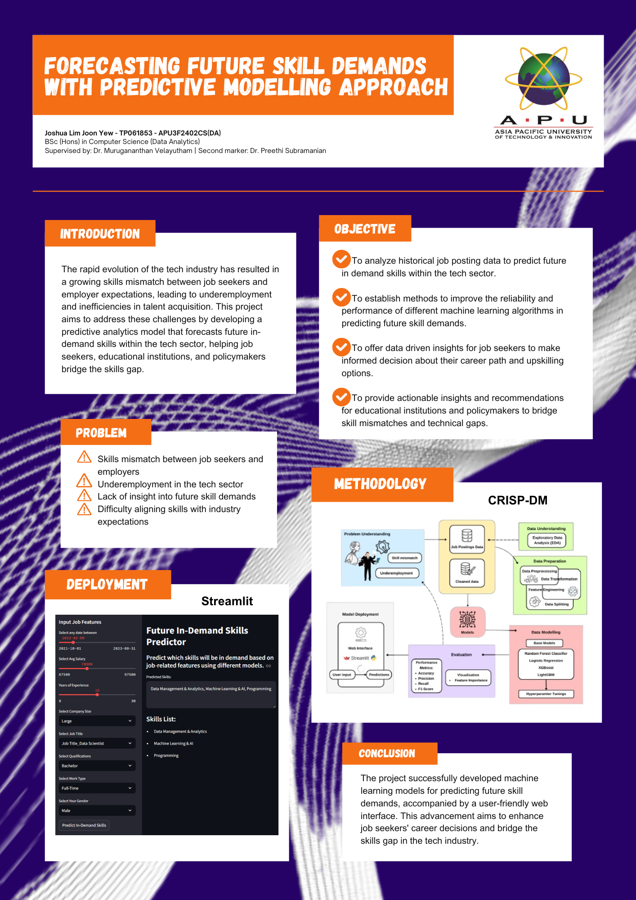

Figure 95: FYP Poster

## Appendix E: Gantt Chart

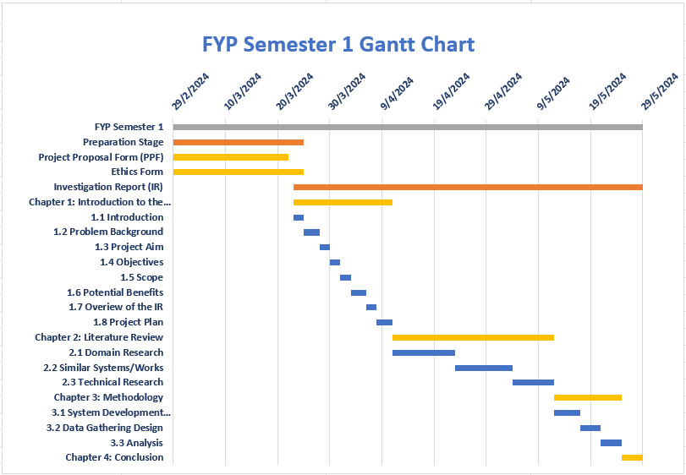

Figure 96: Gantt Chart Semester 1

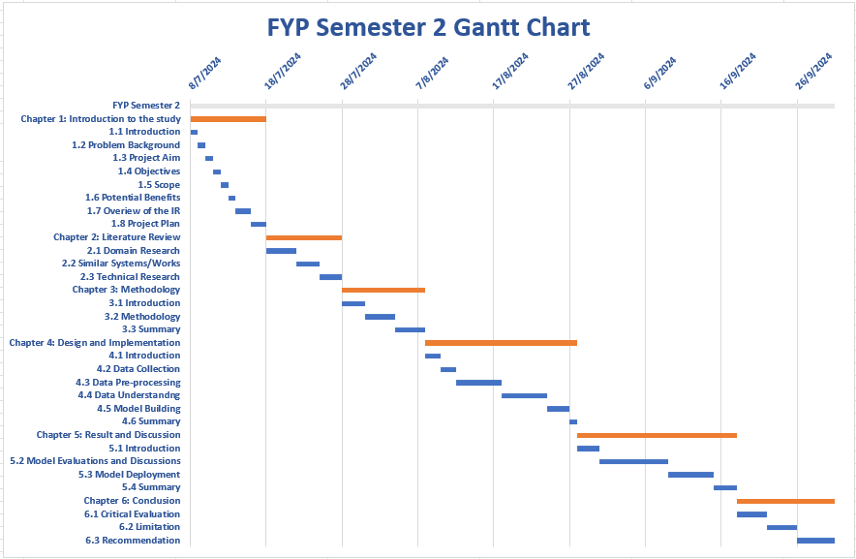

Figure 97: Gantt Chart Semester 2

## Appendix F: Sample Code Implementation

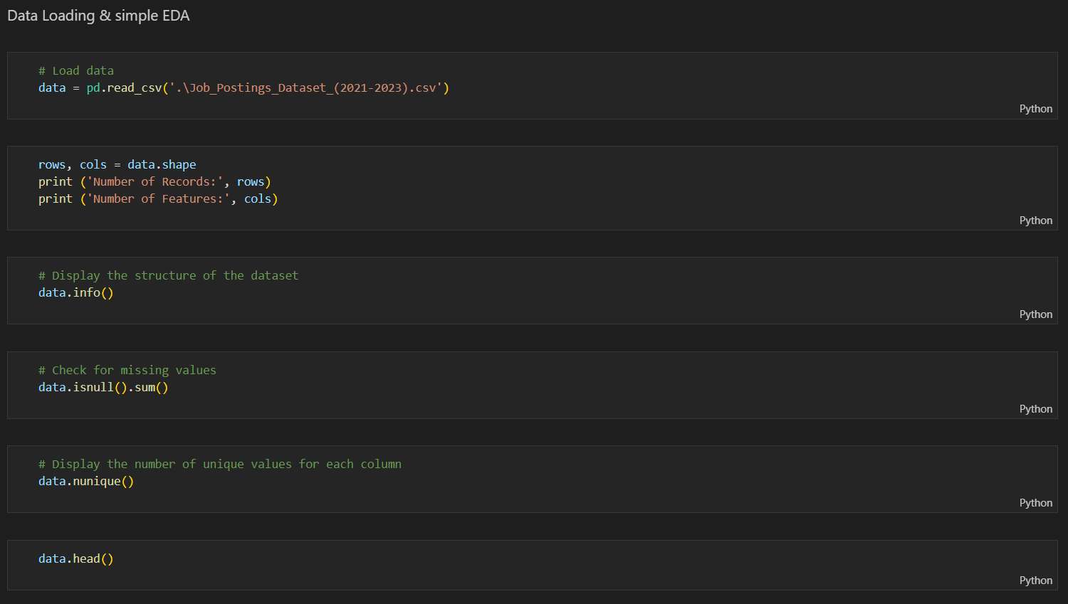

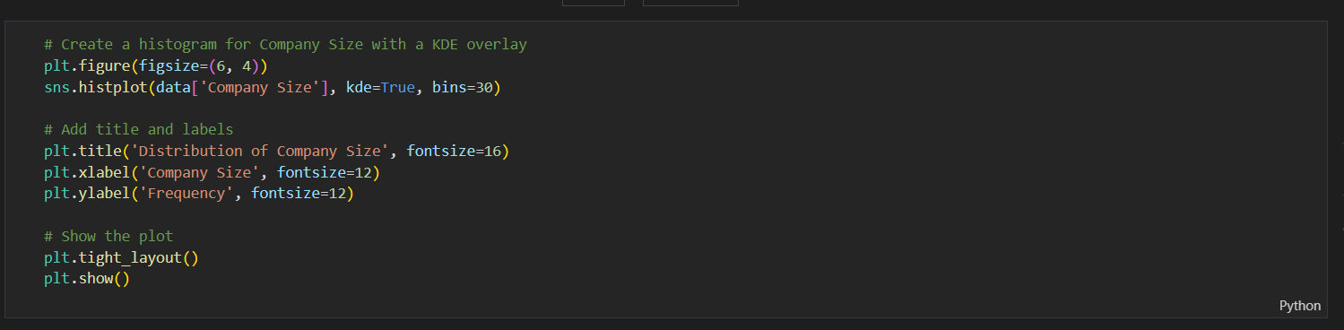

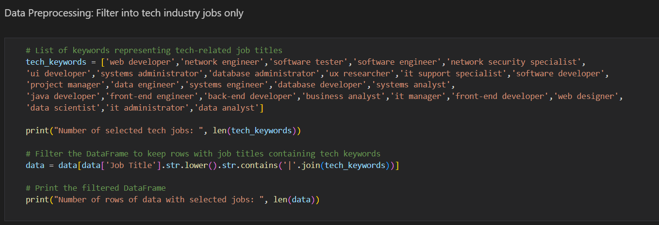 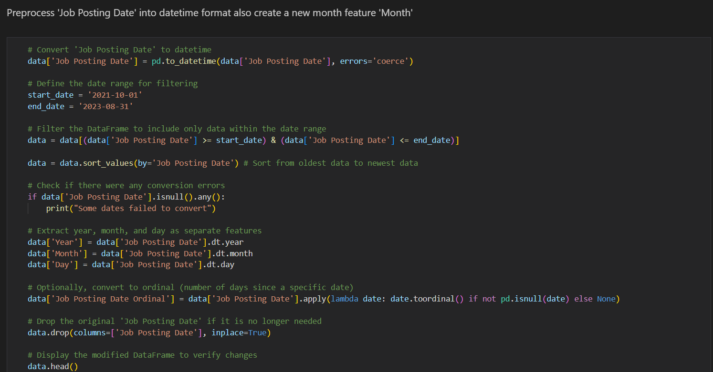 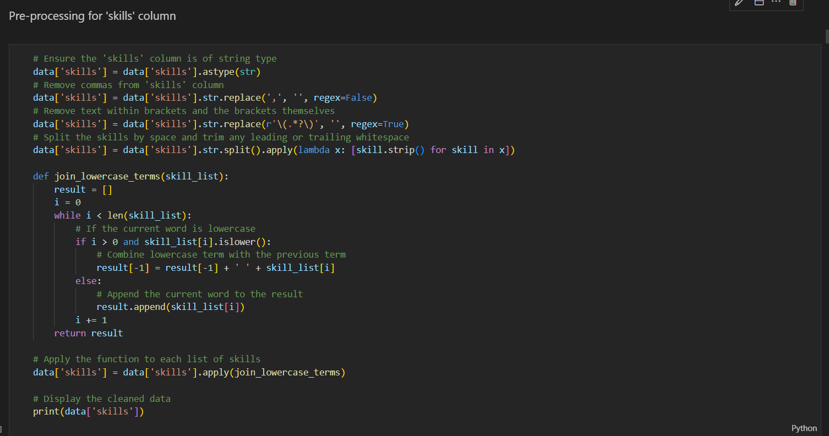 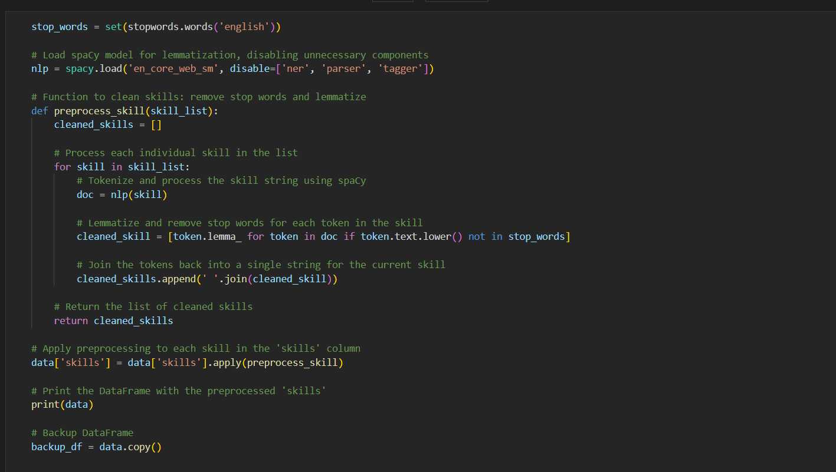 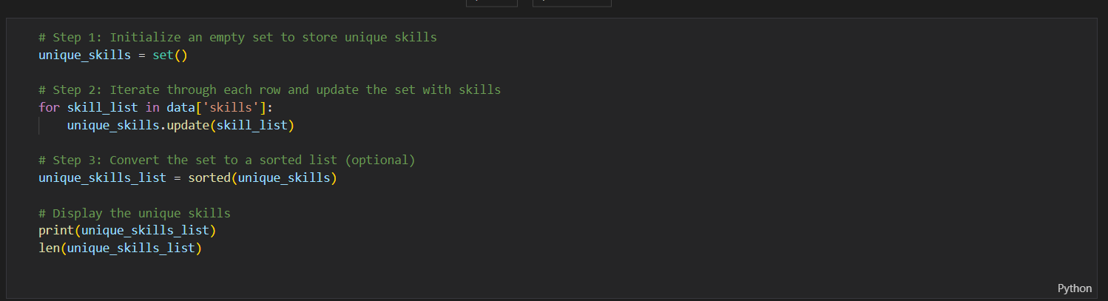 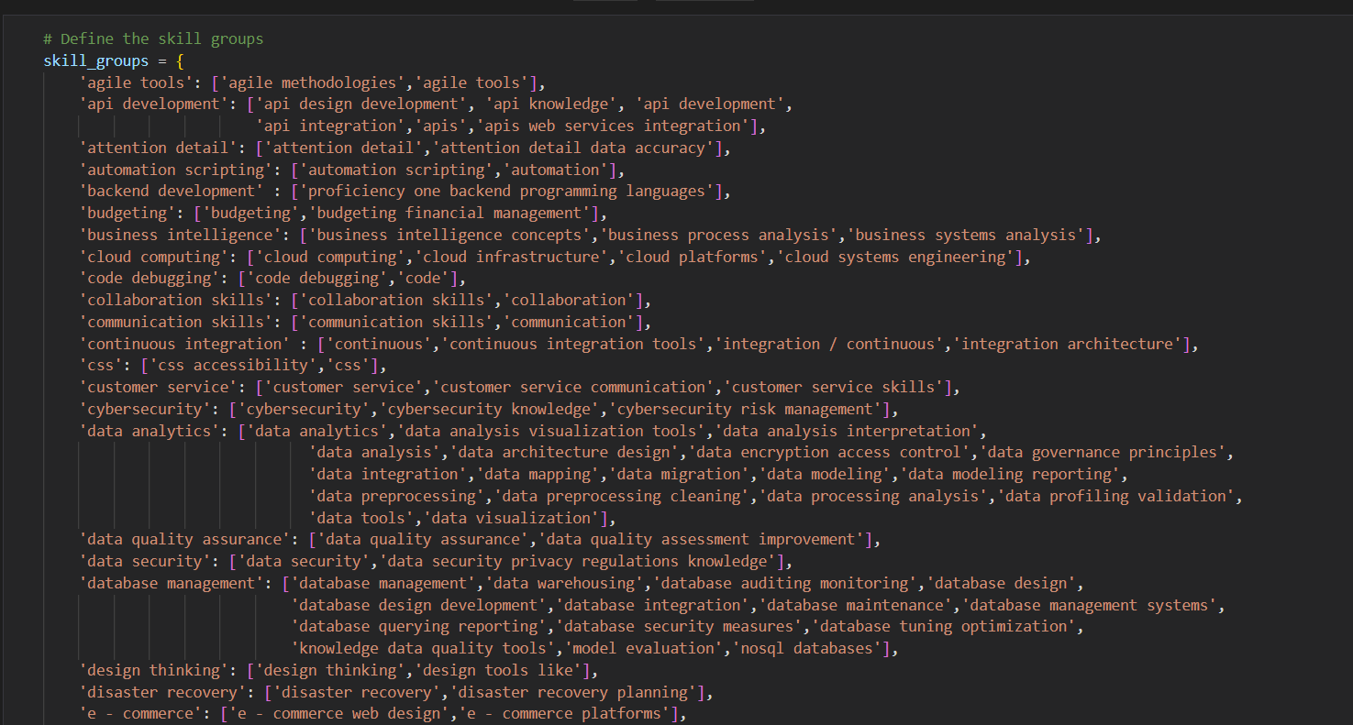 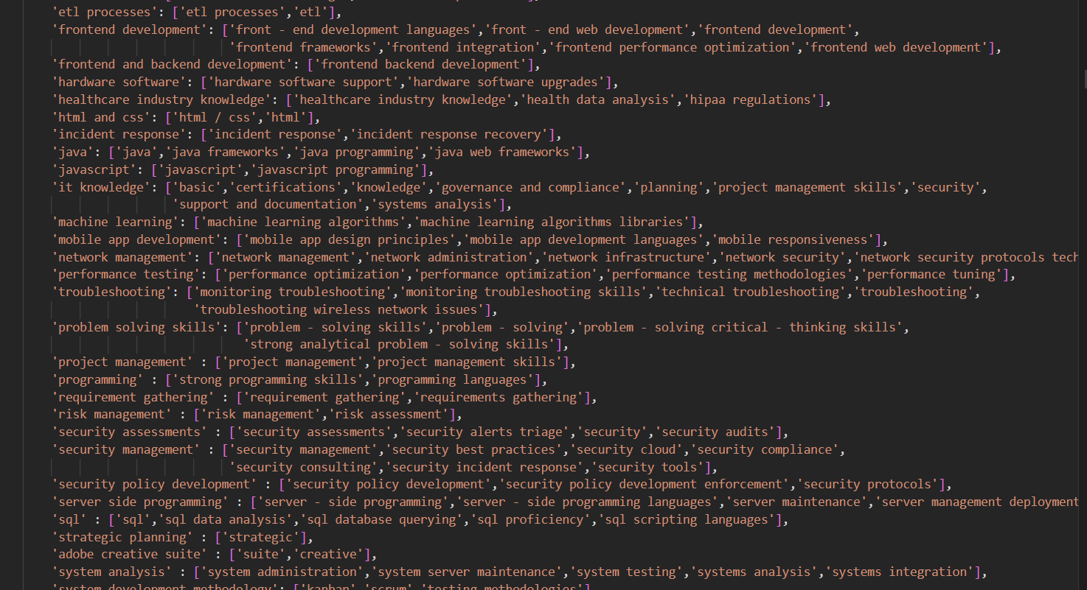 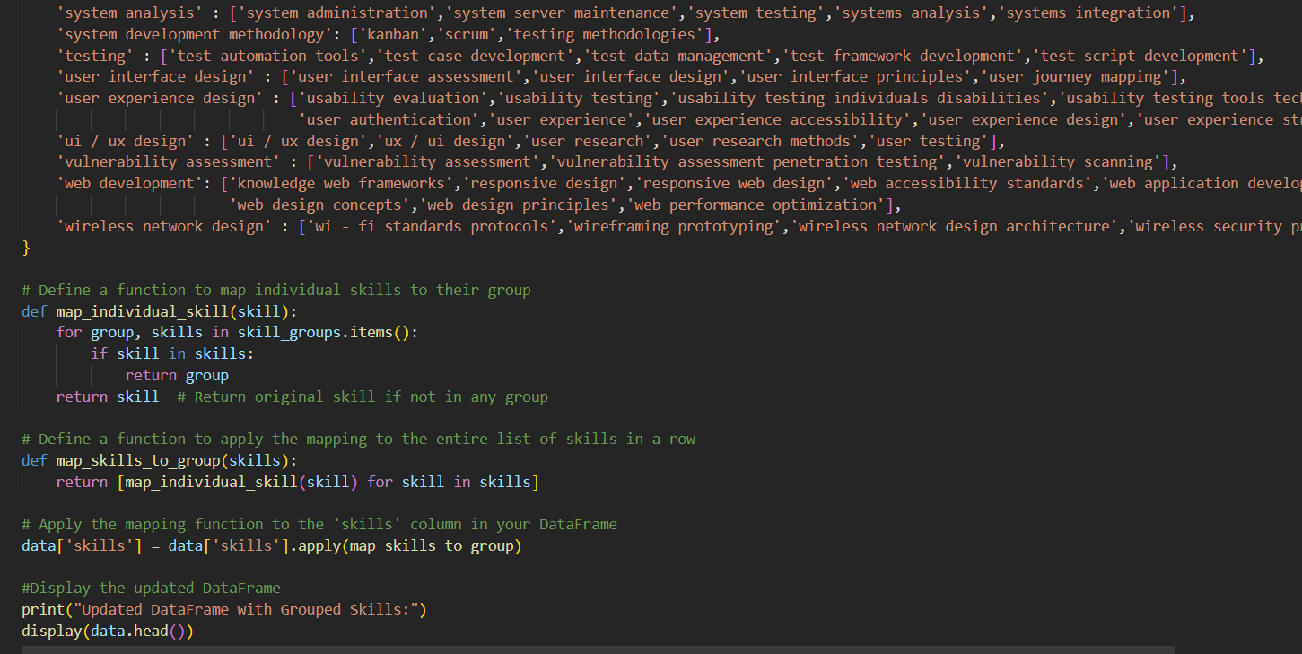 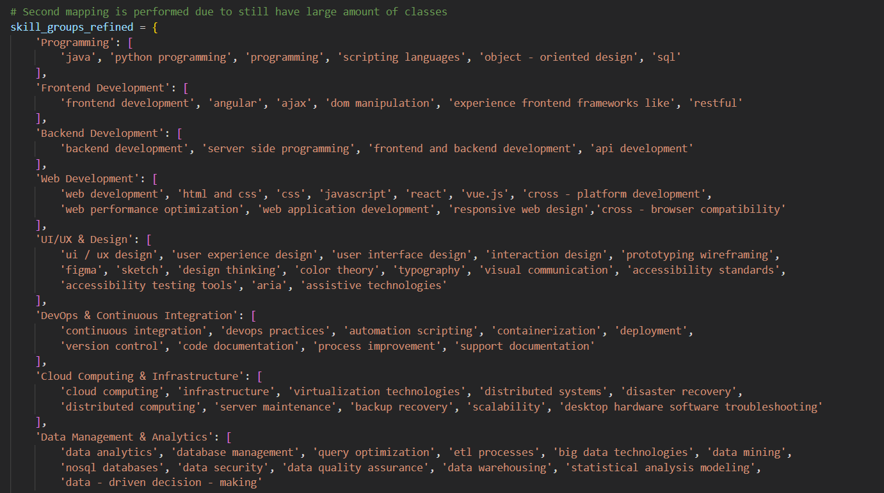 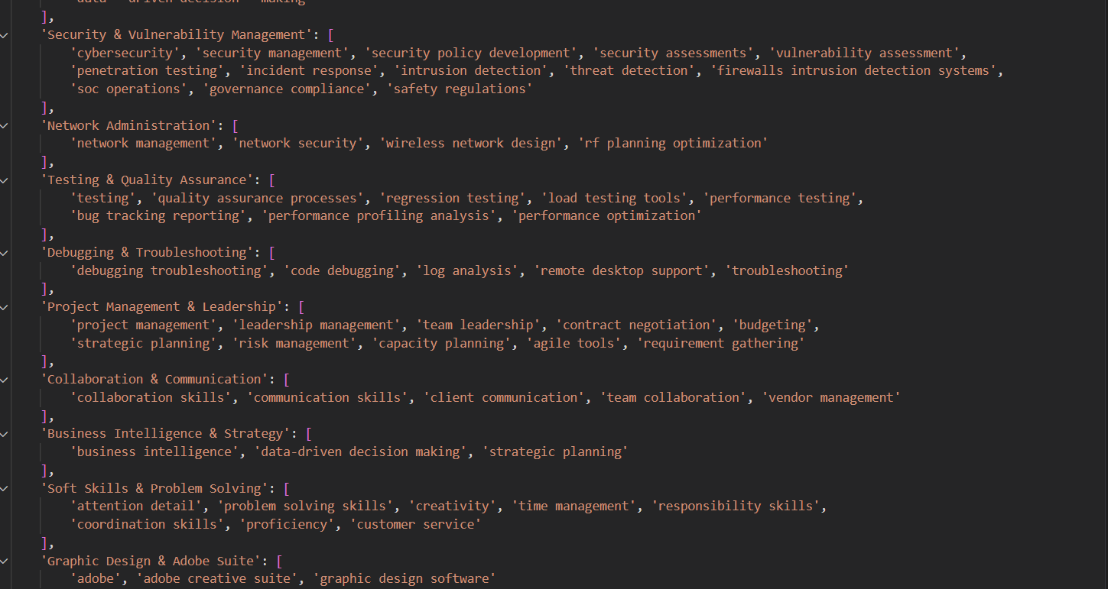 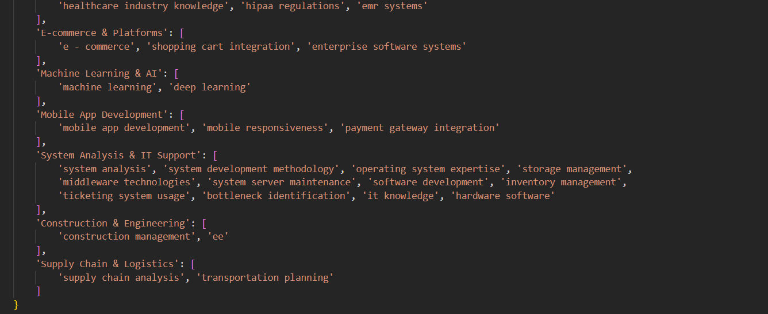 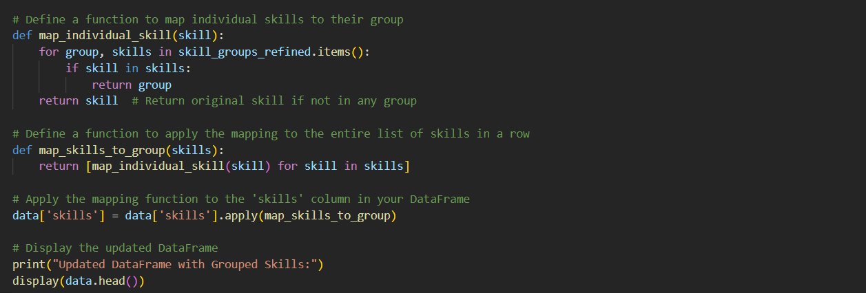 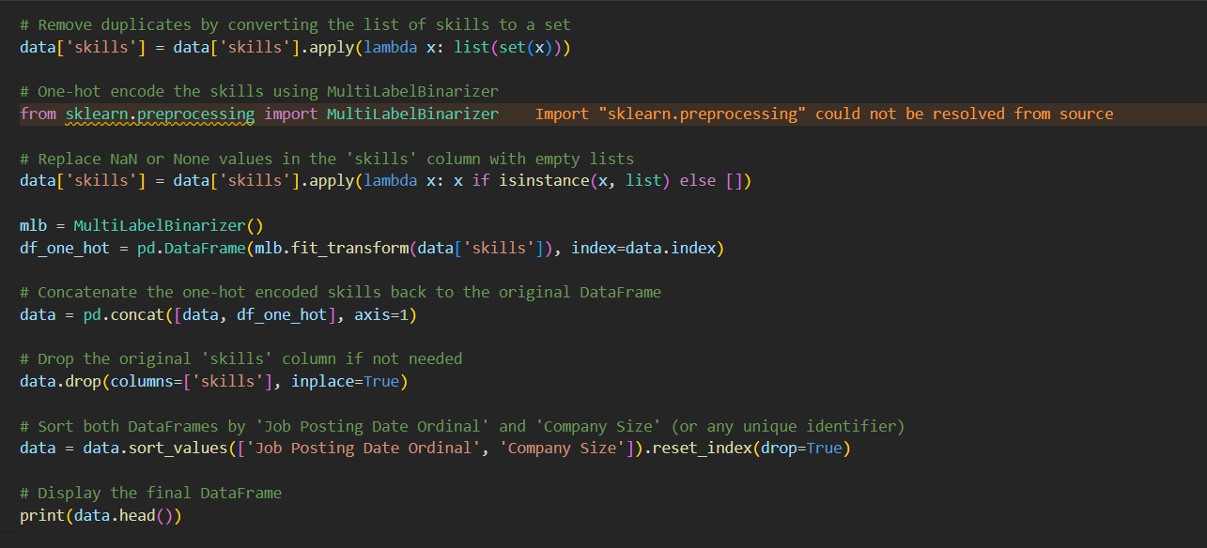 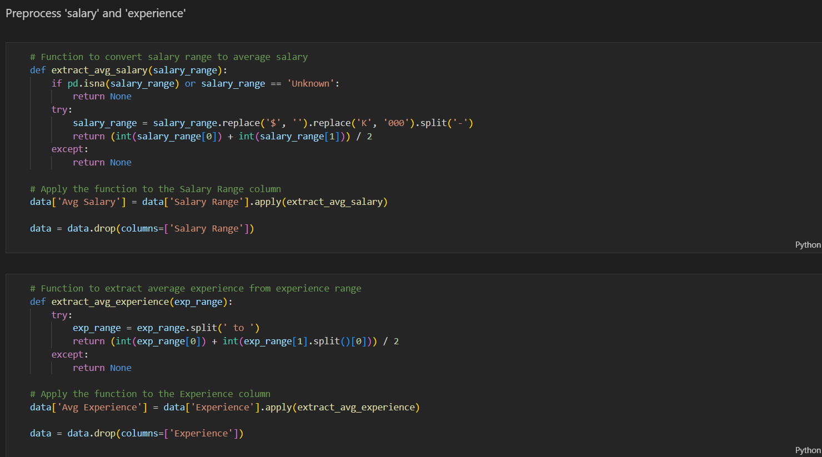 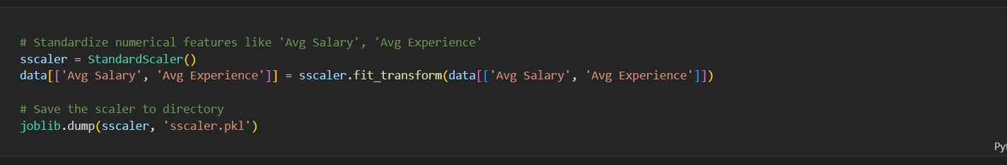 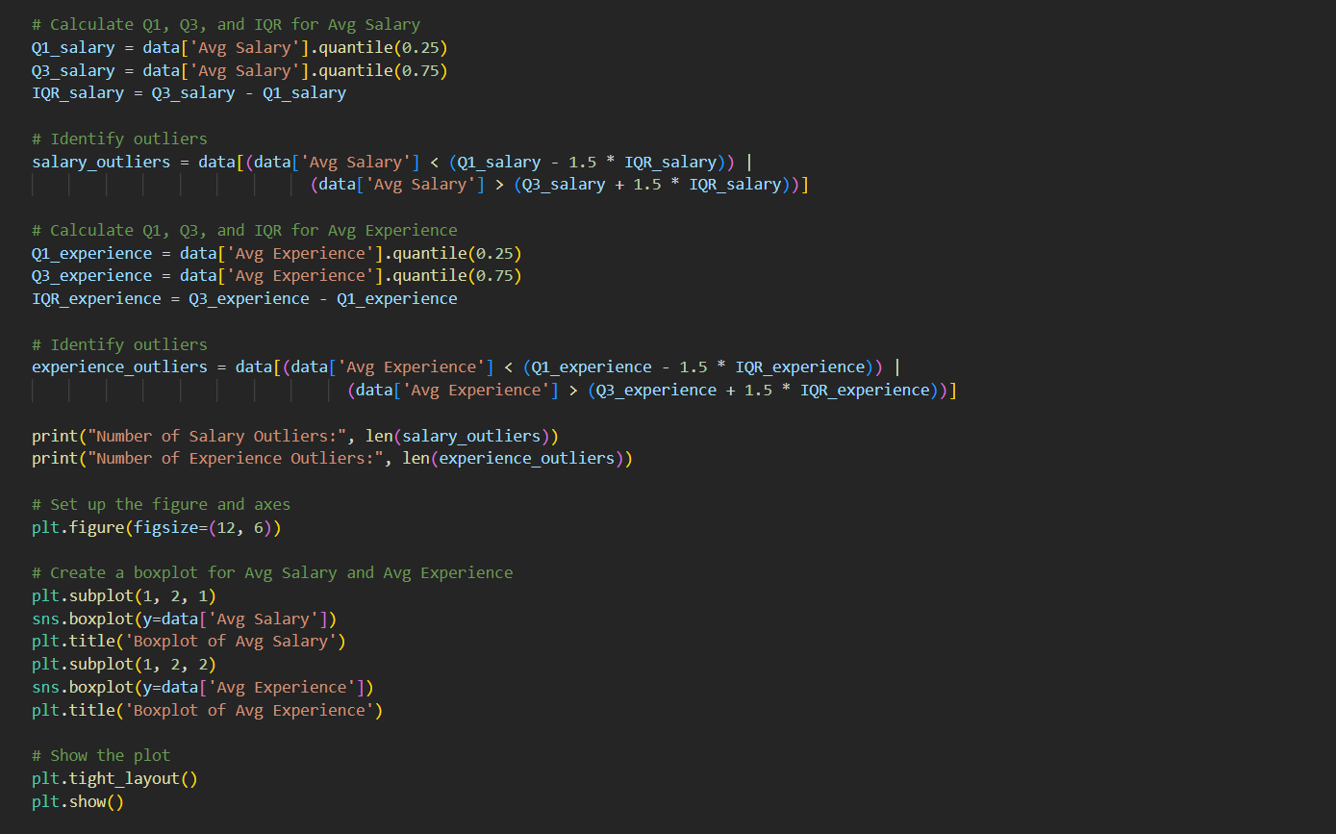 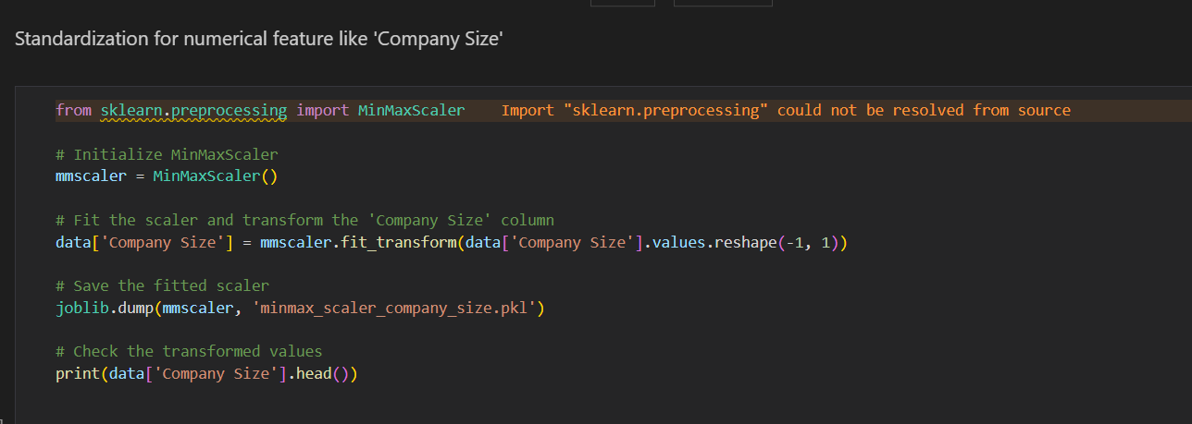 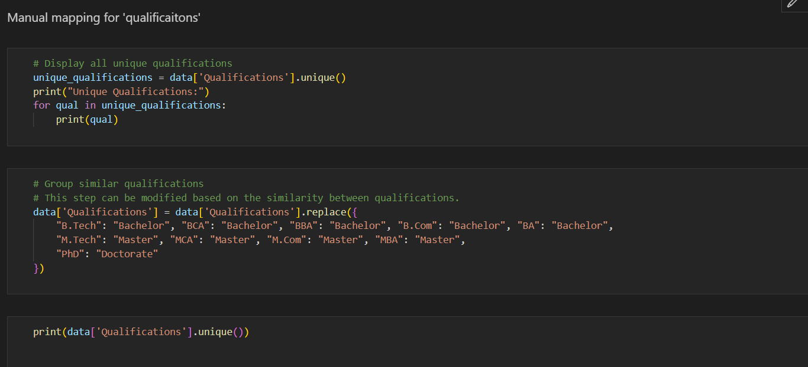 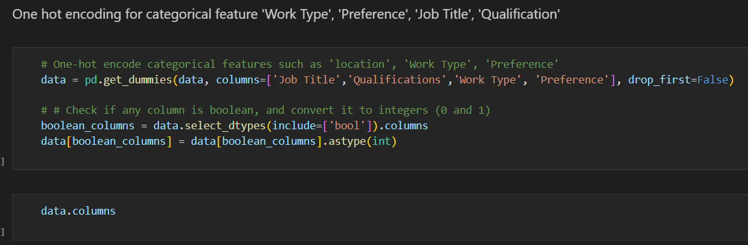 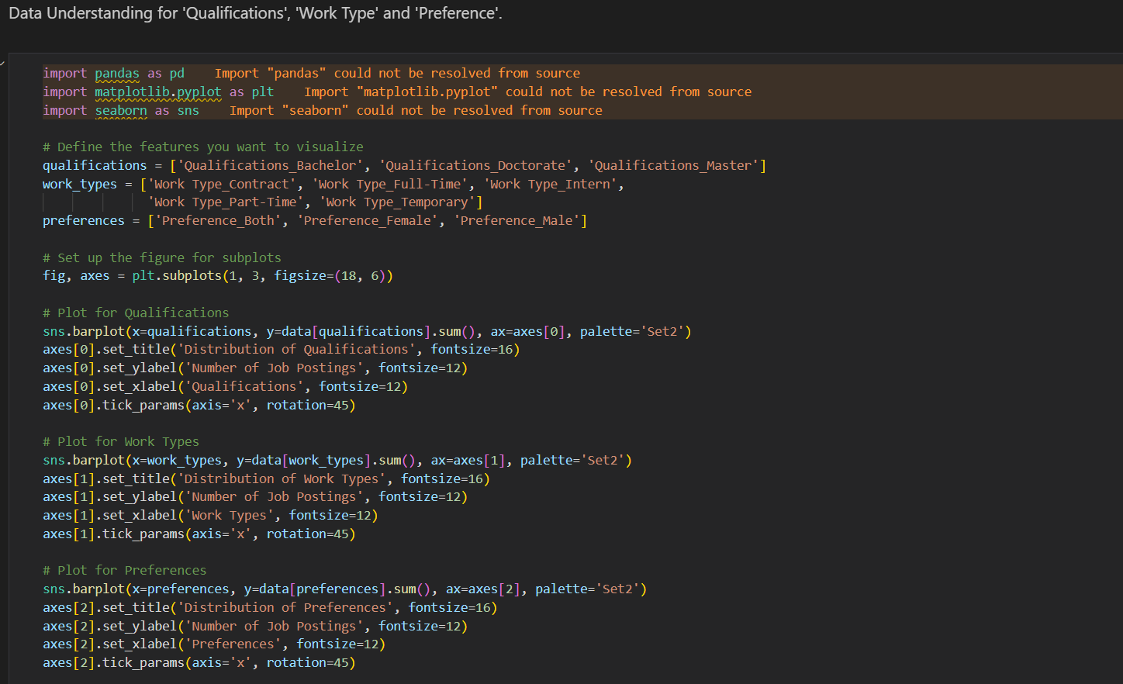 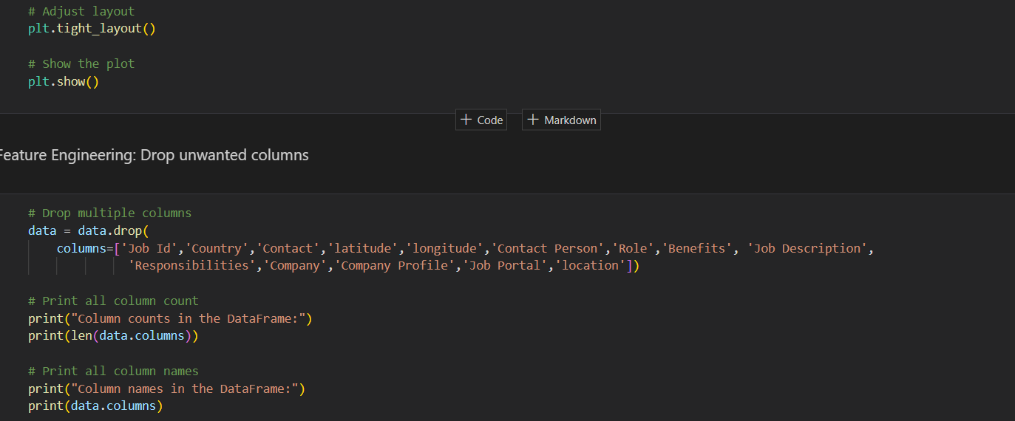 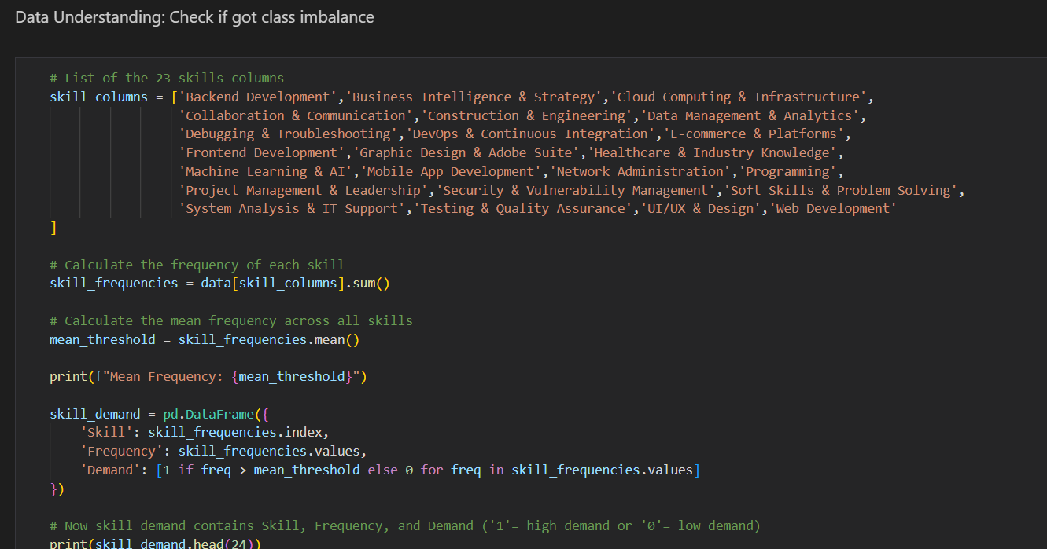 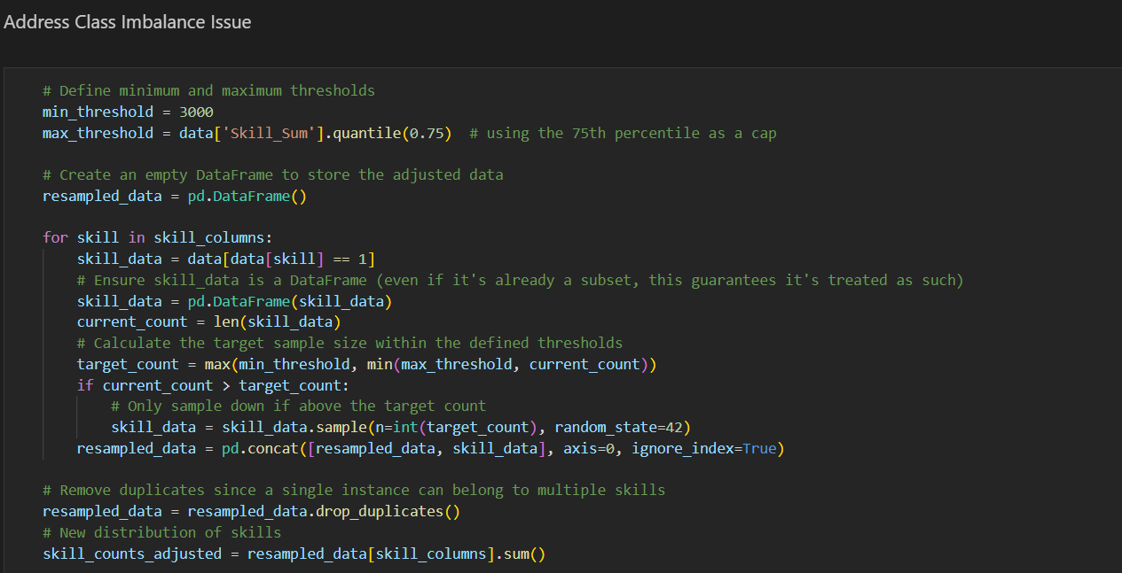

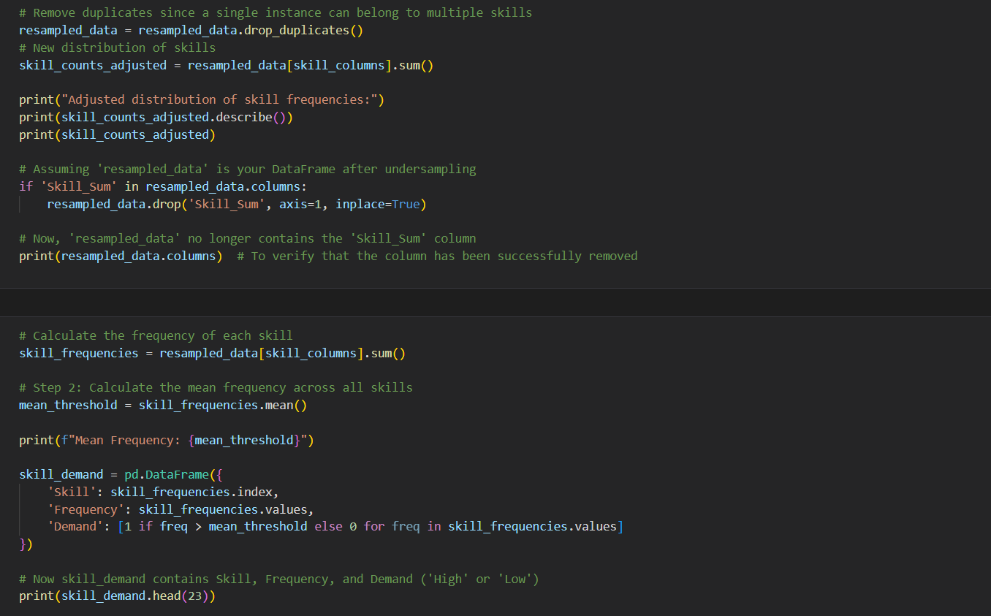 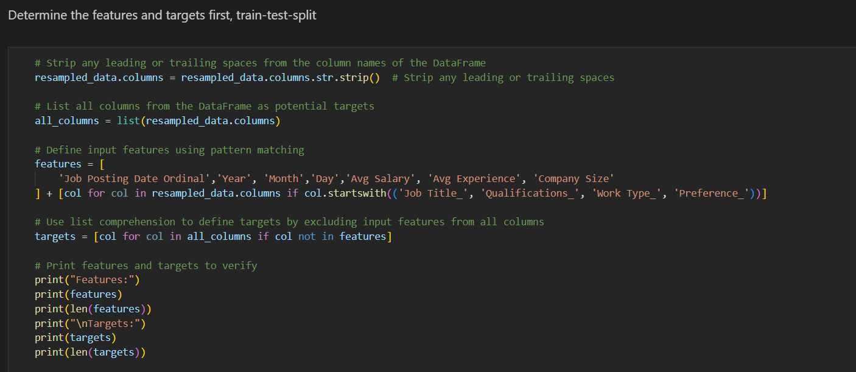 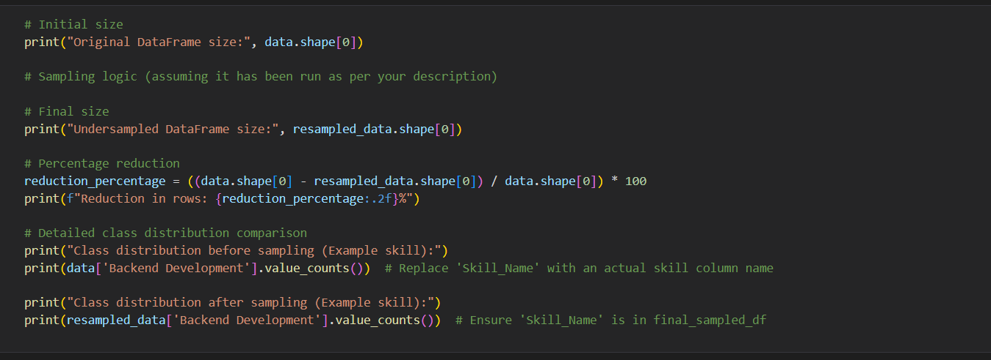 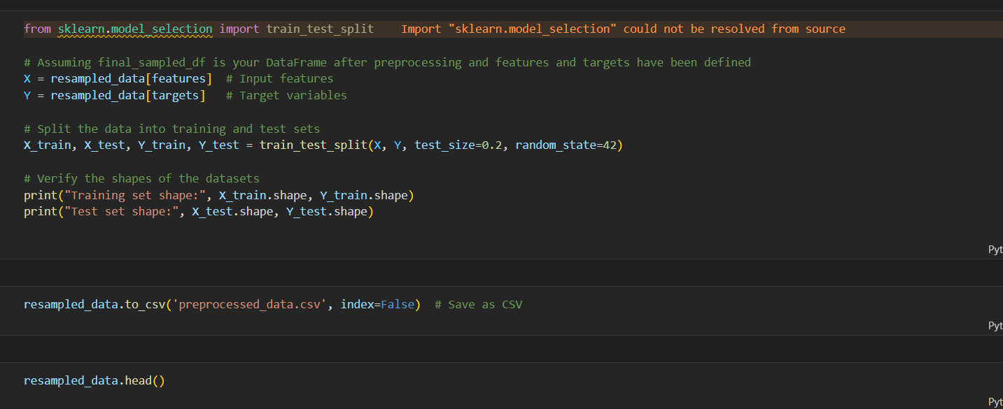 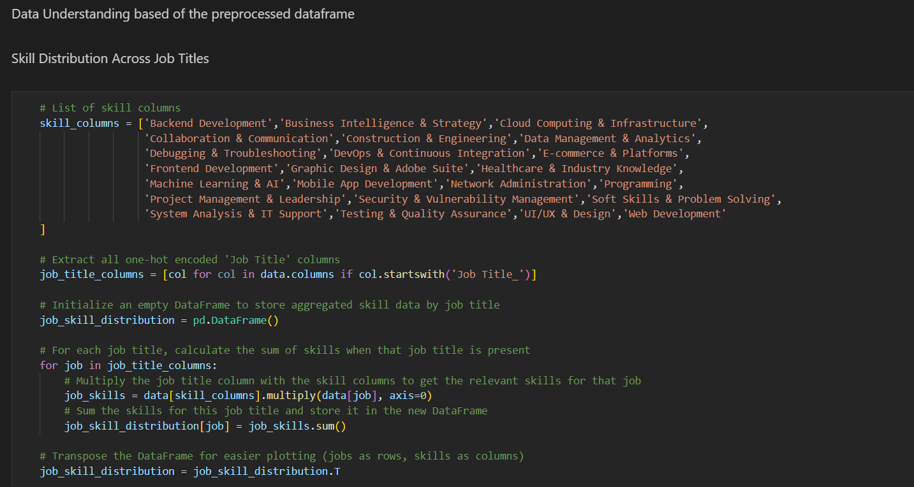 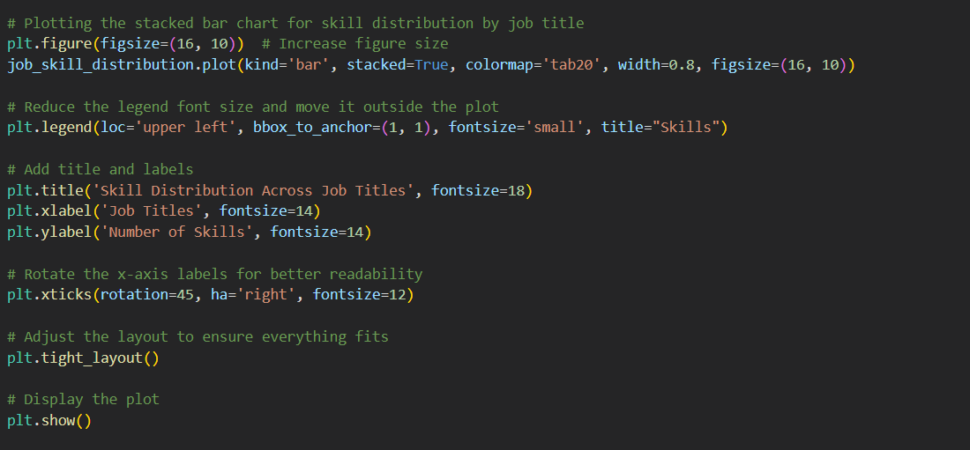 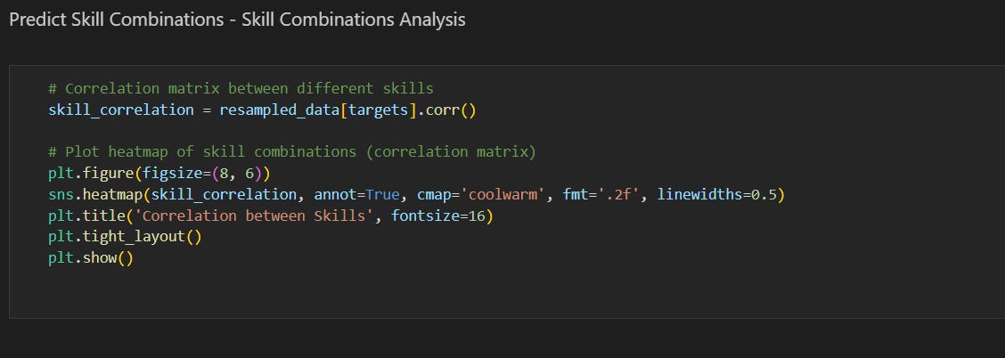 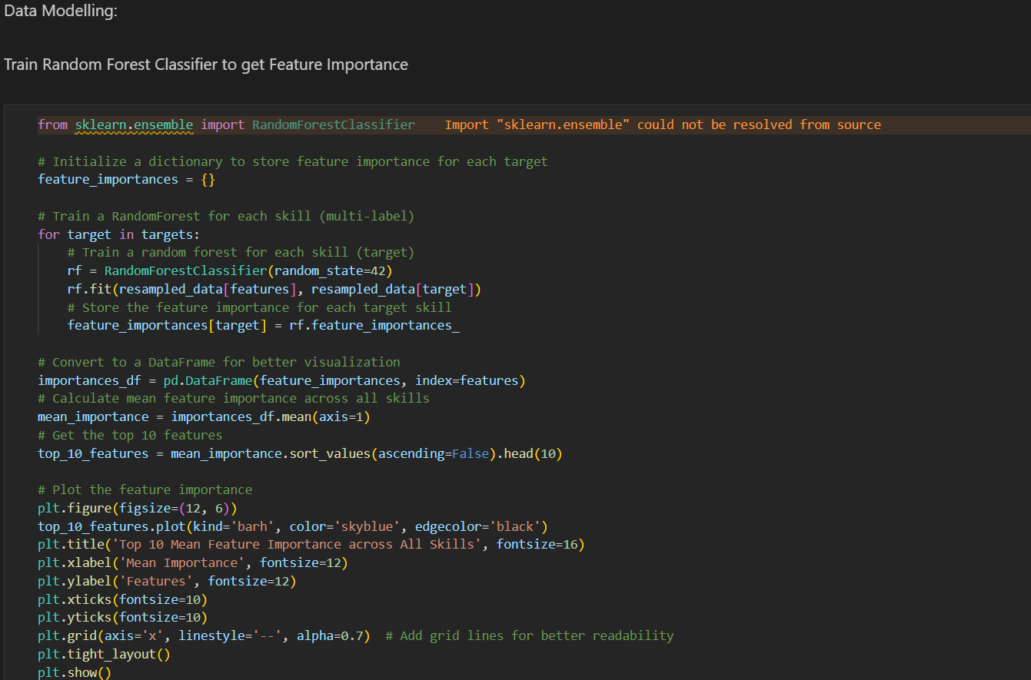 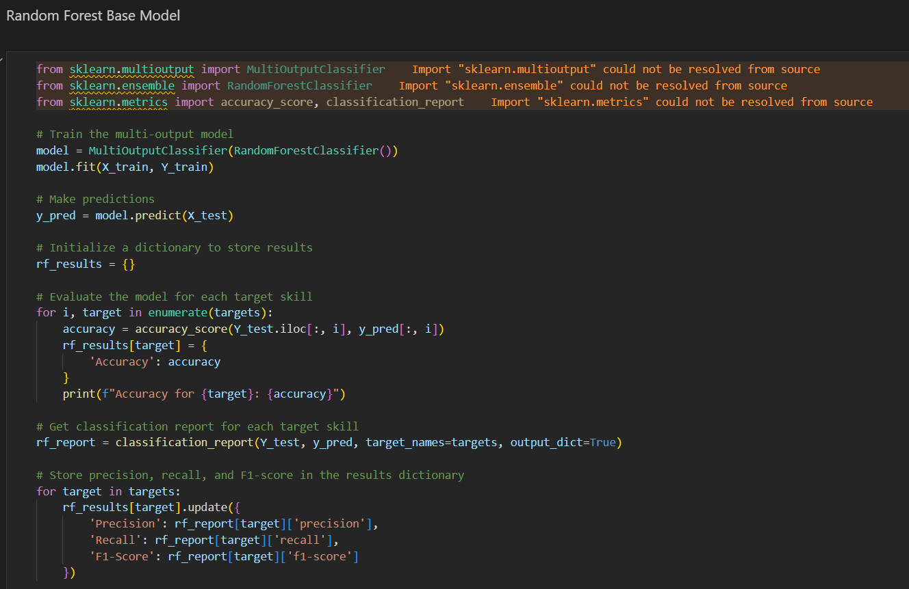 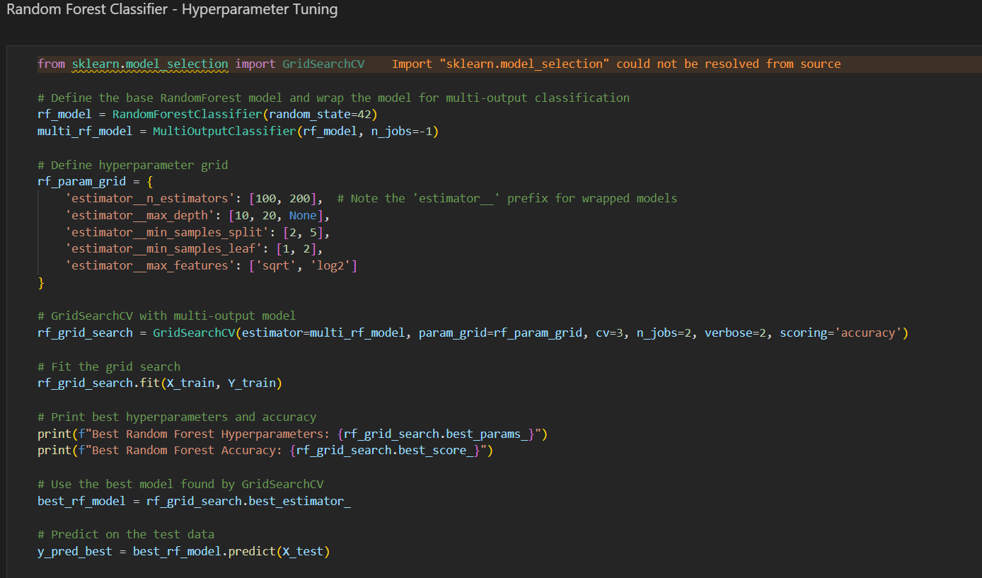 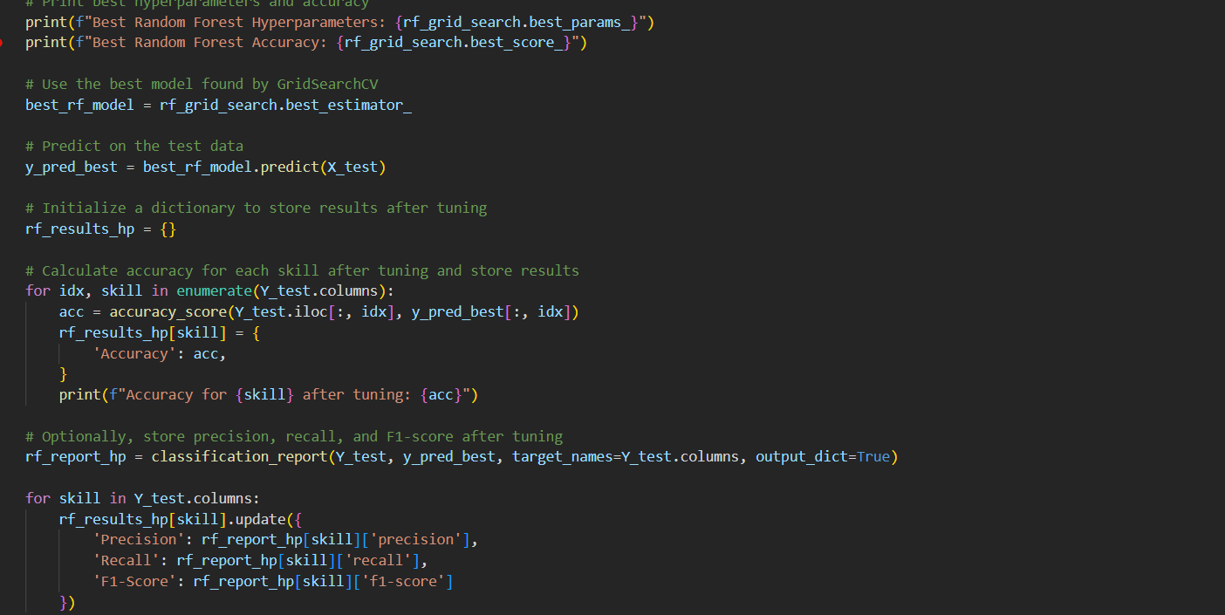 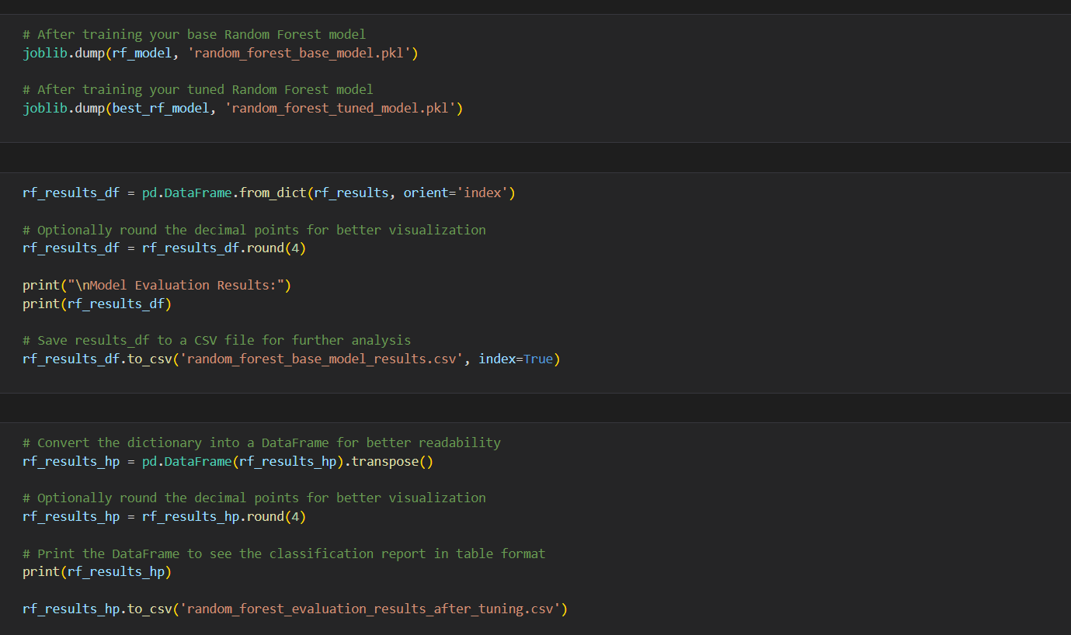 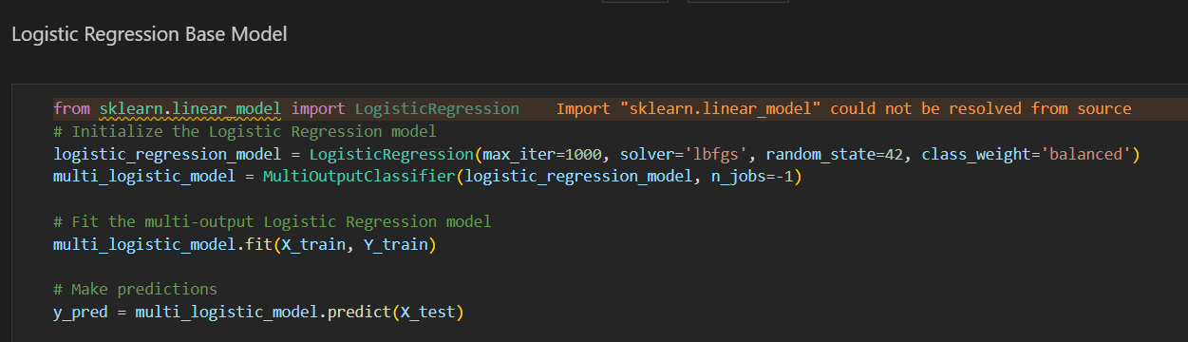 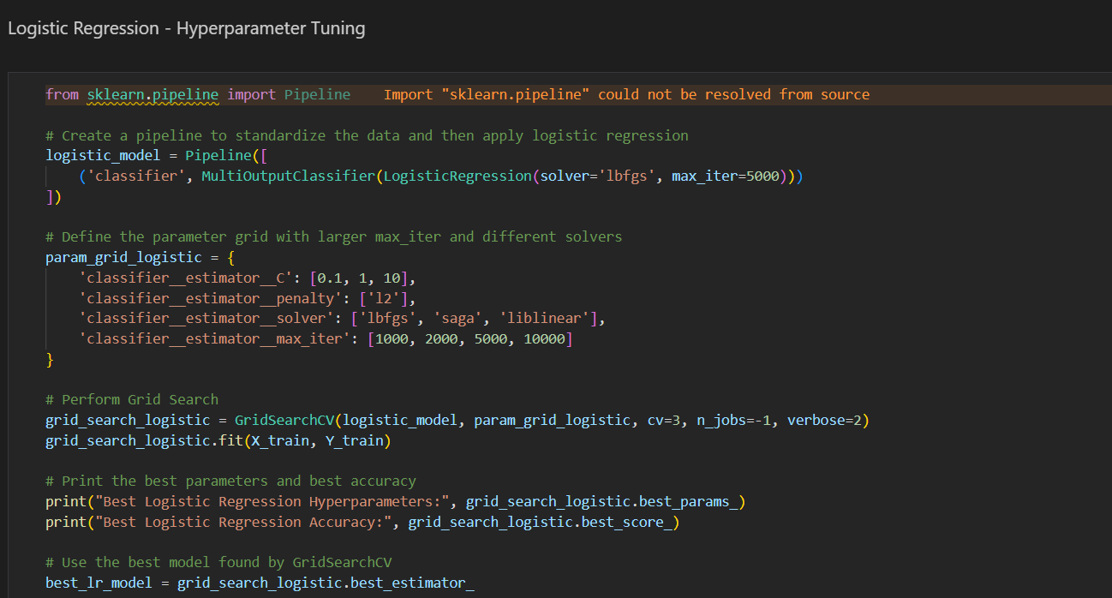 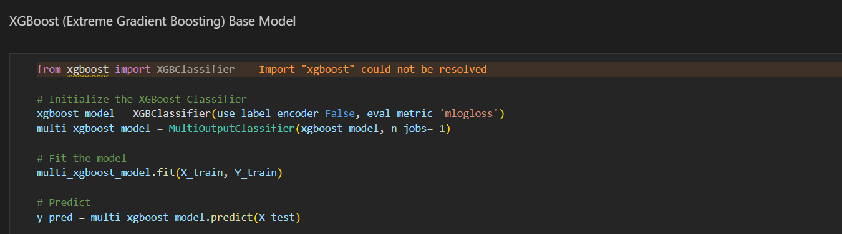 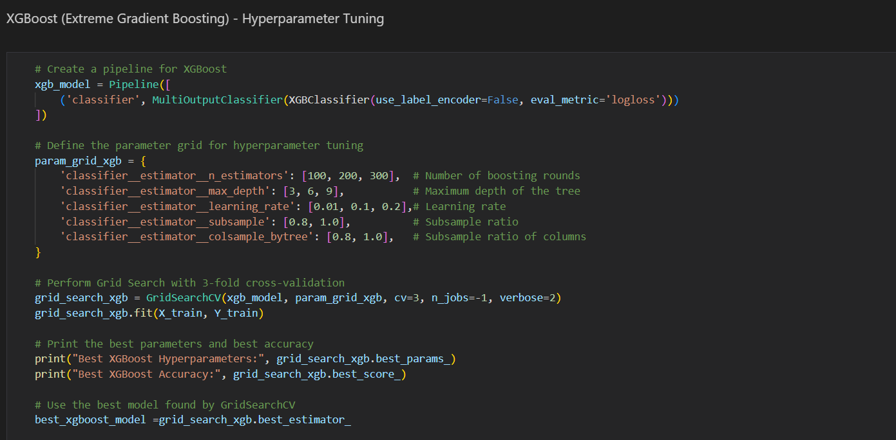 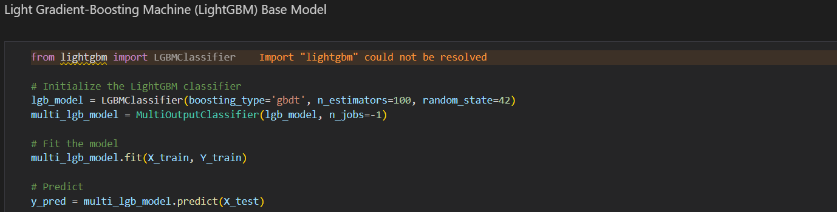 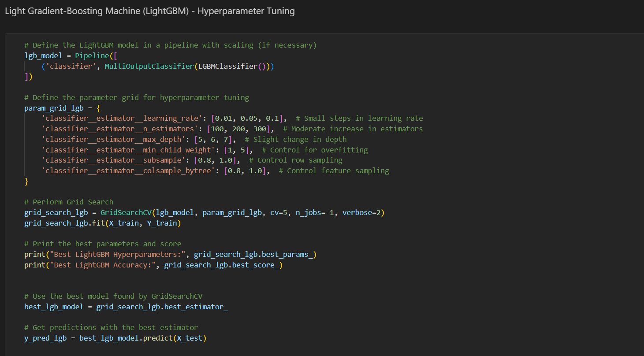 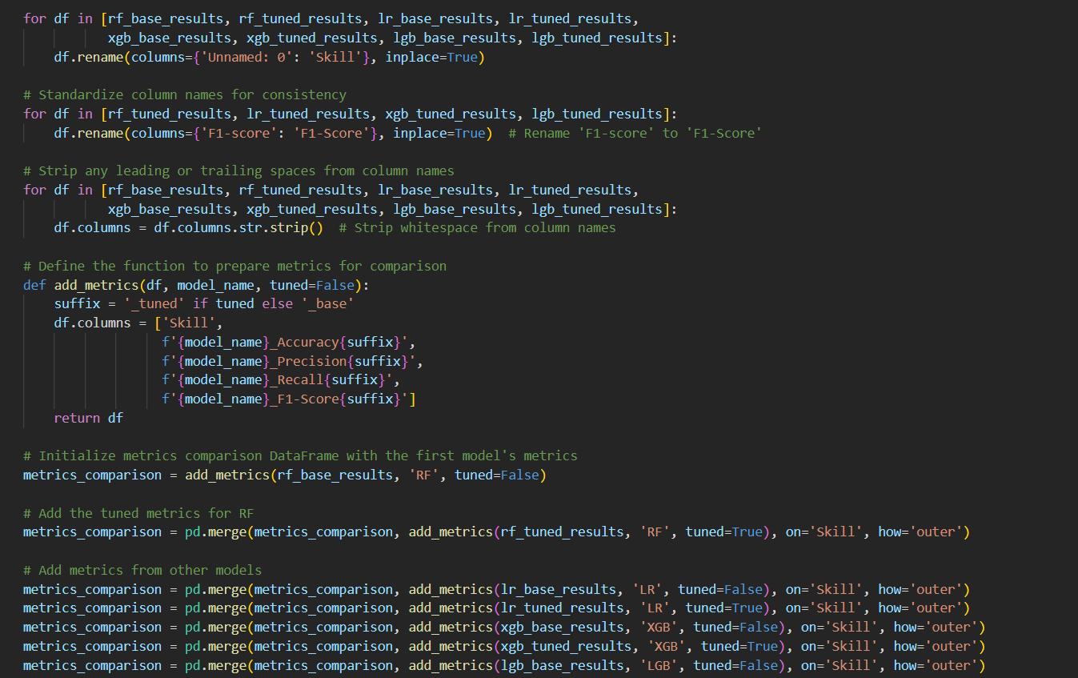 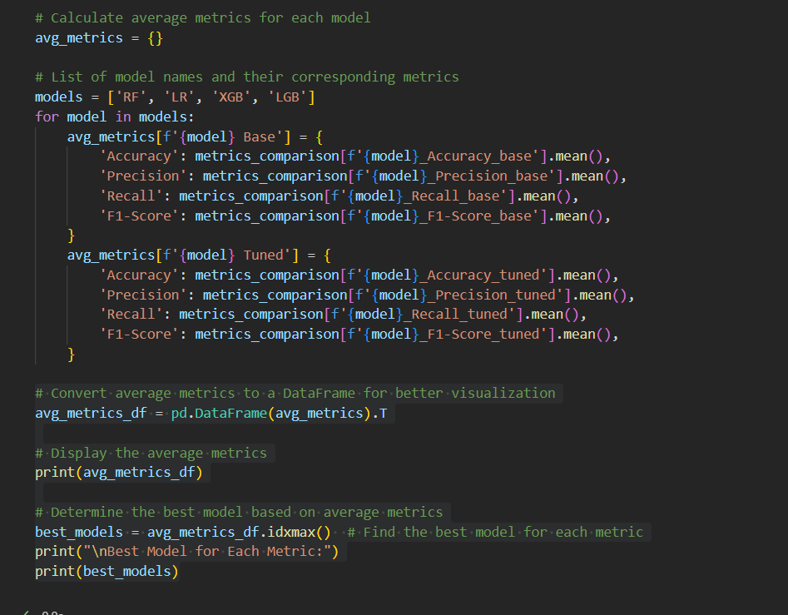 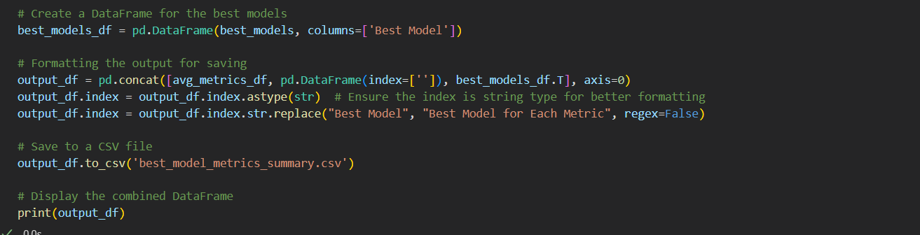 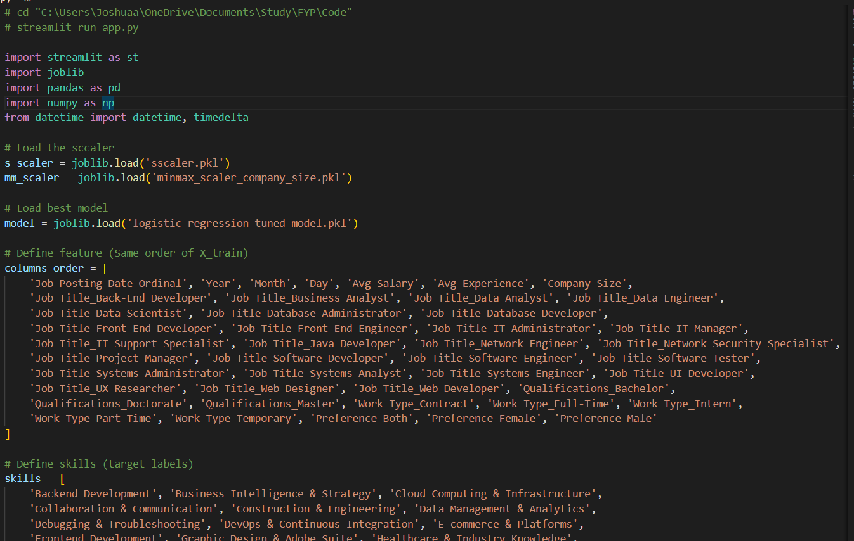 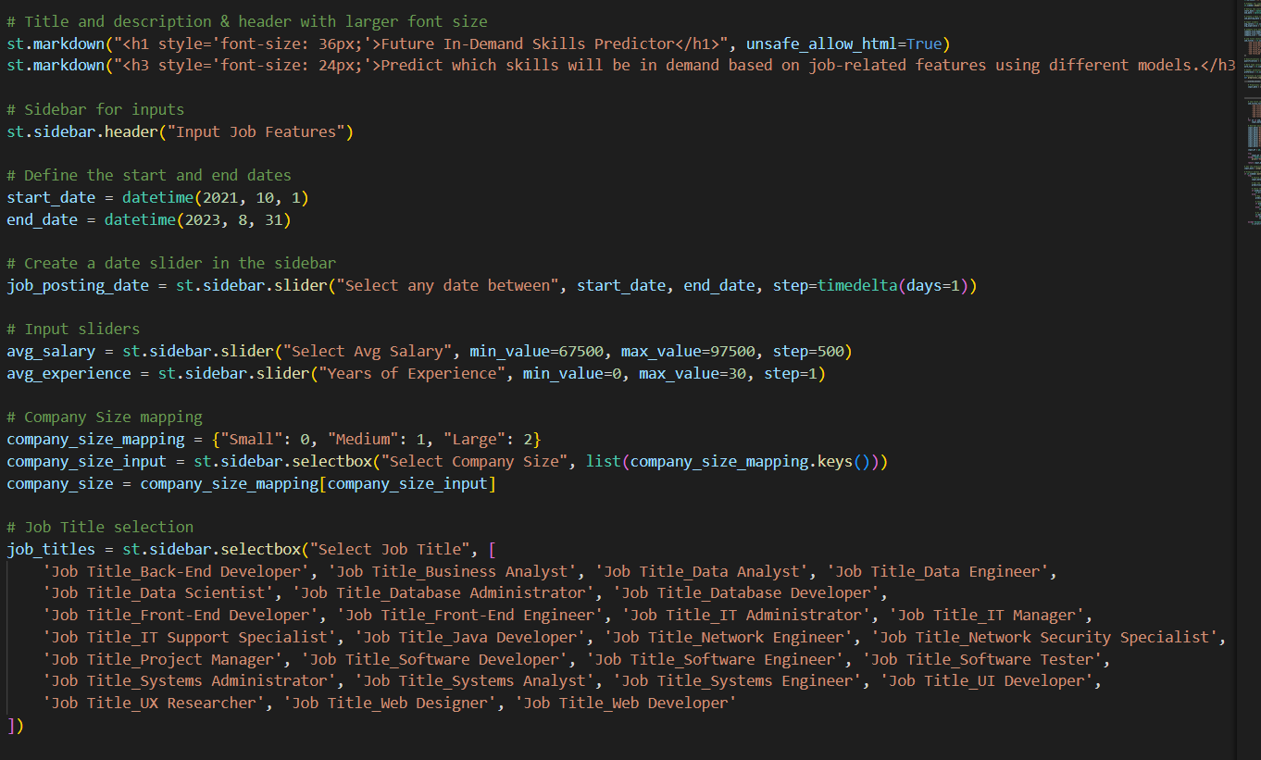 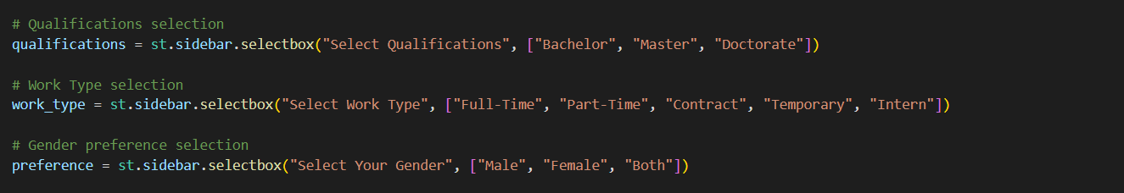 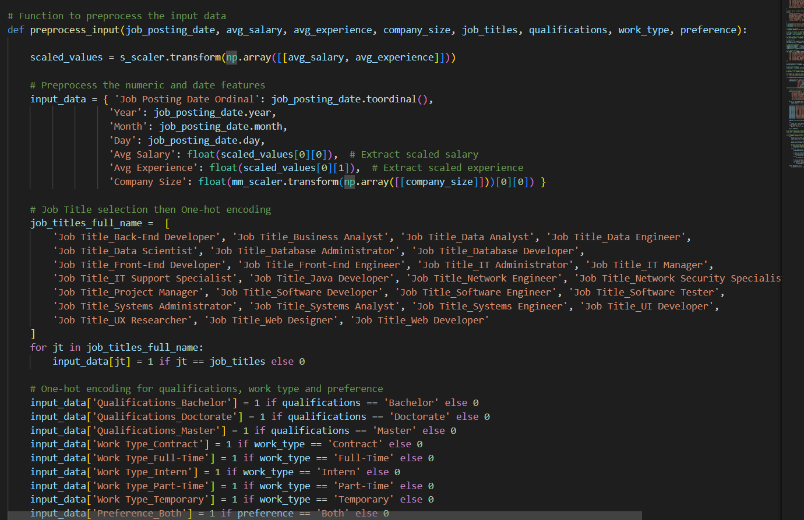 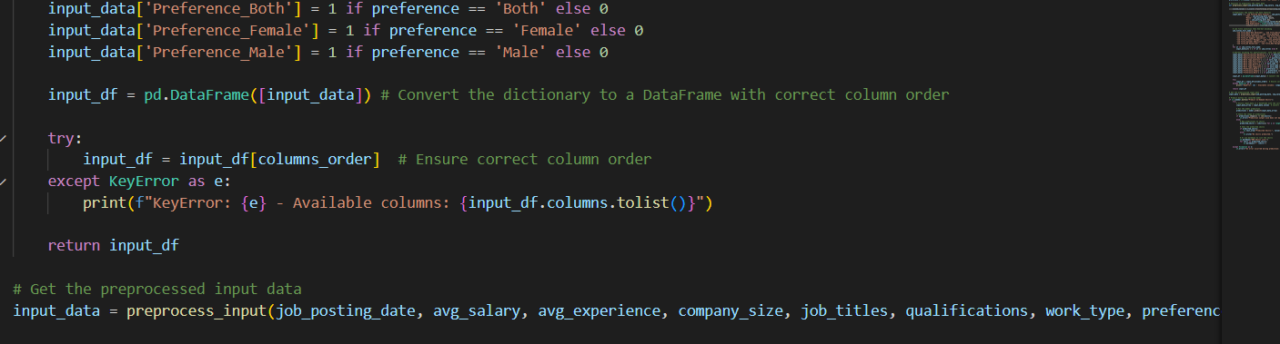 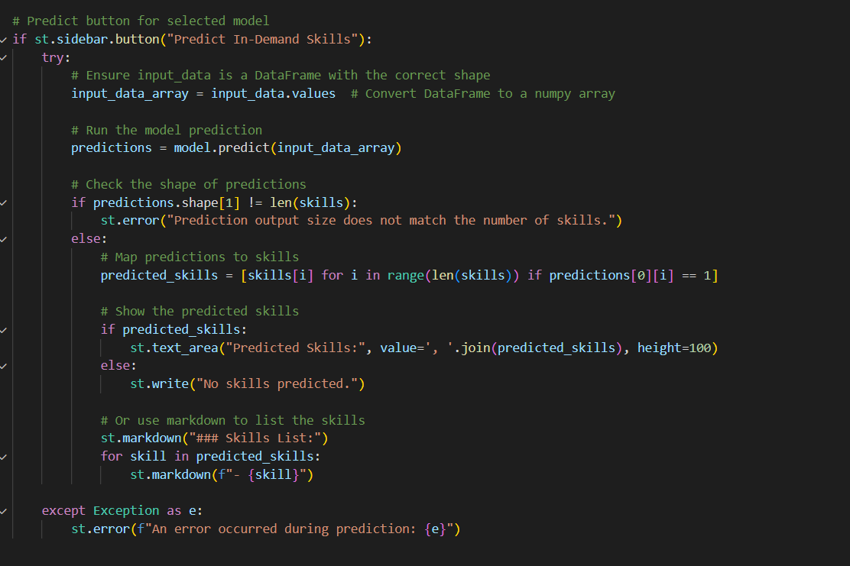

## Appendix G: Turnitin Report

